*Aitbay A.S. ¹
¹ English Language Teacher, ALAN International School, Shymkent, Kazakhstan, e-mail: aitbay.aida11@gmail.com

Robots and Humans:
Friends or Teachers of the Future

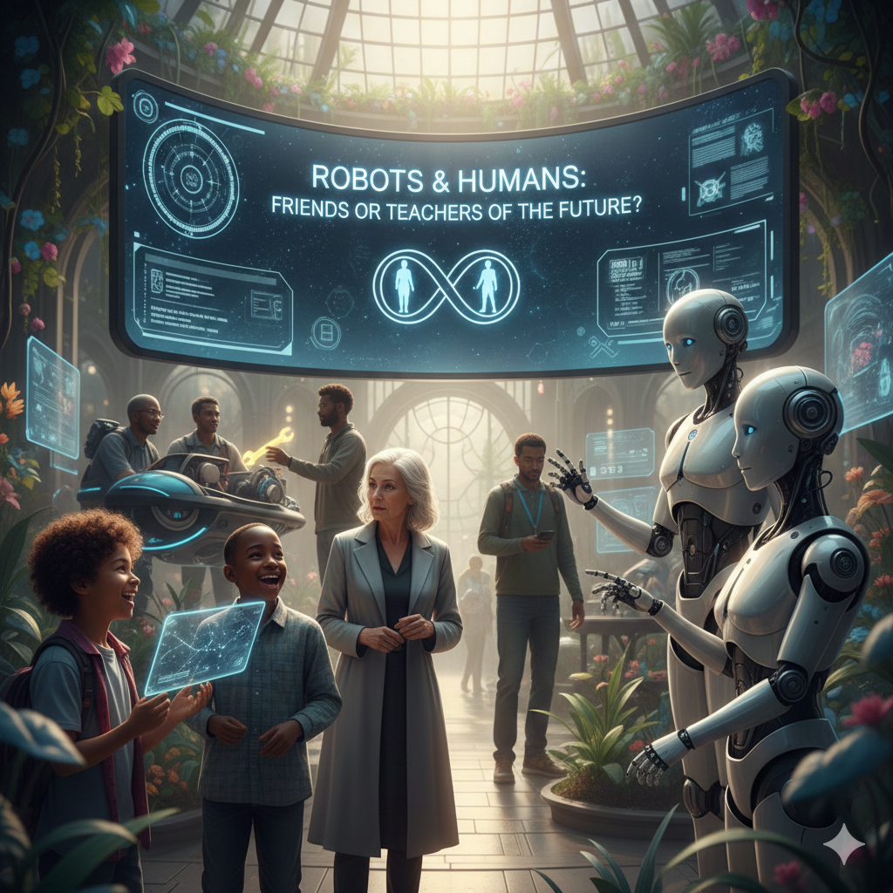

Shymkent, 2026
CONTENTS
ANNOTATION ..............................................................................................4
INTRODUCTION .........................................................................................5
MAIN PART .................................................................................................. 7
PRACTICAL PART ...................................................................................... 8
CONCLUSION ............................................................................................. 14
REFERENCES .............................................................................................. 15

REVIEW
The student’s scientific research project titled “Robots and Humans: Friends of Teachers of the Future” is one of the most relevant and important topics of the modern educational environment. The project focuses on exploring how robots and human teachers can work together and how teachers feel about using robots in the classroom.
Using a simple quantitative research method, the student collected real data from English teachers through an online survey. The student analyzed teachers’ opinions about robots helping in lessons, supporting learning, and working together with teachers. This shows the student’s ability to conduct scientific research, interpret results, and understand modern educational technology.
The structure of the project follows scientific requirements: it includes an annotation, introduction, main part, methods, results, conclusion, and references. The theoretical and practical sections are well connected. The practical part is supported by clear tables and figures, demonstrating teachers’ real opinions about the use of robots in education.
The results of the research show that teachers view robots as helpful tools but do not believe robots can replace human teachers. The student successfully explains why human emotions, care, and understanding cannot be replaced by technology. This highlights the practical value and relevance of the topic.
Overall, this scientific project increases the student’s interest in modern technologies and demonstrates how educational robots can support teaching. The research work is meaningful, well-prepared, and aligned with the needs of the digital age. The project shows a promising direction for future development and improvement.

ANNOTATION
Purpose: To study how robots can help teachers in the classroom and to understand teachers’ opinions about working together with robots in the future.
Objectives:
- To explore how robots are used in education and what tasks they can support.
- To collect teachers’ opinions about robots through a survey.
- To analyze the survey results and determine how teachers feel about robots helping in lessons.
- To identify advantages and challenges of using robots in the school environment.
Relevance: Studying how robots and teachers can work together is important in today’s digital age. As educational technology grows, it is necessary to understand how robots can support teaching and improve learning.
Research Framework: The study includes reviewing information about educational robots, collecting teachers’ opinions through a survey, and analyzing the results.
Hypothesis: If robots help teachers in the classroom, teaching can become easier and more effective, but robots cannot replace human teachers.
Novelty of the Research: This project studies teachers’ opinions about robots in education, using real survey data. The research highlights how robots can become helpful partners for teachers rather than replacements.
Recommendation: To continue improving the study by exploring more types of educational robots, increasing the number of teacher participants, and testing robot-assisted lessons in real classroom situations.
INTRODUCTION
In our modern world, robots are becoming a big part of daily life. They help doctors, drivers, and even teachers. This topic is important because robots can change the way we learn and live. Many scientists from different countries study how robots can help people. Some schools already use robot helpers in lessons. I chose this topic because I am interested in technology and want to know if robots can really teach like humans.
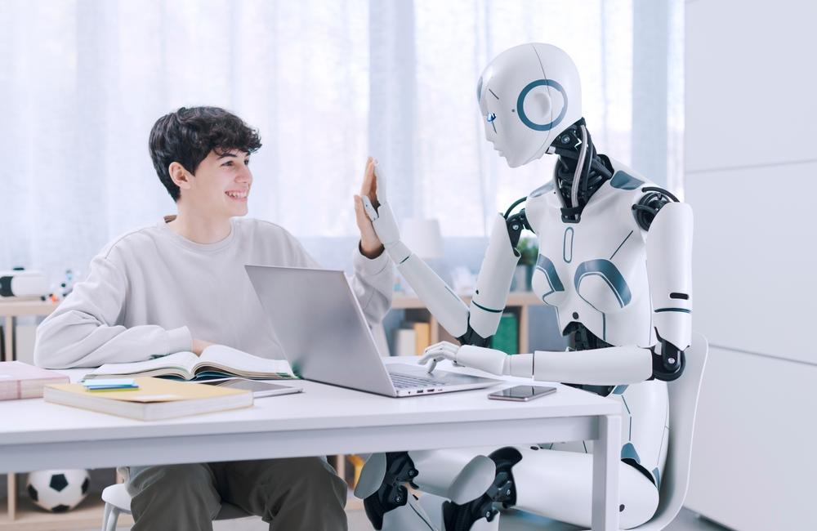
School of Modern Skills. (n.d.). Will robots replace teachers? [Image].
Chen, Qiu, Li, Zhang, Wu, Zeng, and Huang’s (2023) study shows how students feel about learning with robot teachers. The researchers found that many children like learning with robots because robots can talk, help with lessons, and make studying more fun. However, some students still prefer human teachers because they understand feelings and can explain things better. The article says that in the future, robots and teachers can work together. Robots can help students practice, while teachers can guide, support, and care for them. The study shows that when humans and robots work together, learning becomes more interesting and effective.
Xixian Huang’s (2024) article shows how robots are getting smarter and more helpful in schools. It explains that thanks to better mechanics, sensors, voice-recognition and artificial intelligence, robots can now work in classrooms like tools, peers, or teachers. The study looked at many earlier research papers (from 2012 to 2022) and found that robots helped younger students learn language, science and even STEM subjects more actively. However, the article also notes that robots are not yet perfect: some experiments were short, some robots had technical problems, and there’s still a question whether a robot can replace a human teacher. The main idea is that robots are becoming part of education and they can help students, but teachers are still very important.
In 2024, Does really educational robotics improve secondary school students’ course motivation, achievement and attitude? by Erol et al. shows that when students use robots in class, they said the activities were “fun, engaging, interesting, and hands-on.” The study involved 112 students who used robotics kits as part of their lessons. Because they could touch, build and program robots, they felt more involved than with regular lessons. This means robots do not just teach facts, they help make learning feel like a game or a project instead of only listening and writing. You could say: when lessons include robots, children pay more attention, smile more, and want to try again.
Recent studies say that even though robots often look like they are smiling or sad, they do not really feel emotions like we do. For example, a piece by MIT Media Lab explains that robots can respond to our words and move in ways that seem emotional, but there is no real “feeling” inside them. Because of this, one child said “the robot was less stressful … the robot is easier because you feel less judged because robots don’t have feelings.” This means that while robots can act friendly and helpful, students and teachers should remember that a robot doesn’t understand sadness or joy the way a person does.
MAIN PART
The research used a simple quantitative method to learn what English teachers think about using robots in the classroom. The goal was to understand how robots and humans can work together to help teachers in the future. Data was collected through an online survey with clear and easy questions. The study focused on school English teachers because they have real classroom experience and know what support they need. A total of 10 English language teachers took part in the survey. The research was done with the help of the Likert skale. All answers were collected through Google Forms, and the results were studied using Excel to see the percentages of each answer and to summarize what teachers said. This helped the researchers understand teachers’ opinions about robots and their role in future education.
Figure 1
Screenshot of the Google Survey used in this study
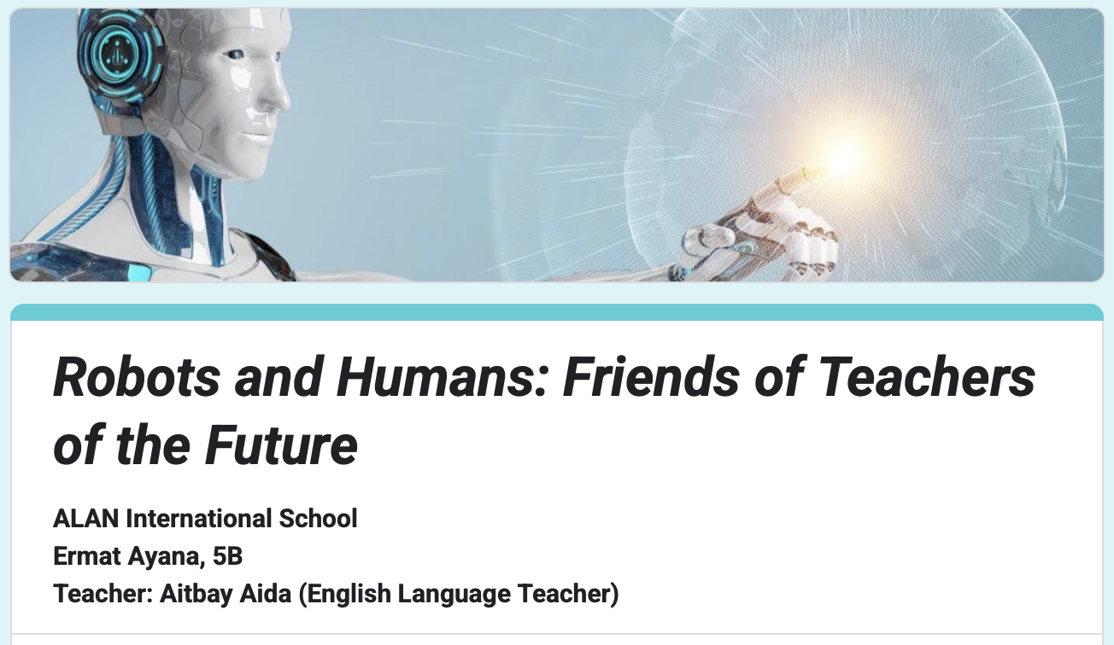
RESULTS
In the future, robots and humans can work together to make learning better. Robots can help with lessons, give fun activities, and make studying more interesting. They can do many things quickly and help teachers save time. But robots do not have real feelings, so they cannot understand when students are sad or need help. That is why human teachers are still very important. The best future is when robots and teachers work as a team - robots help with tasks, and teachers guide students with care and kindness.
A survey was conducted among ten teachers to understand their opinions about using robots in the classroom. The results showed that many teachers had mixed or neutral feelings about most of the statements. For the question “I think robots can help teachers in the classroom,” most teachers selected agree or neutral, while only one teacher disagreed (see Table 1). This suggests that teachers believe robots can support them, but some are still unsure. For the statement of “Learning with robots is fun and interesting,” the majority of responses were neutral, with only a few strong opinions (see Table 2).
Table 1
Opinions on Robots Helping Teachers
Response Type | Count
Strongly Agree | 1
Agree | 4
Neutral | 4
Disagree | 1
Table 2
Opinions on Learning with Robots
Response Type | Count
Strongly Agree | 1
Agree | 2
Neutral | 5
Disagree | 2
When asked whether robots can explain lessons clearly, many teachers chose to disagree or strongly disagree, showing that robots are not seen as very good at teaching yet (see Table 3). A similar pattern appeared for the question “Robots help me understand subjects better,” where most teachers disagreed. Teachers gave stronger answers when comparing robots and teachers. For “Robots can never replace human teachers,” most teachers strongly agreed. They also agreed that they understand feelings better than robots. Responses about excitement and motivation were more mixed, but most teachers agreed that robots and teachers should work together in the future (see Table 4). Finally, answers about robots becoming important in future schools were divided, showing different opinions among students.
Table 3
Opinions on Robots Explaining Clearly
Response Type | Count
Strongly Disagree | 2
Disagree | 3
Neutral | 3
Agree | 2

Table 4
Opinions on Robots and Teachers Working Together
Response Type | Count
Strongly Agree | 2
Agree | 5
Neutral | 2
Disagree | 1
Overall, teachers see robots as helpful partners but still believe human teachers are the most important part of learning.
Robots are becoming more common in schools. They can help teachers and students in many ways. We wanted to know what teachers think about robots in the classroom. We asked teachers in our school about their opinions. The results show what teachers like, what they are unsure about, and what they worry about when it comes to robots and teaching. We asked teachers if robots can help them. Most teachers said “agree” or “neutral,” and only one teacher said “disagree.” This shows that most teachers think robots can help with their work. Some teachers are not sure yet, maybe because they have not used robots in school before. Robots might help teachers do tasks like explaining things, giving extra help, or keeping track of students’ work (see Figure 1)
Figure 1
Distribution of Responses About Robots Helping Teachers
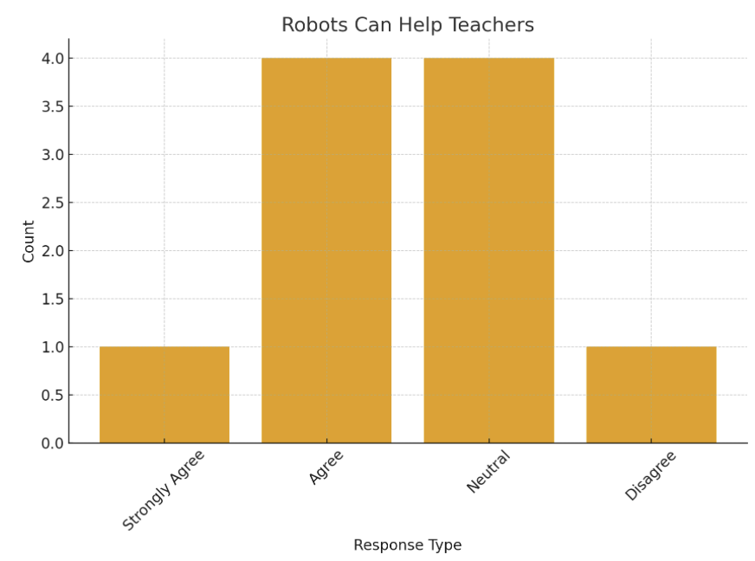
We also asked teachers if they like the idea of students learning with robots. Many teachers chose “neutral,” which means they are not sure. Some teachers said “agree,” which shows they think robots can be useful in learning. The neutral answers might be because teachers have not seen robots in the classroom a lot (see Figure 2)
Figure 2
Teachers’ Opinions on Learning with Robots
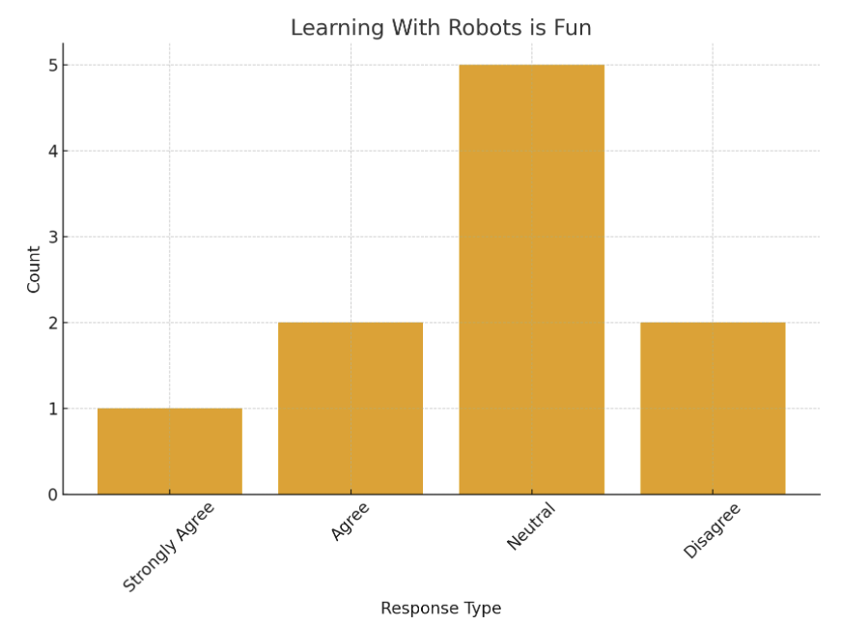
We asked teachers if robots could replace them. Most teachers said “strongly agree” that robots should not replace teachers. This shows that teachers think humans are very important in teaching. Teachers can understand students’ feelings, give guidance, and explain things in a human way. Robots cannot do all of this yet (see Figure 3)
Figure 3
Opinions on Robots Replacing Teachers
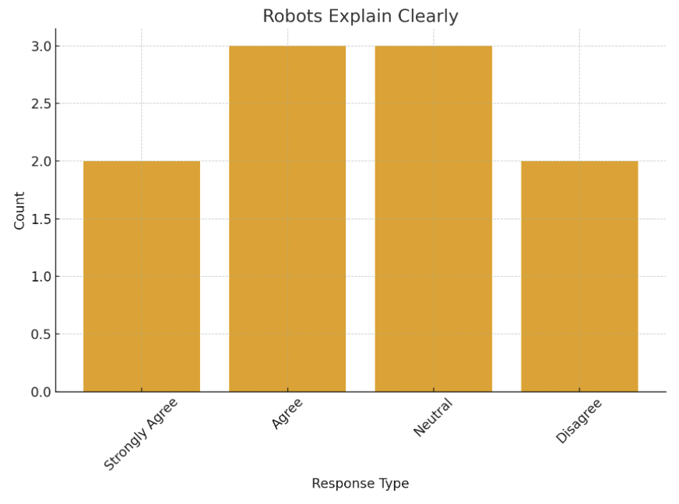
Finally, we asked teachers if robots and teachers should work together. Most teachers said “agree.” This means they think robots can help them, but teachers are still needed. Robots can do small tasks, and teachers can focus on teaching and helping students. Working together can make learning easier and more fun (see Figure 4)

Figure 4
Opinions on Robots and Teachers Working Together
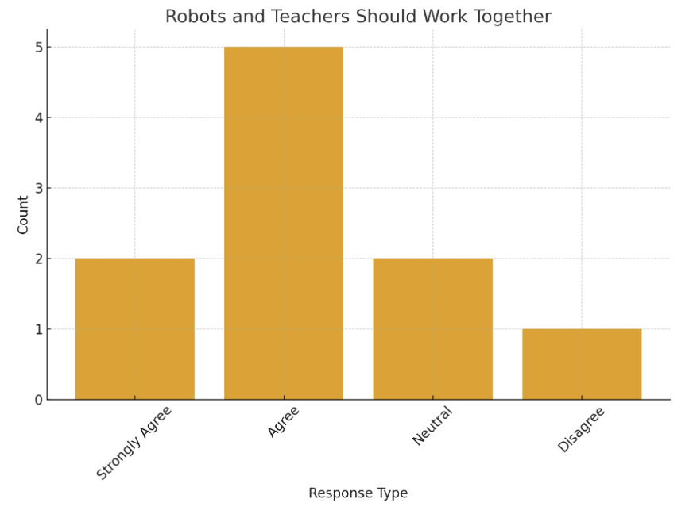

The survey shows that teachers have mostly positive feelings about robots in schools. Most teachers think robots can help them with their work, but robots should not replace teachers. Teachers also believe that robots and teachers can work together to make learning better for students. Some teachers are still unsure about using robots, which means more experience and practice with robots could help them feel more confident. Overall, teachers see robots as helpers, not replacements, in the classroom.

CONCLUSION
In this research, the study explored how teachers perceive the role of robots and their possible use in education. The findings show that most teachers believe robots can help with simple tasks, support learning, and make lessons more interesting. However, teachers also think robots cannot replace human teachers because robots cannot understand emotions, give personal support, or build real connections with learners.
Based on the results, the following conclusions were drawn:
- Robots are useful helpers, especially for routine or repetitive tasks.
- Teachers still play the main role in guiding, supporting, and motivating students.
- Robots cannot replace teachers, but they can work together with teachers to make lessons more effective.
- Technology in education should be balanced, combining human interaction with digital support.
- More research is needed to understand how robots and teachers can work together in real classrooms.
Overall, this study highlights that robots can support teaching, but human teachers remain essential. Using both technology and teacher expertise together can create better learning experiences for students.

REFERENCES:
- School of Modern Skills. (n.d.). Will robots replace teachers? [Image]. https://dubai-sms.com/wp-content/uploads/2024/06/Will-Robots-Replace-Teachers-FI.jpg
- Chen, S., Qiu, S., Li, H., Zhang, J., Wu, X., Zeng, W., & Huang, F. (2023). An integrated model for predicting pupils’ acceptance of artificially intelligent robots as teachers. Education and Information Technologies, 28(9), 11631–11654. https://doi.org/10.1007/s10639-023-11601-2
- Huang, X. (2024). The rise of educational robots: A review of classroom applications. Applied and Computational Engineering, 38, 57–65. https://doi.org/10.54254/2755-2721/38/20230529
- Erol, M., … (2024). Does really educational robotics improve secondary school students’ course motivation, achievement and attitude? Education and Information Technologies, 29, 23753–23780. https://doi.org/10.1007/s10639-024-12773-1
- Murphy, M. (2017, October 2). Can we make robots that experience emotions? Ask an Engineer. MIT School of Engineering. https://engineering.mit.edu/engage/ask-an-engineer/can-we-make-robots-that-experience-emotions/

