SUMMATIVE ASSESSMENT FOR TERM 2
Duration of summative assessment – 40 minutes
Listening – 10 minutes Reading – 10 minutes Writing – 20 minutes
Speaking task is conducted separately.
Total marks- 24
The content of the summative assessment for the 2 term should be selected on topics “Holidays and Travel” or/and “Space and Earth”.
7.L3 Understand with some support most of the detail of an argument in extended talk on a limited range of general and curricular topics.
7.L6 Deduce meaning from context with little support in extended talk on a limited range of general and curricular topics.
7.R3 Understand the detail of an argument on a growing range of familiar general and curricular topics, including some extended texts.
7.R5 Deduce meaning from context in short texts on a growing range of familiar general and curricular topics
7.W2 Write with minimal support about real and imaginary past, events, activities and experiences on a growing range of familiar general topics and some curricular topics.
7.UE9 Use appropriately a variety of active and passive simple present and past forms and past perfect simple forms on a range of familiar general
7.S7 Use appropriate subject-specific vocabulary and syntax to talk about a growing range of general topics, and some curricular topics.

Listening
Task. Do the matching exercise 1 – 5 while you listen to the recording. Complete the table with the correct place from the box above.
Write the correct answer to the question 6. CD3. Tapescript2. Example: What time does the train arrive at Exeter? 6.30 p.m./18.30
Oxford Manchester London Cambridge Exeter
1. Listening A  The speaker wants to go to | [1]
2. Listening B  The speaker wants to go to | [1]
3. Listening C  The speaker wants to go to | [1]
4. Listening D  The train is going to | [1]
5. Listening E  The passengers want to go to | [1]

- Listening E

What time is the train back to London?

[1]

Total [6]
Reading
Task.
Read the article again and give answers to the questions. Write no more than THREE WORDS or A NUMBER.
Example: When will space be a popular place for holiday? In 2070
1. How many people will be able to stay at the hotel? ____________________________________
2. When will the centre be ready? ___________________________________________________
3. Where will tourists be able to travel while they are at the center? ________________________
4. Where will most of the hotel on the moon be? _______________________________________

Holidays in Space

The World Tourism Organization says that space will soon be a popular place to go on holiday – possibly by 2070. One Japanese company is getting ready. They are planning a space holiday centre. It will look like a bicycle wheel and have a hotel for 100 people and a theme park. It will travel round the Earth at a height of 300 km. The company hopes the centre will be ready in 2067. The company chairman says that flying to the centre will probably be quicker than flying from Hong Kong to Singapore. When they are on board of the centre, the tourists will take short trips to the Moon or go for walks in space.
An American hotel group is also thinking of building a hotel, called the Lunar Hotel. This will be on the Moon. Most of the hotel will be under the ground so it won’t become too hot or too cold. The rooms will look just like they do on Earth. The guests will eat normal food for lunch. The cooks will just push a button to mix dried food with water to become an instant meal!

Total [4]

Writing
Task. Read the beginning of the story and create your continuation.
Last month I travelled to Italy. When I came to Italy I realized that I had some problems _____________________________________________________________________________________
What were the problems? _______________________________________________________________________________________________________________________________________________________________________________________________________________________________________________________________
How did you solve them? _______________________________________________________________________________________________________________________________________________________________________________________________________________________________________________________________
Describe the end _______________________________________________________________________________________________________________________________________________________________________________________________________________________________________________________________

Total [4]

Speaking
Task. You have to work in pairs. Discuss the questions. You have one minute to prepare and 2-3 minutes to talk.
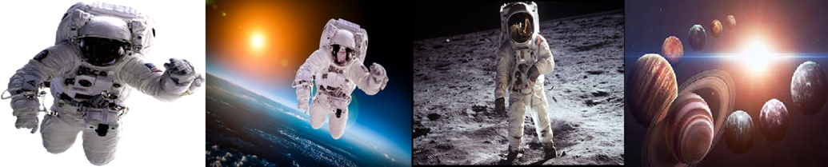
You may use the questions:

1. Would you like to be an astronaut?
2. Have you ever wanted to be an astronaut?
3. Would you like to go to the Moon or travel into space?
4. What kinds of people become astronauts?
5. How important is the job of an astronaut?
6. What planet would you like to travel?

Total [6]

Total [20]

Mark scheme
№ | Answer | Mark | Additional  information
1 | Cambridge | 1
2 | Manchester | 1
3
 | Oxford | 1
4
 | Exeter | 1
5
 | London | 1
6
 | 4.20 p.m. | 1 | 16.20
1 | 100 (one hundred) | 1
2 | 2070 | 1
3
 | To the Moon | 1
4
 | Under the ground | 1
Speaking  Shows sustained ability to maintain a conversation and to make relevant contributions at some length.  Produces extended stretches of language despite some hesitation.  Can respond to change in direction of the conversation.  Pronunciation is intelligible.  Intonation is appropriate  Produces error-free simple sentences.  Attempts some complex grammatical forms, but may make errors, which rarely cause comprehension problems.  Uses a range of appropriate vocabulary to give and exchange views on a growing range of general and curricular topics. |  | 6
Writing  Uses a range of basic connectors correctly and attempts to use referencing, but not always clearly or appropriately.  Uses paragraphs to separate ideas; all paragraphs revolve around one idea or a set of like ideas; the size of each paragraph allows for a proper and balanced development of ideas.  The format is appropriate, but may be modified for a better reading experience.  Uses a range of everyday vocabulary appropriately; attempts to use less common lexical items with occasional inappropriacies.  Has good control of word formation; may make occasional errors in producing less common word forms.  Spells common vocabulary items correctly; very few (one or two) occasional spelling mistakes may be present.  May occasionally misspell less common lexical items.  Errors in word choice and/or spelling do not distort  meaning. |  | 4
Total |  | 20

