Даниярова Бейбіткүн Қаржауқызы, Алматы қаласы, Бостандық ауданы
М. Базарбаев атындағы #138 гимназияның ағылшын тілі мұғалімі
Short term plan
Unit of a long term plan: 8a Self-expression “What’s in a Smile? |  |  | School: №138
Date: 02.04.2024 |  |  | Teacher name:Daniyarova B.K
Grade: 11a |  |  | Number present: 22 Absent: -  absent:
Lesson title | 8a Self-expression “What’s in a Smile?
Learning objectives | 11.1.8 - develop intercultural awareness through reading and discussion;  11.4.1 - understand complex and abstract main points in extended texts on a wide range of familiar and unfamiliar general and curricular topics;  11.4.2 -understand specific information and detail in extended texts on a wide range of familiar and unfamiliar general and curricular topics
Lesson objectives | - Discuss the topic from various perspectives  - By watching the video students will improve their listening skills  - Pump up reading and comprehension skills by doing tasks
Time | Teachers actions | Students actions |  | Assessment | Resources
Beginning  10-15 min  Middle  25 min  End 5 min | Hello students!  Let’s start the lesson!  Home task was: exercise 4 p 98  The task (true, false, doesn’t say)  - The teacher presents a short video "Why is mono Lisa so popular?"  The video shows how the portrait of Mono Lisa was created and why she is so popular. And what events happened to this portrait. So that students understand what today's topic is about.  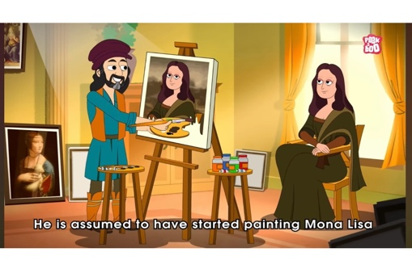  - Task test about mono Lisa. The teacher presents a test in which a frog falls with the wrong answer. Students must answer correctly so that the frog does not fall  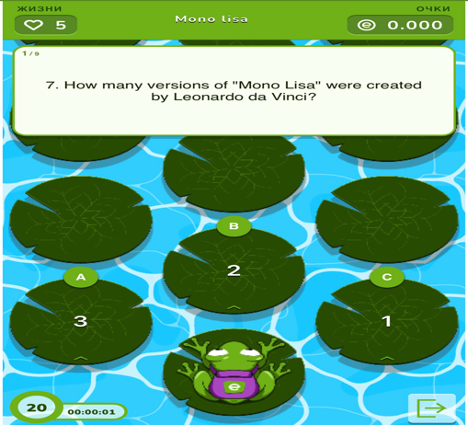  - The task is to connect the portrait with the correct name.  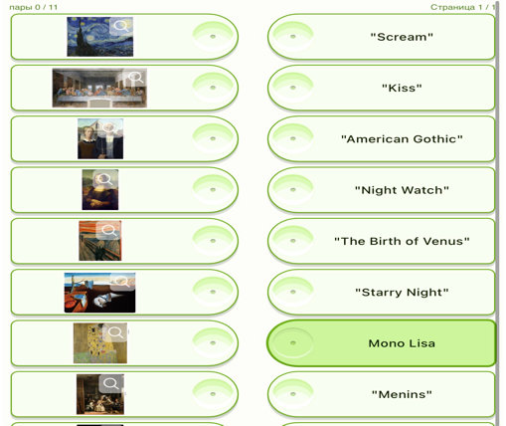  - "Words" task. We have letters and a hint in the task. You need to guess the word from these hints and letters.  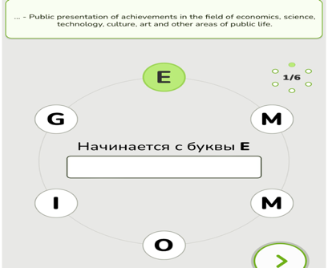  - In the task, you need to put the missing words in the right place.  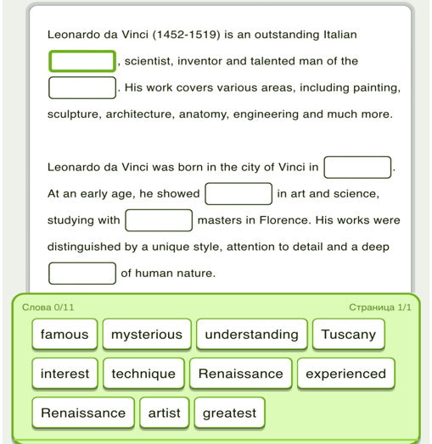  Home task:  Exercise: 5, 6(a, b) p 99 | Students take turns telling their answers.  Students carefully watch the video about Mono Lisa to complete the tasks  After watching the video, the students will solve the test. Students try to complete the task without mistakes so that the frog does not fall into a puddle in the game.  There are famous paintings in the task. Students will guess their names from these paintings  Students will guess the words using tips and photos  Students will carefully read the text and put the missing words in the right place in terms of meaning |  | Formative assessment  Students get 1 point for every correct answer  Formative assessment  Students get 2 points if they complete the task correctly  Formative assessment | Book  https://youtu.be/yJiG8qz-hRI?si=7tQ3xQeIVoPfZJVo  https://www.educaplay.com/learning-resources/18499018-mono_lisa.html  https://www.educaplay.com/learning-resources/18499117-picture_and_name.html  https://www.educaplay.com/learning-resources/18499224-words.html  https://www.educaplay.com/learning-resources/18499418-leonardo_da_vinci.html

