Lesson plan

LESSON: Module 5 Lesson 14 |  | School: 8
Date: 11.02.2022 |  | Teacher name: Uteyeva I.D.
CLASS: 5 b |  | Number present: |  | absent:
Learning objectives(s) that this lesson is contributing to | 5.2.4.1 understand the main points of supported extended talk on a range of general and curricular topics;  5.2.5.1 understand most specific information and detail of short, supported talk on a wide range of familiar topics;  5.3.6.1 communicate meaning clearly at sentence level during, pair, group and whole class exchanges;
Lesson objectives | All learners will be able to:
 | identify some main ideas and detailed information in the text and present some detail correctly in listening and speaking tasks
 | Most learners will be able to:
 | identify most main ideas and detailed information in the text and present some detail correctly in listening and speaking tasks
 | Some learners will be able to:
 | identify all main ideas and detailed information in the text and present a range of detail correctly in
Previous learning | Famous people of the past
Plan
Planned timings | Planned activities |  | Resources |  | Teacher  Notes
Beginning the lesson | Class organization and lesson objectives presentation  (W) Greetings / Icebreaking activity  Teacher greets learners  Good afternoon class. I’m glad to see you. How are you doing today? I suggest to answer in an unusual way. Look at the board! Choose the cat, describing your mood and tell us.  Eg. Today I’m cat № 6, I feel a bit nervous because we have guests and I should do all my best. Now you! 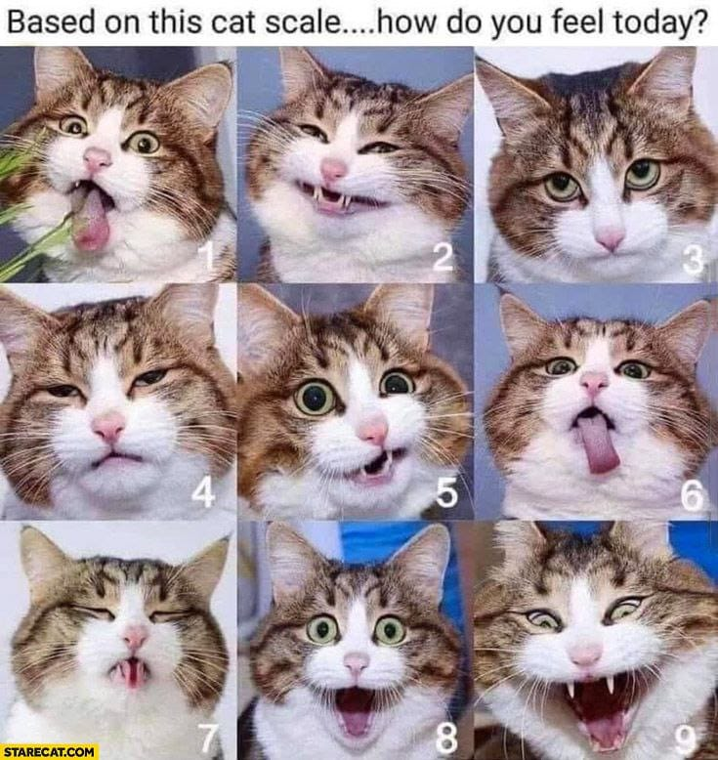  Checking hometask  What was the theme of our lesson yesterday?  (Famous creative people)  Yes, we talked a/t painters and writers. And your home task was to tell a/t A.Kasteev using LRS method  Who wants? (assess them)  (W) Defining the topic.  What is the name of this module?  Yes, yesterday we talked a/t ART and Literature.  And today we’re going to talk a/t creativity too.  Look at the pictures and try to suggest - What’s the theme of the lesson?  Yes, you right – “Musical instruments”.  (W) Brainstorming.  Let’s think What is music? What associations do you have with this word?  MUSIC  Lesson objective:  By the end of the lesson you will be able to  -understand specific information from the text  - identify different musical instruments and types of music  To introduce the topic and present musical instruments – Ex 1 p 72 sb  - Open your books at page 72  - Draw Ss’ attention to the musical instruments in the pictures.  - Play the recording. Ss listen and repeat chorally or individually.  - Elicit the L1 equivalents from Ss around the class. |  | PPT Slide 2-3  PPT Slide  Board  Excel  whiteboard cd

 | Main Activities | To present types of music – Ex. 2 p 72 sb  - Go through the names and types of music in the lists.  - Play the recording. Ss listen and match.  - Check Ss’ answers. |  | Excel  whiteboard cd
 |  | Now, tell me - What Kazakh instruments do you know?  To listen for specific information  Groups dividing: (take pictures of dombra, kobyz, Ss choose picture and divide for groups)  - Differentiation by task.  Ss watch and listen the myth a/t dombra and groups do their own tasks.  1st group Listen to the text. Who, the younger or the older brother.  2nd group Choose True or False  3rd group Complete the sentences. |  | Excel  whiteboard cd  Excel Video
 |  | - Quiz  Ss listen different instruments and try to guess what’s the instrument |  | Video
 | Ending the lesson | - Reflection  Our lesson is coming to end, I suggest you evaluate how you have learned today's lesson, whether you have understood everything or whether you still have some work to do. You see the target on the board, please evaluate your knowledge on a 10-point scale.  H\t to create a poster showing traditional music instruments  - Explain the task and tell Ss to work in groups and use the internet or encyclopaedias/ other reference books to look up traditional musical instruments from Kazakhstan.
 | Additional information
 | Differentiation – how do you plan to give more support? How do you plan to challenge the more able learners? |  | Assessment – how are you planning to check learners’ learning? |  | Cross-curricular links  Health and safety check  ICT links  Values links
 | monitor less able groups in poster writing task and provide support through further modelling and providing sentence starters |  | monitor accuracy of use and pronunciation of module vocabulary and remodel and drill as necessary |  | cross-curricular links: Music
 | challenge more able learners to write two or three connected sentences for each part of poster |  | highlight errors in poster text in pencil for learners to self-correct before display

NOTE:
LRS (Logically Reference Signal) method- Students draw small pictures and relying on them, they retell the text. This method allows students to overcome the excitement, and not worry about the fact they may forget the text.

