Short-Term Lesson Plan №2
Name of the Educational Institution |  | Communal State Institution "Secondary School No. 2 of the City of Shchuchinsk, Education Department of Burabay District, Department of Education of Akmola Region"
Subject: |  | English
Unit: |  | 1
Teacher's Full Name: |  | Yerzhanova Gulnur Sarsenbaevna
Date: |  | 10.09.
Grade: |  | Number of Participants: |  | Number of Absentees:
Topic: |  | Letter A and B
Lesson Objective: |  | To learn the sounds, words, and shapes of letters A and B
Lesson Procedure
Planned Lesson Stages | Teacher's Actions |  | Student's Actions |  | Assessment | Resources
Lesson Beginning | "Secret Gift" Method  Objective: Encourage students and increase their interest in the lesson.  - The teacher informs students that the most active participant of the lesson will receive a "secret gift."  - The gift can be a small item (badge, candy, stickers) or a card with words of praise.  - This method helps boost students' motivation and engagement. |  | Follows Instructions |  | Verbal Praise |     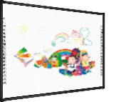
Lesson Middle | 🟠 Task 1: Apple and Ball Toss Game  Game-Based Learning  Pedagogical Technology: Kinesthetic learning (TPR)  Neural Network Element: Motor coordination + auditory recognition  Description:  Set up two baskets labeled “A” and “B”. Students toss toy apples into “A” and toy balls into “B” when hearing the letter pronounced.  Example:  Teacher says: “A!” → student tosses apple  Teacher says: “B!” → student tosses ball  Descriptor:  - Recognizes the letter sound  - Matches object to correct basket  - Uses accurate motor control  Answer:  Toss apple into A basket for “A”  Toss ball into B basket for “B”  🟠 Task 2: "A or B?" Sorting Challenge  Game-Based Sorting  Pedagogical Technology: Inquiry-based learning  Neural Network Element: Categorization + visual filtering  Description:  Provide a mix of pictures (apple, bear, airplane, banana, etc.). Students sort them into "Starts with A" or "Starts with B".  Example:  Students drag or place image of "apple" into A group, "banana" into B group.  Descriptor:  - Sorts words accurately by beginning sound  - Understands initial phoneme  - Explains choices clearly  Answer:  A: apple, ant, airplane  B: ball, banana, bear  🟠 Task 3: AI-Powered Phonics Echo  Tech-Enhanced Game  Pedagogical Technology: Digital auditory learning  Neural Network Element: Phoneme repetition and pattern prediction  Description:  Use a voice-recognition app (or teacher mimics AI). It says a word, and students echo the word and identify its first letter.  Example:  AI says: “Apple”  Student says: “Apple starts with A!”  Descriptor:  - Repeats the word clearly  - Identifies starting sound  - Engages in active listening  Answer:  Dog? → Not A/B  Apple? → A  Ball? → B  🟠 Task 4: Letter Art Station (A is for Apple, B is for Ball)  Creative Play Task  Pedagogical Technology: Project-based learning  Neural Network Element: Visual-motor integration and symbolic representation  Description:  Students use paper, stickers, crayons to make “A is for Apple” and “B is for Ball” art. They say the sentence aloud while pointing.  Example:  Student glues red circles on “A” paper and says, “A is for Apple!”  Descriptor:  - Associates letter with picture  - Creates visual representation  - Uses spoken sentence  Answer:  Paper with letter A = apple drawing  Paper with letter B = ball drawing  🟠 Task 5: Alphabet Detective – Find A & B in the Classroom  Scavenger Hunt Game  Pedagogical Technology: Discovery learning  Neural Network Element: Spatial awareness + semantic mapping  Description:  Students search the room for objects or words that begin with A or B and report back.  Example:  Student finds: Art box (A), Book (B)  Descriptor:  - Identifies relevant items  - Reports clearly  - Engages with environment meaningfully  Answer:  A: Apple picture, Art supplies  B: Book, Bag |  | Completes Tasks  Completes Tasks  Completes Tasks  Completes Tasks  Completes Tasks |  | Descriptor    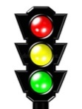  Traffic Light  Verbal Praise   | 
Lesson End | "Two Stars, One Wish"  - Each student writes two positive things (stars) and one suggestion (wish):  ⭐ Today I learned this well...  ⭐ I completed this task successfully...  💡 I need to improve on this...  - The teacher collects and analyzes students' responses.  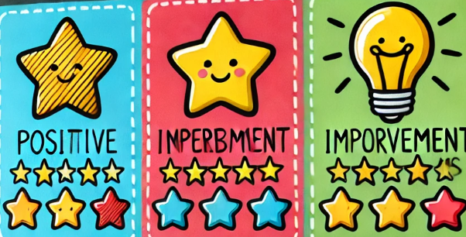 |  | Follows Instructions |  | Provides Feedback | 

