Lesson Plan
Unit 1  Animals |  |  | School: School-lyceum №6, Kokshetau
Term 1 |  |  | Teacher name: Takambaeva M. R  V. V.
Class: 3 |  |  | Number of present: | absent:
Lesson title |  | Body parts
Learning objectives(s) that this lesson is contributing to (link to the Subject programme) |  | 3.R1 recognise, identify and sound with support a limited range of familiar words in simple sentences  3.L6 understand some specific information and detail of short, supported information or talk on a limited range of general and some curricular topics 3.S1 make basic statements which provide personal information on a limited range of general topics
Lesson objectives |  | By the end of the lesson  - all learners will be able to:  - recognize and say animals’ body parts using words  - describe a favouгite animals using some of the new words in simple sentences with a considerable support  - most learners will be able to:  - recognize and say animals’ body parts using phrases  - describe a favourite animal using some of the new words in simple sentences with a limited support  - some learners will be able to:  - identify animals’ body parts using simple sentences  - describe a favourite animals using some of the new words in sentences with no support
Level of thinking |  | Application and knowledge
Assessment Criteria |  | - Recognize and identify animals’ body parts in simple sentences  - Listen and identify animals’ body parts in simple sentences  - Describe learners’ favourite animal
Values links |  | - attentive listening  - collaborative skills  - respect
Cross-curricular links |  | Biology
Previous learning |  | Animals
Plan
ссс

Planned timings | Planned activities (replace the notes below with your planned activities) |  |  |  | Resources
Start  2 min | CLASS ROUTINE  Greeting: Teacher greets learners;  Introduction (Odd one out strategy )  Teacher shows the pictures of the animals’ body parts and one of and children should guess the theme of the lesson.  OK. You are right. The theme of the lesson is ‘Body parts”.  Teacher introduces the learners learning and lesson objectives. Teacher says that in that day they will get acquainted with body parts of the animals, read the text, draw body parts and describe them. |  |  |  | Pictures with the animals’ body parts
Middle  4 min  5 min  7 min | Pre-reading  Task 1  [W, I] Teacher introduces new words using Flashcards (Drilling) Learners should repeat and individually  Vocabulary  beak клюв  feather перо  fur мех  hoof копыто  mane грива  paw лапа  skin кожа  tail хвост  wing крыло  Descriptor: a learner  - listen to the teacher  - read the word  - repeat after the teacher  - pronounce the words correctly  Assessment: Self assessment (Thumbs Up, Thumbs Down)  Task 2  While-reading  [W, I] Teacher shows to students Handout 1. Pupils read the text and rewrite the body parts of animals.  Handout 1  Dear, friend! My name is Kate. I am reading a book about animals now. There are a lot of animals and birds in the world: elephant, tiger, lion, dog, horse and others. For example, Birds have got beaks, Lions have got a mane. Elephants have got grey skin. Horses have got hooves. Parrots have got colourful feathers. Butterflies have got colour wings. Dogs have got a tail. What is you your favourite animal?  - Assessment criteria: Recognize and identify animals’ body parts in simple sentences  Descriptor: a learner  - read the text  - find the name of body parts  - rewrite the body parts of animals correctly  Assessment: Self assessment. Learners check the task according to the criteria.  Post-reading  Task 3  [I] Teacher shows to learners handout 2. Learners should read the sentences and match them to the pictures.  Pupils choose one picture which they like and write short description.  Handout 2  - It has got an orange beak.  - It has got colourful feathers  - It has got colourful wings  - It has got paws. It is an orange with black stripes.  - It has got a tail  - It has got hooves  - It has got a mane  - It has got grey skin  - It has got a brown fur.  - 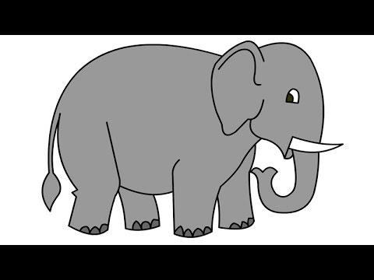  - 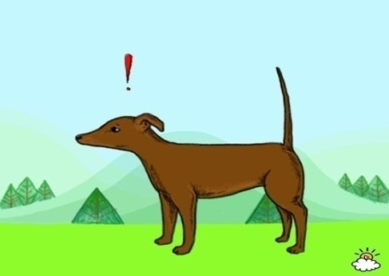  - 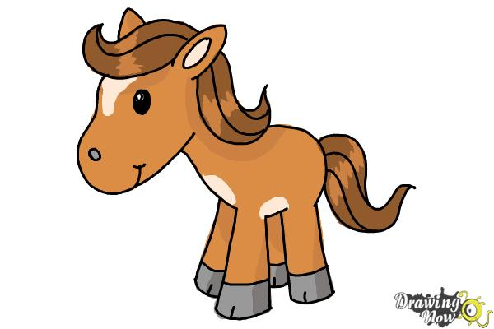  - 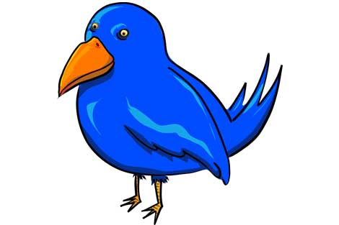  - 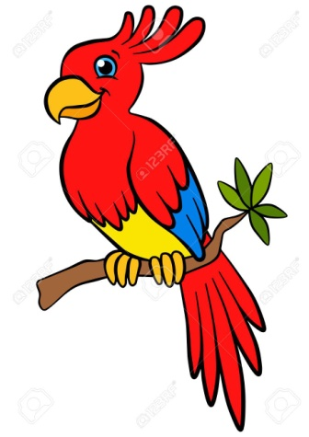  - 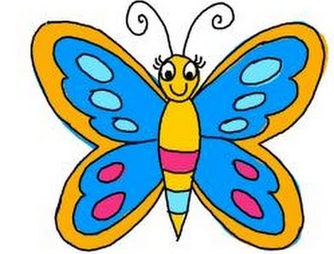  - 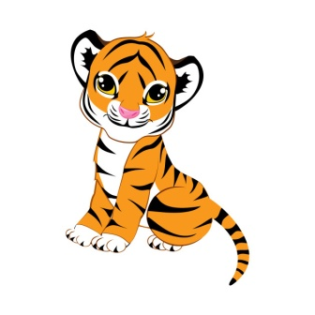  - 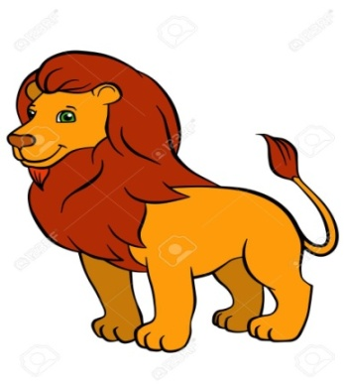  Differentiation by level of discorse  - High achieving learners describe animals using sentences.  - Middle achieving learners describe animals body using phrases  - Low achieving learners describe animals body parts using words  - Assessment criteria: Recognize and identify animals’ body parts in simple sentences  Descriptor: a learner  - Read the sentences  - Match the sentences to the pictures  - Describe the picture which learners like using words, phrases or sentences. |  |  |  | Flashcards with the animals body parts  Cards  Handout 1  Handout2  a) https://www.google.com/search?biw=1366&bih=607&tbm=isch&sa=1&ei=RhI0XaGlCOnhrgTqiYK4Cg&q=for+kids+elephant&oq=for+kids+elephant&gs_l=img.3..0i7i30l4j0i8i30l6.169409.182615..183060...0.0..0.355.2693.0j14j1j1......0....1..gws-wiz-img.......35i39.AVfasLaJTqc&ved=0ahUKEwih4NrevMXjAhXpsIsKHeqEAKcQ4dUDCAY&uact=5#imgrc=wdJQIDegksw1nM:  b)  https://www.google.com/search?biw=1366&bih=607&tbm=isch&sa=1&ei=qRM0XZvkH43D6ATa4o_YBQ&q=tail+fdog&oq=tail&gs_l=img.1.0.35i39l2j0i10j0i67j0l6.42415.42415..45528...0.0..0.178.178.0j1......0....1..gws-wiz-img.ZewpUhtvHiM#imgrc=jN1pcc2VmGqxUM:  c) https://www.google.com/search?biw=1366&bih=607&tbm=isch&sa=1&ei=2BM0XYTvJ4exrgTNwb4g&q=horse+for+kids&oq=horse+for+&gs_l=img.1.0.35i39j0i30l9.31573.36481..38297...0.0..3.200.2158.1j13j1......0....1..gws-wiz-img.....0..0j0i67.p3KNQPKF2Xg#imgrc=nTJo6l2YvMsViM:  d) https://www.google.com/search?biw=1366&bih=607&tbm=isch&sa=1&ei=ABQ0Xa_tEq-yrgSL8o_YAg&q=birds+for+kids&oq=birds+for+kids&gs_l=img.3..0i19l2j0i7i30i19l8.31432.34120..34579...0.0..0.326.1826.0j9j0j1......0....1..gws-wiz-img.......0i7i30j35i39j0.UKHWOsiSQI0&ved=0ahUKEwiv7caxvsXjAhUvmYsKHQv5AysQ4dUDCAY&uact=5#imgrc=bjlRi6jhawj9WM:  e) https://www.google.com/search?biw=1366&bih=656&tbm=isch&sa=1&ei=mI02XaWBNMe06ASwqoH4Cg&q=parrot+for+kids&oq=parrot+for+kids&gs_l=img.3..0i19l2j0i5i30i19l4j0i8i30i19l4.3865.5922..6045...0.0..0.409.2542.2-1j5j1......0....1..gws-wiz-img.......0j0i67j0i30.byExxpRr2Fo&ved=0ahUKEwilrebQmsrjAhVHGpoKHTBVAK8Q4dUDCAY&uact=5#imgrc=QUoJ-e-_j4wpgM:  f) https://www.google.com/search?biw=1366&bih=607&tbm=isch&sa=1&ei=QBQ0XbSKPI6RmwWbvLvgDA&q=monkey+for+kids&oq=monkey+for+kids&gs_l=img.3..35i39j0j0i7i30l8.35217.38452..38955...0.0..0.216.1598.0j9j1......0....1..gws-wiz-img.......0i19j0i7i30i19j0i7i10i30i19.TIB__0aNfpA&ved=0ahUKEwi0qrLQvsXjAhWOyKYKHRveDswQ4dUDCAY&uact=5#imgrc=F3fhHnaPXc_cKM:  g) https://www.google.com/search?biw=1366&bih=607&tbm=isch&sa=1&ei=Dw80XbufIY-trgTD04_QBw&q=buutterfly+for+kids&oq=buutterfly+for+kids&gs_l=img.3...5898.13338..13777...1.0..0.363.3000.0j15j1j1......0....1..gws-wiz-img.......0i7i30j0i7i5i30j35i39j0.HVGhUBQclqY&ved=0ahUKEwj74rvWucXjAhWPlosKHcPpA3oQ4dUDCAY&uact=5#imgrc=-XEYIfx-7jTyGM:  h)  https://www.google.com/search?biw=1366&bih=607&tbm=isch&sa=1&ei=1w80XfXjE6HnrgSH85jIBw&q=for+kids+tiger&oq=for+kids+tiger&gs_l=img.3..0i7i30l5j0i8i30l5.8126.8441..8881...0.0..0.236.793.0j2j2......0....1..gws-wiz-img.A_aCusGuQaY&ved=0ahUKEwi1q921usXjAhWhs4sKHYc5BnkQ4dUDCAY&uact=5#imgrc=7jfBZ-4UGFLYFM:  i)  https://www.google.com/search?biw=1366&bih=607&tbm=isch&sa=1&ei=HhI0XaHgOsKIrwSioq64Bw&q=mane+animal++for+kids+lion&oq=mane+animal++for+kids+lion&gs_l=img.3...33210.37091..37614...0.0..0.154.727.0j5......0....1..gws-wiz-img.30T6TbtzoWQ&ved=0ahUKEwih54MvMXjAhVCxIsKHSKRC3cQ4dUDCAY&uact=5#imgdii=Hz_vqHwVFxOakM:&imgrc=ToJNcyWf2en-hM:
Reflection  2 min | Learners’ feedback. Let’s do exercises  Different movements can also reflect the evaluation of the task :  If you can say 9 new words clap your hands  If you can say 7 new words raise your hands  If you can say 5 new words stand up  If you can say 3 new words sit down  If you can describe animals with no support clap your hands  If you can describe animals with a limited support raise your hands  If you can describe animals with a considerable support stand up
Additional information
Differentiation – how do you plan to give more support? How do you plan to challenge more able learners? | Differentiation by level of discorse  - High achieving learners describe animals using sentences.  - Middle achieving learners describe animals body using phrases  - Low achieving learners describe animals body parts using words
Assessment – how do you plan to check students’ learning? | Self assessment (Thumbs Up, Thumbs Down)

