Module 4 Charities and Conflicts

LESSON: Module 4 Charities and Conflicts  Skills 4c The Borgen Project |  |  | School: Birlik basic secondary school
Date: 13.12.2023 |  |  | Teacher’s name: Abdreimova G.D
CLASS: 9 |  |  | Number present: |  | absent:
Learning objectives that this lesson is contributing to |  | 9.1.10.1- use talk or writing as a means of reflecting on and exploring a range of perspectives on the world  9.2.3.1 - understand most of the detail of an argument in unsupported extended talk on a wide range of general and curricular topics;  9.4.4.1- read a range of extended fiction and non-fiction texts on familiar and unfamiliar general and curricular topics;  9.4.2.1 - understand specific information and detail in texts on a range of familiar general and curricular topics, including some extended texts;  9.2.7.1- recognize typical features at word, sentence and text level of a wide range of spoken genres
Lesson objectives |  | All learners will be able to:
Listen and read for gist, read for specific information
Most learners will be able to:
Listen and read for gist, read for specific information, describe the various types of charities
Some learners will be able to:
Listen and read for gist, read for specific information, describe the various types of charities, present the Borgen Project
Assessment criteria |  | Learners have met the learning objective if they can: talk about charities and the Borgen project
Value links |  | Explore the themes of charities
Plan
Planned timings | Teacher’s activities |  |  | Pupil’s activities |  | Marks | Resources
BEGINNING THE LESSON | - Checking the home task  - To introduce the topic and topic vocabulary  Draw Ss' attention to the questions in the rubric and the list.  Initiate a class discussion about charities and elicit how many, if any Ss know about and what kind of help they give. |  |  | Students in a team solve the Tarsia’s task  Suggested Answer Key  Oxfam is a charity that sells clothes, books, toys and other things in shops to raise money to help people in poor countries.  Doctors without Borders gives medicine and medical help to people in poor countries.  Water Aid is a charity that helps people get access to dean drinking water.  Shelter is a charity that helps homeless people. |  | Ss evaluate each other and encourage classmate with phrases like:  Well done! Brilliant! Good job! I like it! | Whiteboard  Cards  Pupils Book  e-book Excel 9th grade
 | 3. To introduce the topic of the text; to listen and read for gist  Elicit what, if anything, Ss know about The Borgen Project.  Ask Ss to read the first sentence of each paragraph and then elicit answers to the questions in the rubric from Ss around the class.  Play the recording. Ss listen and follow the text in their books to find out.  Allow Ss some time to prepare their answers to the questions in the rubric and then elicit answers from various Ss around the class. |  |  | Suggested answer  The Borgen project is a non- profit organization set up by Clint Borgen that works to reduce extreme poverty. It supports projects such as digging wells, building medical centres and vaccinating babies and children. It also campaigns for sustainable development. |  | Descriptor:  Learner answers the first question.  Learner answers the second question.  Total 2 scores | Whiteboard  Pupils Book  Assessment card “Kundelik”
 | 3.To read for specific information  Ask Ss to read the questions (1-3) and the possible answers, and then give them time to read the text again and answer them.  Check Ss' answers.  Then, give Ss time to look up the meaning of the words in bold in the text using their dictionaries as necessary. |  |  | Answer Key  IB 2 В ЗА  Suggested Answer Key  realise (v) = to come to know  come up with (phr v) = to think of  support (v) - to help financially  shining (adj) = being brilliant at sth prosperous (adj) = rich/wealthy  Refer Ss to the Word List to look up the words in the Check these words box.  Play the video for Ss and elicit their comments. |  | Descriptor:  Learner chooses the correct answers. 1 point for each correct answer.  Total 3 scores | Whiteboard  Pupils Book  https://www.plickers.com/packs/657871db69a7245accf0d733
 | 5. To consolidate information in a text and new vocabulary  Explain the task and give Ss time to consider their answers using words from the Check these words box.  Elicit answers from Ss around the class. |  |  | Suggested Answer Key  I was impressed that Clint Borden went to work in a refugee camp to help people before he went to university. I was impressed that he set up his non-profit organisation only using his wage from his job.  I was impressed that the Borgen Project supports projects such as digging wells, building medical shelters and vaccinating children and babies. |  | Descriptor:  Learner says one thing that impressed him/her.  Total 1 score | Whiteboard  Pupils Book
 | 6. Writing. To practise pronouns and consolidate information in a text  Explain the task and give Ss time to complete it.  Check Ss' answers around the class. |  |  | Students write ex. 5 to their notebooks.  Answer Key  1. someone  2. himself  3. those, who  4. themselves |  | Descriptor:  Learner chooses the correct item.  1 point for each correct answer.  Total 4 scores | Whiteboard  Pupils Book
ENDING THE LESSON | Ex. 8 To discuss Clint Borgen’s personality |  |  | 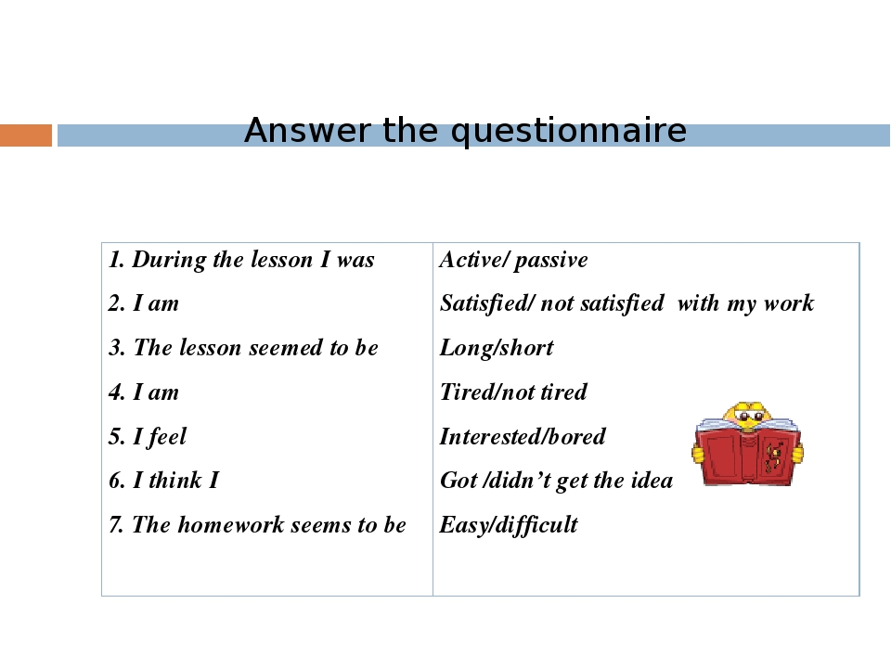  Explain the task. Tell Ss to work in small groups and think of their attitude to this person. Ask various Ss to present their ideas. |  | Ss evaluate each other and encourage classmate with phrases like:  Well done! Brilliant! Good job! I like it! | Whiteboard  Pupils Book
 | Reflection |  |  |  |  | Students tell about their achievements that they got | Reflection cards
 | Feedback |  |  | Students give their feedback for the lesson |  | Plicker’s platphorm | Plicker’s platphorm

