Tasks for the Summative Assessment for the Term 4

Listening Task 1. Listen to the teacher and follow the instructions.
Teacher asks learners to prepare two coloured pencils: red and blue.
- Colour T-shirt in red.
- Colour trousers in blue.
- Colour shoes in green?
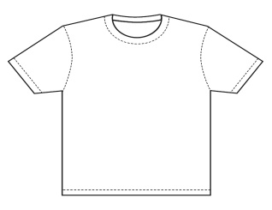 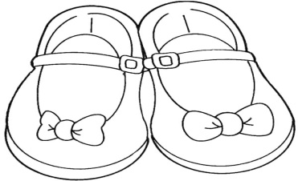 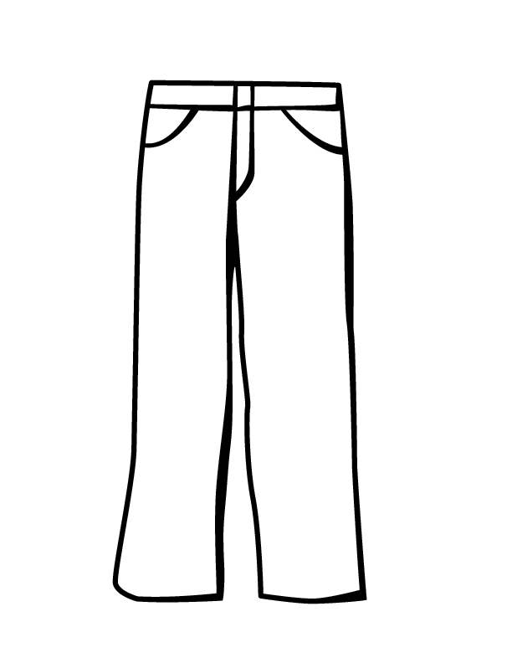Reading Task 2. Look at the picture. Read the sentences. Underline the sentences that describe the picture.
- Children are going to the lake to swim.
- It is very cold.
- Children are playing snowballs and skating.
- The weather is very hot.
- The trees are white with snow.

Writing Task 3. Write the missing word in the sentence.
1. | We go to school by a ___________________. | 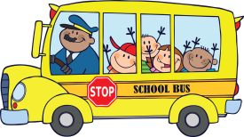
2. | He flies to London by ___________________.
3. | They can go to Astana by _______________. | 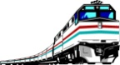
Use of English.
Task 4. Look at the picture and answer the questions.

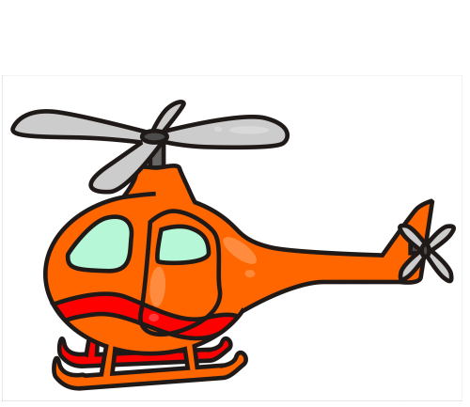1.What colour is the plane?
1. What season is it?
2. What colour is the boat?

