Unit: 8 Sports |  | Secondary school named after D.Konaev
Teacher`s name: |  | Zh. Erkimbek
Date: |  | 09.01.2025
Grade: |  | 5 | Number present: |  | Number absent:
Theme of the lesson: |  | Sport for all
Learning objectives: |  | 5.4.1.1 Understand the main points in a limited range of short simple texts on general and curricular topics.  5.3.7.1 Use appropriate subject-specific vocabulary and syntax to talk about a limited range of general topics
Lesson objectives: |  | Students will be able to:  Identify the main ideaof the text based on the Sport  Summarize the text about Sport  Apply topic related vocabulary in speech appropriately in phrases and sentences  Students with individual needs will be able to:  Find the names of sports according to the pictures  Answer the questions with support
Assesment Criteria |  | Read and identify the main idea in the text  Apply topic related vocabulary in speech appropriately arranging words and phrases into well-formed sentences
Level of thinking skills: |  | Application  Knowledge and comprehension
Plan
Planned timings | Planned activity |  | Learners` activities | Assessment |  | Resources
Beginning  3 min | The teacher greets students, checks their preparation for the lesson and creates positive learning environment.  Warm Up  The teacher asks learners to stand in two lines facing each other and say “hi” with:  - their hands  - their shoulders  - their elbows  - their knees |  | Learners greet each other | Learners assess each other by clapping |  | Song
Checking homework  5 min | Checking up homework / A box with sentences  Teacher asks students to take out a piece of paper with a sentence written on it from the parcel and say whether it is true or false. e.g.  1.Minecraft is a 2D game.  2.You can build from blocks in Minecraft.  3.There are dragons in the game.  4.The game is from the USA.  5.Minecraft has many fans.  6.Boys and girls play Minecraft. |  | Learners take out a piece of paper with a sentence written on it, read it and say whether it is true or false | Descriptor:  A learner:  - reads the sentence and expresses his\her thoughts appropriately  Formative assessment  Students assess each other using strategy  Fist or five  ( learners show  - a fist if the peer gave a totally wrong answer  - five fingers if the peer gave a correct answer |  | A box
Middle of the lesson  7 min  10 min  Relaxation  3 min  12 min | Task 1. Pre – reading Task. / “Eleciting techneques”  Eleciting the new topical vocabulary  Teacher shows pictures and elecits topical vocabulary of the lesson by using “Eleciting techneques”.  Hockey – A sport you play in an ice rink (giving definitions)  Figure skating -using visual aids  Tennis – miming  Skiing – using visual aids  Cycling -miming  Basketball - miming  Task for learners with individual needs (difficulty of speaking):  Teacher asks to find the names of sports in the grid and circle them  Task. Find the names of sports in the grid and circle them  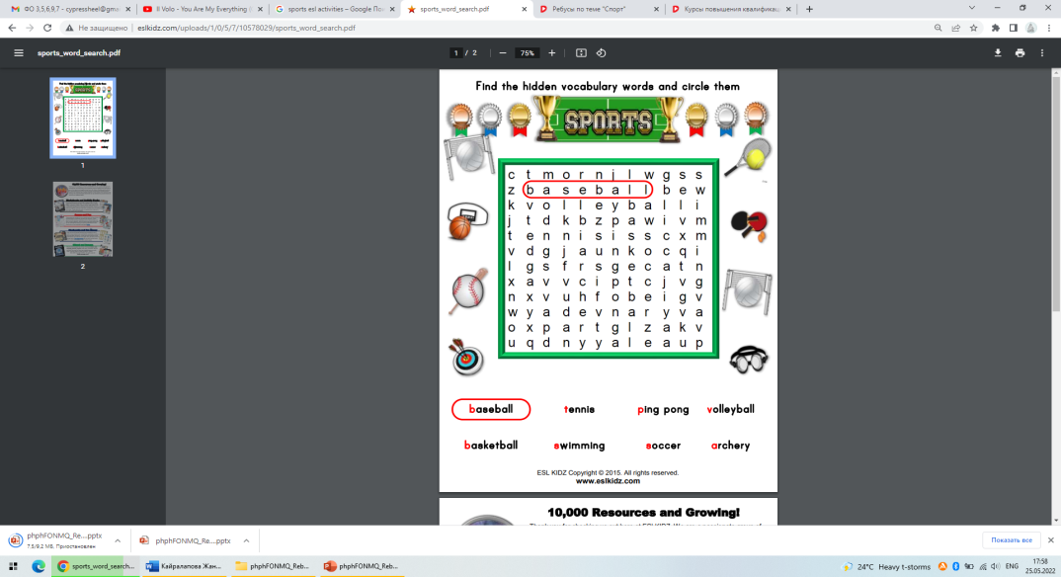  Differentiation by negotiation: Most able students help less able students.  While reading  Task 2. Read the text and write True or False  Are these sentences True or False?  1. My favourite sport is boxing.  2. Sport isn't so important in our life.  3. My friend is brave and he likes boxing.  4. There are some popular kind of sports in our country, windsurfing, cricket, baseball, diving.  Teacher suggests learners to make a short break, sing a song and do actions.  Do DoDoDo Do  DoDo Do Do  DoDoDoDo Do  Do not give up.  Do DoDoDo Do  DoDo Do Do  DoDoDoDo Do  Do not give up.  Task 3.Post reading. Picture prompt  Look at the picture and describe it, answering each question with 1-2 sentences.  Teacher shows students picture about sport and asks questions what are they doing?  What can you see in this picture?  What are the boys in the foreground doing?  What is the woman on the left doing?  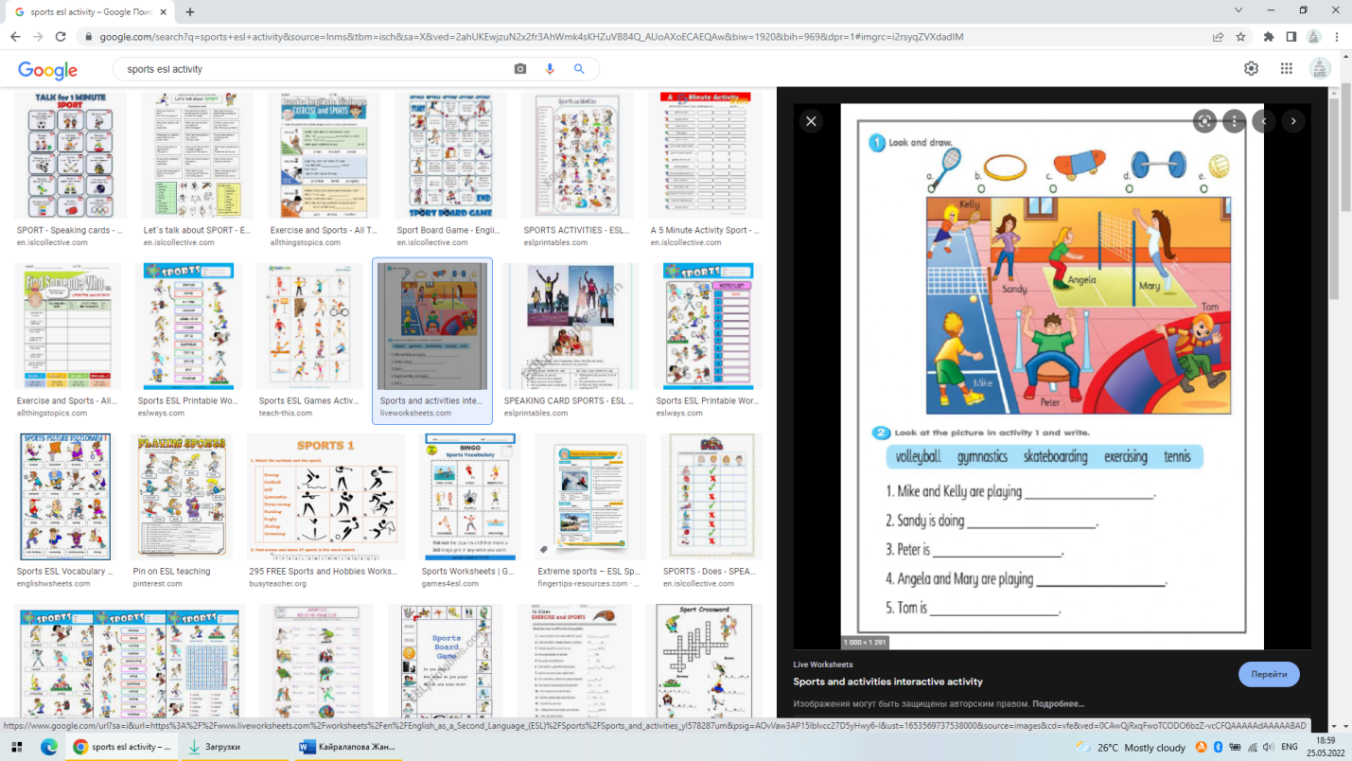  Task for learners with individual needs(difficulty of speaking):  Teacher asks CCQ question about Sport.  -Do you like sport?  - Can you play tennis?  -Do you like playing basketball?  Differentiation by support: Students will be provided with key words ( Yes, I do, No I don’t, Yes, I can, No, I can’t) |  | Learners give the definition of the words based on Sport according to pictures  Scaffolding by using visual aids, miming, giving definitions  Learners find the names of sports in the grid and circle them  Learners read the text and show True or False with green and red cards.  Learners sing a song and do actions.  Learners describe the picture then answer the questions  A learner answers Yes/No questions | Descriptor:  A Learner:  Gives definitions  ( “Claps”)  Learners assess each other by clapping  Descriptor:  A learner  -finds the names of sports  - circles word  Answers:  - False  - False  - True  - True  ADescriptor:  A learner  reeds the text  shows True or False  Descriptor:  A learner :  Describes the picture  Answers the teacher`s questions accordingly  Formative assessment:  “Stop and Go”  (Teacher shows:  - green card if the learner`s answer is fully correct;  - yellow card if the learner`s answer is fully correct)  - red card if the learner`s answer is totally incorrect and the needs to correct it)  Descriptor:  A learner  - answers Yes/no question |  | Pictures  Cards  https://ds03.infourok.ru/uploads/ex/11b6/00057c6d-632672ff/img4.jpg
End  Feedback  5 min | The teacher asks learners to reflect on the lesson using “Roll the dice”:  - “1”- I want to remember …  - “2” - Something I learned today  - “3” - One word to sum up what I learned  - “4” - Something I already knew  - “5” - I’m still confused about …  “6” - An “aha” moment that I had today |  | Learners reflect on the lesson by throwing the dice and saying their impressions of the lesson according to the number they get on the dice |  |  | A dice  
Home task | Revision

