Lesson plan
Module 9  Lesson: 1 |  |  | College: ASNTC
Date: |  |  | Teacher name: Aizhan Amreyeva
Grade: 1`st year student |  |  | Number present: |  | absent:
Lesson: VIII Unit. Space X. Things you did not know about space.
Learning objectives(s) that this lesson is contributing to |  | 10.1.5 Use imagination to express thoughts, ideas, experiences and feelings.  10.3.4 - evaluate and comment on the views of others in a growing variety of talk contexts on a wide range of general and curricular topics, including some unfamiliar topics;  10.2.4 Recognize the attitude or opinion of the speaker(s) in unsupported extended talk on a wide range of general and curricular topics, including talk on a limited range of unfamiliar topics.  10.4.5 understands the main points in extended texts on a wide range of unfamiliar general and curricular topics
Lesson objectives |  | Students will be able to
- discuss and express their ideas on space
- assess and comments on peer’s views
- elicit the speaker’s view on space from the speech
- read for and define the main issues of the text on space
Assessment criteria |  | - Comments on space issues and says their attitude to it  - Evaluates peers’ statements on space and comment them  - Define the speaker’s point of view on space  - Identify the main questions of the text about space
Value links |  | encourage students to work independently; develop the ability to work in a team and make a joint decision.
Cross curricular links |  | Action. Student`s book, https://agknt.edupage.org
Previous learning |  | Breakthrough technologies. Robotics.
Use of ICT |  | Computer, internet, PowerPoint
Plan
Plannedtimings | Planned activities (replace the notes below with your planned activities) |  |  |  |  | Resources
Beginning | Greetings.  Teacher greets learners and sets a positive atmosphere by asking some questions:  - Good morning!  - How are you?  - Who is on duty today?  - Who is absent?  - ……… is absent  - Let`s begin our lesson !  - Before beginning the new lesson let`s review our last theme. Do you remember our last theme. What is about it?
Middle | Task 1.  Listen to the audio. There is the texts about Space. Things you did not know about space.  What is a space?  Space is the boundless three-dimensional extent in which objects and events have relative position and direction. Physical space is often conceived in three linear dimensions, although modern physicists usually consider it, with time, to be part of a boundless four-dimensional continuum known as spacetime. The concept of space is considered to be of fundamental importance to an understanding of the physical universe. However, disagreement continues between philosophers over whether it is itself an entity, a relationship between entities, or part of a conceptual framework. There are eight planets in our Solar system. They are Mercury, Venus, Earth, Mars, Jupiter, Saturn, Uranus and Neptune. The nearest planet to Sun is Mercury. The biggest planet is Jupiter. The coldest planet is Neptune. Mars is also called Red Planet. People can see some planets and stars through telescope. To travel in space astronauts wear space suits. They use space ships to move in space.  Question: What is the author’s point of view on space.  Descriptor:  A student  - Listens to the text  - Defines the speaker’ attitude.  Task 2  Read the sentences and say is it True information or False.  1) Solar System has eight planets. True/ False  2) Mercury is the nearest planet to the Sun. True /False  3) Saturn is the coldest planet. True /False  4) Space ships are used to move in space. True /False  5) We can see planets and stars through telescope. True/ False​  Descriptor:  A learner  *reads the statement  *ticks true or false statement  More able students explains their choice.  Task 3  Students match the words to the pictures.  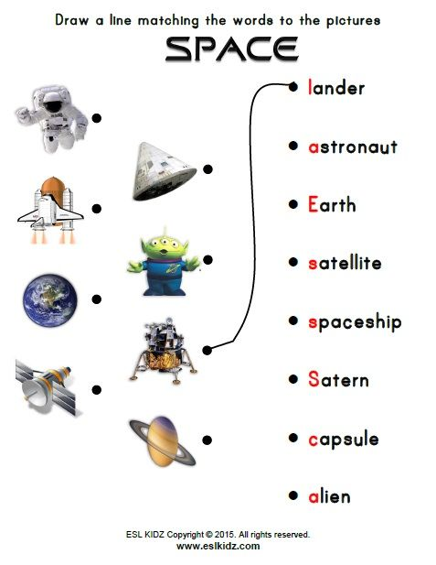  Descriptor  A learner  *matches the words to the pictures. |  |  |  |  | Action. Student`s book  Action. Student`s book  https://yandex.kz/images/search?text=excercise%20on%20theme%20Space&
End | Reflection: Rocket of success.
Additional information
Differentiation – how do you plan to give more support? How do you plan to challenge the more able learners? |  |  |  | Assessment – how are you planning to check learners’ learning? |  | Health and safety check  ICT links
Differentiation by task:  True/false statements.  Descriptors:  A learner  *reads the statement  *ticks true or false statement  More able students explains their choice.  Differentiation by learning styles:  For auditory learners – listen to the audio. Listening to audio they get more information and interesting facts about Space.  For visual learners – learn new vocabulary basing on the pictures and acquiring it..  For kinesthetic learners – answering the questions and making notes of the planet facts helps them to practice speaking skills.  Differentiation by scaffolding:  Less able students are supported through modeling, instructional checking questions and such error correction techniques as reformulating  More able students in the individual tasks work out of zone of proximal development. |  |  |  | Reflection – Rocket of success. |  | Health promoting techniques  Breaks and physical activities used.

