LESSON: 5.3C.Values |  |  |  | School: school 8
Date: |  |  |  | Teacher name: Makisheva S. B.
CLASS: 5 |  |  |  | Number present: |  | absent:
Theme of the lesson: Qualities of a friend
Learning objectives(s)  that this lesson is  contributing to |  | 5.R2 understand with little support specific information and detail in short, simple texts on a limited range of general and curricular topics  5.W3 write with support factual descriptions at text level which describe people, places and objects  5.S6 communicate meaning clearly at sentence level during, pair, group and whole class exchanges  5.L1understand a sequence of supported classroom instructions
Lesson objectives |  | All learners will be able to:  - describe main events in texts with some support  -present ideas clearly in whole class conversation  -find the adjectves in the text;  Most learners will be able to:  - listen, understand and answer to questions;  - complete the sentences with new words ;  Some learners will be able to:  --find the solution of the problem without teacher’s support
Assessment criteria: |  | Can understand the main points of short texts;  Can write with support factual descriptions at text level which describe people  Can communicate with each other clearly during, pair, group and whole class exchanges
Value links: |  | National pride, True friends
Cross-curricular links: |  | Kazakh language, Art
ICT skills: |  | Interactive board for showing a presentation
Previous learning: |  | Learners know some words and adjectives connecting with theme “Friend”
PLAN
Planned timings | Planned activities |  |  |  |  |  | Resources
Start  0-2 min  Middle  End | (T-S) (W) Teacher greets students and checks the homework.  Students sing a song “I am always here for you.  Teacher uses strategy “No hands questioning” to find the new theme of the lesson;  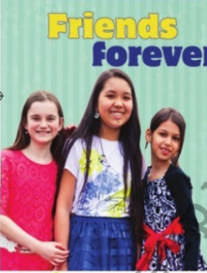  -What qualities should best friend have?  -What is friendship for you?  Students answer the question and find out the theme of the lesson. Teacher explains that today is “friendship day”.  Teacher divides class into 3 groups using flowers.  1st group (red) 2nd group (yellow) 3rd group(green)  strong kind funny  Students exchange the flowers and say compliments.  Task 1  (S-S) (G)  Pre-reading  Work with vocabulary  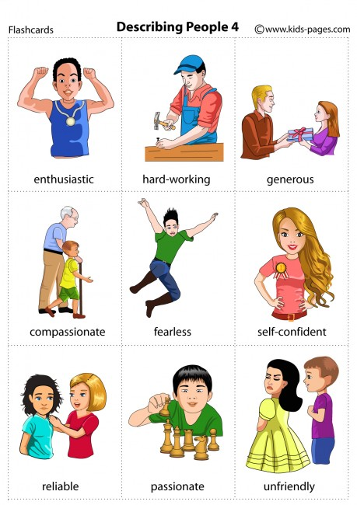  Tell the truth  Trust  Gossip  Respect  Keep a secret  Teacher uses the strategy “Jigsaw reading” and gives the text for each group.  Students work with poster.  1st group find out the best qualities of a friend.  2nd group find out bad qualities of a friend.  3rd group explain what is friendship.  Assessment criteria Descriptor  Can understand the main points of short texts; A learner: -works in group; -understands the text; -finds the qualities of friend; -draw or write them in posters;  Formative assessment: Smiles  Task 2  Teacher gives the text with missing words for each student.Students find the the words and complete the sentences, then read in pairs.  Formative assessment: Thumbs up or down  Task 3  (S-S) (I) Teacher uses the strategy “Draw your card” for speaking. Students draw card for best friend and complete the sentences. Then they give cards for best friends.  Happy Friendship Day  My best friend’s name is .....  She/He is my best friend because.......  We like .......  (T-S ) (I)Teacher uses the method “Cinquain” for conclusion.  1.the first line is a one-word title  2.the second line is a pair of adjectives describing that title  3.the third line is a three-word phrase that gives more information about the subject  4.the fourth line consists of four words describing feelings related to that subject;  Plenary: Teacher uses strategy “Draw your brain”. Students draw the outline of a brain in their exercise book and fill it with words that explain what they have learnt during that lesson. |  |  |  |  |  | Pictures  Flowers for dividing class into groups.  PPT 2  Worksheet 1  Posters,colourful pencils  Worksheet 2
Additional information
Differentiation – how do you plan to give more support? How do you plan to challenge the more able learners? |  |  | Assessment – how are you planning to check students’ learning? |  | Cross-curricular links  Health and safety check  ICT links  Values links
- More able learners will be supported by prompts  - To provide support to less able learners while they have group discussion.  - More able students can support less able students  - While speaking less able learners are given examples, more able learners will ask and answer the questions  - While working with grammar more able learners works individually |  |  | Learners will assess themselves by descriptors and formative assessments |  | Cross-curricular links:  History, Literature  ICT skills: Interactive board for showing a  presentation, video file  Health and safety check  Everyday classroom precautions will ensure that safety measures are provided to prevent the exposure of electrical power cords.  Value links: Being a hero, Common history, culture and language
Reflection  Were the lesson objectives/learning objectives realistic? What did the learners learn today? What was the learning atmosphere like?  Did my planned differentiation work well?  Did I stick to timings?  What changes did I make from my plan and why? |  |  | Use the space below to reflect on your lesson. Answer the most relevant questions from the box on the left about your lesson.
 |  |  | The learning objectives were realistic. Learners learnt about the qualities of best friend. They learnt to describe their best friends. The learning atmosphere was interesting and cognitive. My planned timing worked well. I could stick to timings. I didn’t any changes from my plan.

