Кызылалиева Жанар Ерболовна.
«№173 мектеп лицей» КММ
Ағылшын тілі пәні мұғалімі
Алматы қаласы, Әуезов ауданы

At the right time

Learning objectives(s) that this lesson is contributing to |  | 3.R6 understand with considerable and particularly visual support, some specific information in short, simple texts on familiar topics  3.R3 read and follow with considerable support simple, words, phrases and sentences on familiar and general topics and familiar instructions for classroom activities  3.L7 use contextual clues to predict content in short, supported talk on routine and familiar topics
Lesson objectives |  | Learners will be able to:  - Say the time using o’clock  - Learners have met the learning objectives if they can: present/revise numbers 1-100; make calculations.
ICT skills |  | Using ZOOM interactive board, Liveworksheet, Kahoot, Quizizz, РРТ, in the end of lesson Google Classroom
Lesson plan

Planned timings | Teacher's actions |  | Pupils` actions | Assessment | Resources
10  minutes | ORGANISATION MOMENT:  Greetings & warm up  - greet students, let them respond to greeting.  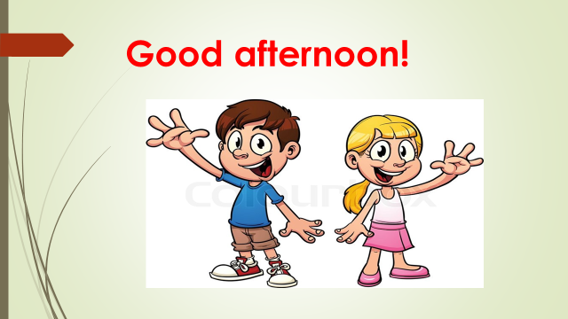  - a mini teacher asks lesson-opening questions about day, date, topic, etc.  - ask sts to write down the following in their copybooks:  The $2^{nd}$ of December  Revision  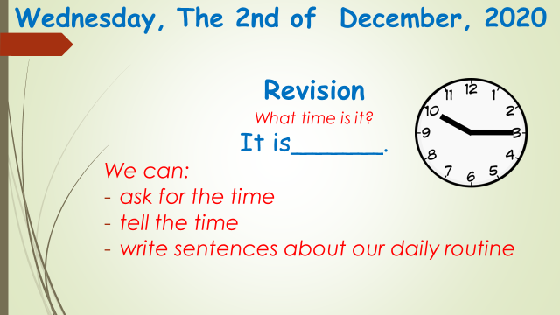  Today we will ask for and tell the time and write about our daily routine  - draw sts attention to the lesson objective and make sure they all understand it  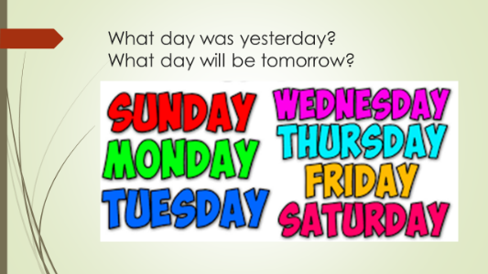  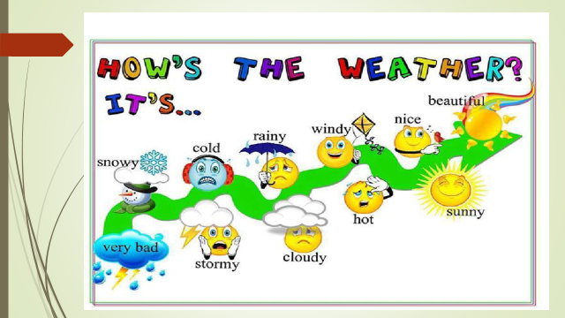  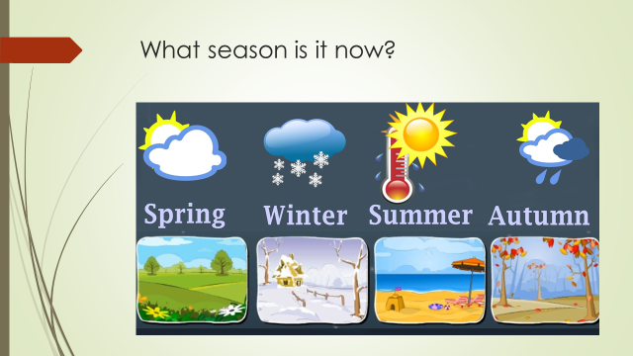  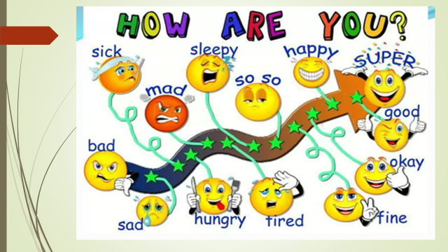  Warm up  Speaking  Play ‘Guess time’ game. Show PPT slides, ask sts to look at clocks and say which of them shows the appropriate time.  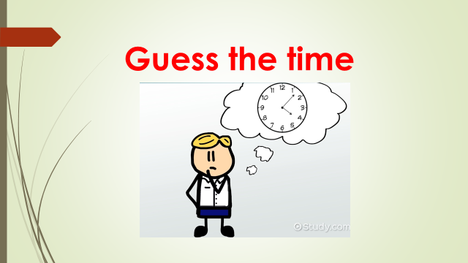 |  | Students respond to greeting and take their places  L answer -  E.g.: I wake (get) up at 7 o’clock on Monday.  get up, wash face, brush teeth, get dressed, have breakfast, go to school, get ready, have classes, eat lunch, go home, watch | - | РРТ  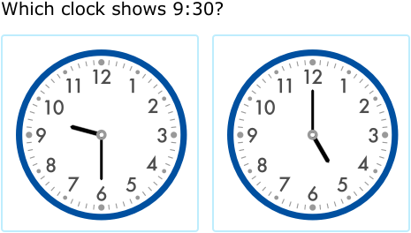  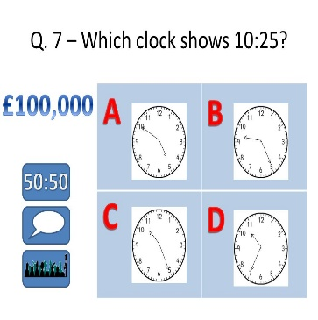  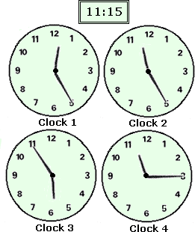  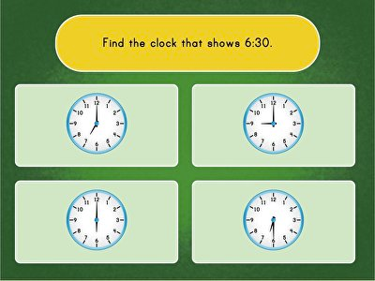  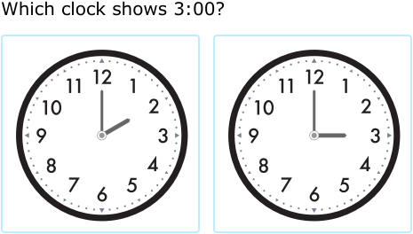  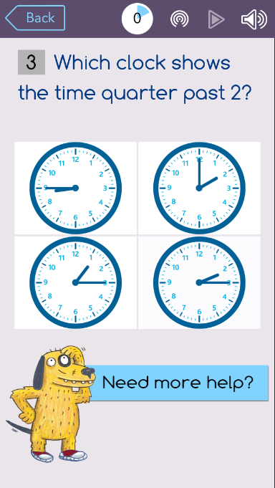
20  Minutes  The remaining 10 minutes to the lesson | MAIN PART  Time Practice  Speaking  -Review telling time with the game Quizzez – learners activity with answering the questions. Then sts show each other their points, compare them and peer assess.  *Differentiation: Less able students get support from more able ones  Dynamic break  -Play the game Kahoot  Time Practice  Reading  Do the task in British council  - Read and choose correct answer.  After reading start to solve the crossword puzzle  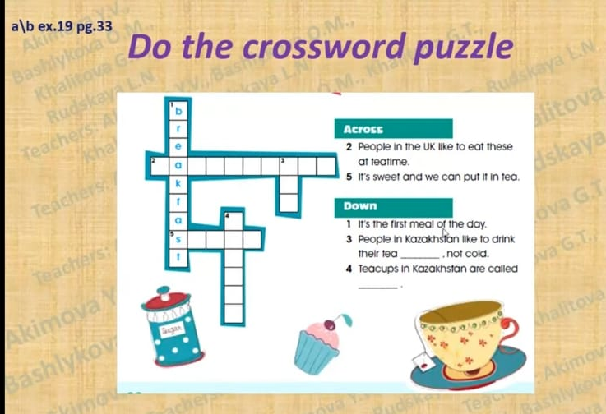  Revision of daily activities  Learners reads phrases and find their`s pictures, then puts them in their places  In the end online lesson teacher pass to learners classwork and hometask in their Google Classroom |  | read the sentences; Say the time, the action.  rearranges the letters and completes the sentences. Then match. | Formative assessment | https://quizizz.  com/admin/  quiz/5fb236  aaa51de900  1b927d78/  unite-revision  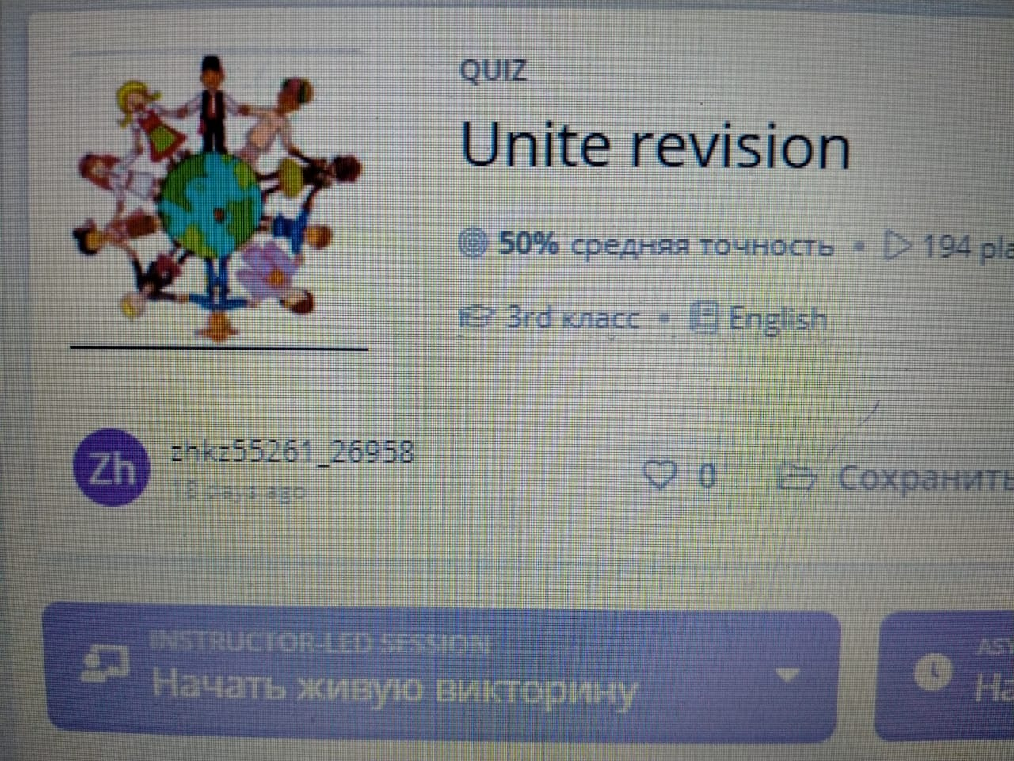  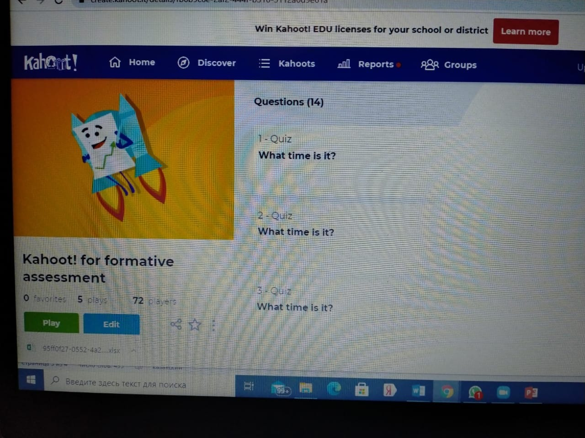  P/b p-46  https://www. youtube.com/ watch?v=3o TEMhhDn2o  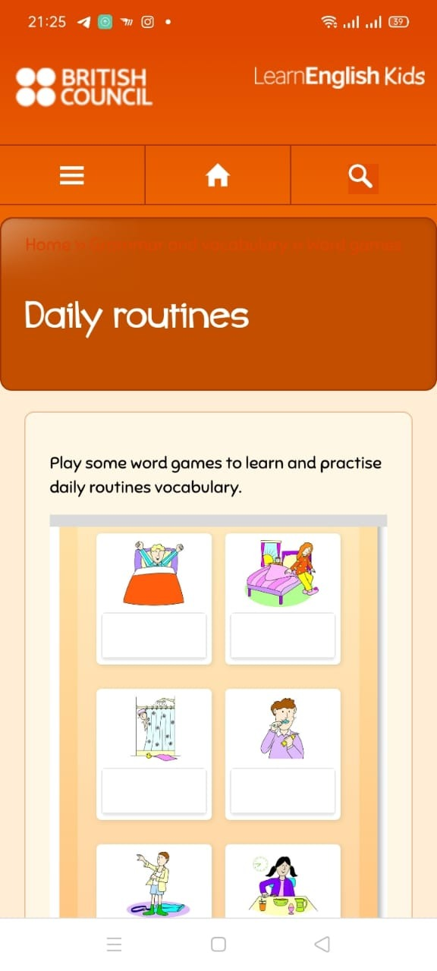
10  minutes | ENDING THE LESSON:  Exit Questions  Pass out worksheet for writing the time, days of the week, month and seasons. Sts should do it as a classwork.  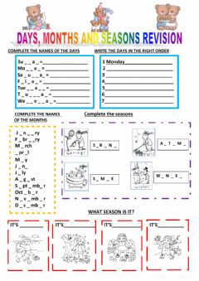  Home task  Pass for hometask checkpoint  -Ask students what they do at 9 AM. Ask students what they do at 9 PM |  |  | Feedback | https://www. liveworksheets. com/lh75ib

