Ахмад Лилия Маликовна
учитель английского языка средней школы № 7 имени К. Ушинского города Талдыкорган
открытый урок в 5 классе на тему
«Family Friends»

LESSON: Module 3 |  | School: 7, Taldykorgan
Date: |  | Teacher’s name: L. Akhmad
CLASS: 5б |  | Number present: 15 |  | Absent:
Theme of the lesson: |  | Family Friends(Character Adjectives)
Learning objectives(s) that this lesson is contributing to |  | 5.3.6.1 communicate meaning clearly at sentence level during, pair, group and whole class exchanges;  5.6.3.1 use a growing variety of adjectives and regular and irregular comparative and superlative adjectives on a limited range of familiar general and curricular topics;  5.6.3.1 use a growing variety of adjectives and regular and irregular comparative and superlative adjectives on a limited range of familiar general and curricular topics;
Lesson objectives |  | All learners will be able to identify some specific information in the text correctly and use some target language correctly in summarizing it  Most learners will be able to identify most specific information in the text correctly and use a range of target language correctly in summarizing it  Some students will be able to identify all specific information in the text correctly and use a range of target language correctly in summarizing it including expressing less obvious connections
Cross curricular links |  | Russian language
Kazakh culture |  | Students will be able to value the work in Kazakh culture
Previous learning |  | vocabulary for family members / basic adjectives describing personality
Assessment criteria |  | Pupils can describe person with adjectives and opposites
Plan
Planned timings | Planned activities (replace the notes below with your planned activities) |  |  |  | Resources
Beginning  3 min | Warm-up:  Students listen to the song and predict the topic of the lesson  Teacher presents the topic and objectives of the lesson. |  |  |  | https://www.youtube.com/watch?v=4p4k-P8Cn4U&feature=emb_title
Middle  5 min  Reading  10min  Making posters 5 min  3 min  5 min  5min  Conclusion  3 min | Main part  Direct Ss to the picture and elicit what they know about the cartoon  Play the recording. Ss listen and follow the text in their books and find out.  Dividing into two groups  (Flinstone and Rebbels)  Activity 1:To read for specific information  Draw Ss’ attention to the picture again and allow them time to read through the text and use the descriptions in the text to identify the people in the picture.  Activity 2: Groups make the posters and present it  Type of assessment: Group assessment  Physical training  Activity 3: (teacher is watching how students understand and remember information about two families)  Check out:  - This woman has got red hair and she is very modern (F)  - Whose man is very silly? (R)  - Who has dino as a pet? (F)  - He can play the piano and the drum (R)  - This child is very strong (R)  - Whose family has got a daughter? (F)  Activity4:Introducing new vocabulary Ex 4 P 35  Student match opposites  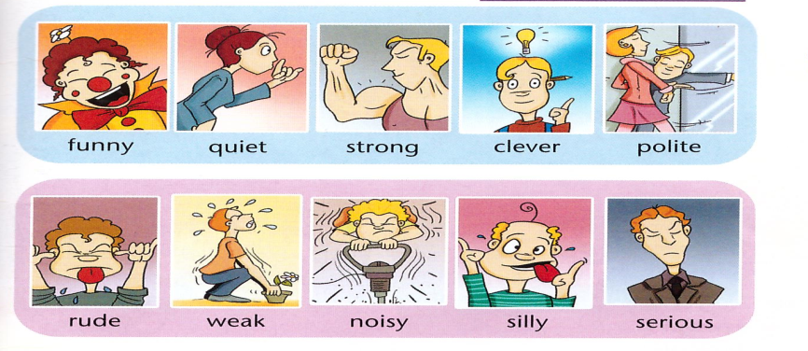  Type of assessment: peer assessment  Mime game “My best friend” Ex 6 P 35  My best friend is (mimes “Strong”) and students guess it |  |  |  | CD  Ls watch video  SB Ex 1 p 34  Flash cards  (F and R)  (Handout 2)  Check up with CD  SB
End  1 min | Reflection  “Saying goodbye
Additional information
Differentiation – how do you plan to give more support? How do you plan to challenge the more able learners? |  |  | Assessment – how are you planning to check learners’ learning?
monitor less able learners in comprehension task and prompt them to scan to find target information in the text |  |  | check answers in comprehension task using thumbs up or down technique and follow-up questions
Reflection provide challenge through questioning about text which prompts more able learners to make less obvious connections e.g. Are Fred and Barney similar?

