**Summative Assessment for term 1**

**LISTENING**

**Task 1. Listen to the man talking about school.**

**Choose the correct option.**

1. What makes kids dislike going to school?

A) Long and difficult lessons

B) Boring subjects and a lot of homework

C) Short lessons and long holidays

2. What activity is not mentioned?

A) doing science experiments

B) playing sports

C) celebrating holidays

3. What can students do five days a week?

A) have music lessons

B) have fun with friends

C) have science lessons

**Task 2. Fill in the gaps with NO MORE THAN TWO WORDS.**

4. The speaker thinks that exams are ___________.

**[__/4]**

**READING**

**Task 2. Read the texts and choose the correct answer.**

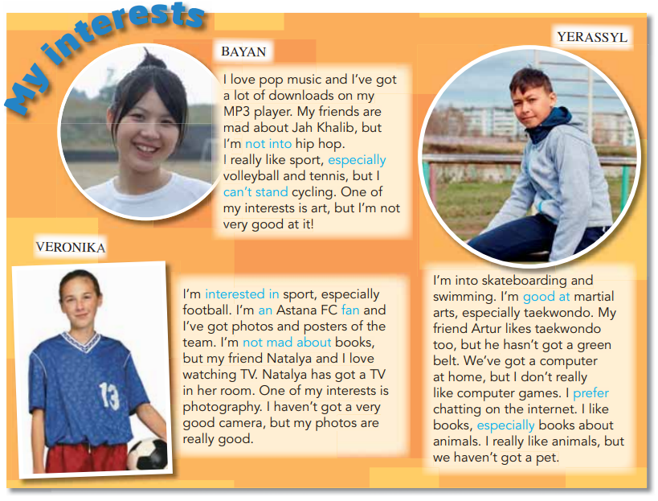

|  |  |  |
| --- | --- | --- |
| 1. Veronika is not into ____. | | |
| Football | photography | books |
| 2. Natalya has got a ________. | | |
| Camera | TV | photo of a football team |
| 3. Yerassyl is good at ______. | | |
| Swimming | taekwondo | computer games |
| 4. Yerassyl isn’t interested in _____. | | |
| Computer games | books | swimming |
| 5. Bayan is into _____. | | |
| Hip hop | cycling | pop music |
| 6. Bayan isn’t good at ______. | | |
| Art | tennis | volleyball |

[__/6]

**WRITING**

**Task 3. Write a biography of Toktar Aubakirov for an international school magazine (60-80 words). Follow the plan. Check your piece of writing and edit it.**

**Plan**

|  |
| --- |
| Para 1: name, when/where born  Para 2: early years *(At the age of 13 he ... He studied and entered ...)*  Para 3: achievements; later years *(... he tested over ... He was the first Kazakh to ... In 1993, he became ... To this day, people consider him ...)*  Para 4: your feelings, comments *(... is a successful ... He worked hard to ... and he is an inspiration to ...).* |

[__/6]

**SPEAKING**

**Task 4. Choose one of the cards and make a monologue. Give own opinion on topic, explain your position and answer questions.**

**You have 1 minute to prepare and 2 minutes to talk.**

[__/6]

TOTAL [__/22]

Card 1. The topic ‘Our class’. The following questions will help you to organize your talk:

1) What grade are you in?

2) Do you have to wear a uniform?

3) What are your favourite school subjects? Why (not)?

4) What are you not good at?

5) What do you usually do after school?

Card 2. The topic ‘Helping and Heroes’. The following questions will help you to organize your talk:

1) Who is a hero?

2) Do you believe in superheroes? Why (not)?

3) Do people need superheroes? Why (not)?

4) Do you think sports stars are bigger heroes than movie stars? Why (not)?

5) Do you think soldiers and police officers are heroes? Why (not)?

Card 3. The topic ‘Our class’. The following questions will help you to organize your talk:

1) Is your school big or small?

2) What do you like about the school? Why?

3) What are five things you don’t like about your school? Why (not)?

4) Can you describe your ideal school?

5) What colour of classroom walls is the best for you?

Card 4. The topic ‘Helping and Heroes’. The following questions will help you to organize your talk:

1) Do you usually help other people? Why (not)?

2) What do you usually do to help other people?

3) Who is the kindest person you know? What are some of his/her acts of kindness?

4) Have you ever been inspired by someone's act of kindness? How?

5) Do you agree that helping others is the act of heroism? Why (not)?

Card 5. The topic ‘Our class’. The following questions will help you to organize your talk:

1) Are grades important to students? Why (not)?

2) Which subject do you enjoy studying? Why?

3) What are the qualities of a good student?

4) What are the qualities of a good teacher?

5) Do you go to any clubs at your school? What are they?