Lesson plan
Unit of a long term plan Unit 7. |  | School: Bogdanov primary high school.
Date: |  | Teacher name: Kappassova D.S.
Grade: 6 |  | Number present: | absent:
Lesson title | White Fang by Jack London
Learning objectives | 6.2.6.1 deduce meaning from context in supported extended talk on a range of general and curricular topics  6.3.4.1 respond with limited flexibility at both sentence and discourse level to unexpected comments on a range of general and curricular topics
Lesson objectives | -identifying the main idea and the purpose of a talk/conversation  -using the context toselect the most appropriate meaning for new vocabulary  (unknown words)  - providing short, relevant responses with examples
Stages / Time | Teachers actions | Students actions | Assessment | Resources
Beginning the  lesson  10 min | Greeting.  Lead-in.  (W ) To show video about  types of books.  Ask questions after the video:  1 .What have you seen at video?  2. What books do you read?  3. What books would you recommend to another?  The teacher summarized the discussion.  The teacher introduces  lesson objectives and Assessment Criteria to the learners. | Students respond to greeting of the teacher and take their places.  Listen and answer the following questions. |  | https://youtu.be/YYoGQ-paC5s
Main  Activities  20 min  End of lesson  10 min | Main part.  Task 1  (I) Method “Connection”. This method will allow learners to develop their skills in working with information.  Match questions 1-6 to answers a-f to find out about him.  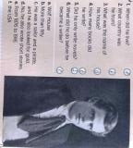  Vocabulary: listen and watch.  Teacher shows new words on video, and repeat with students  (P)Task 2  "Method of using pictures". This method develops memory and is very useful for focusing the student's attention.  Pair work in s. Look at the book cover and the picture from Chapter 1 and answer to the questions below. Then listen the text and check your answers.  1. Where does the story take place?  2. Who are the main characters?  3. Are the animals friendly or unfriendly?  4. What do you think will happen?  Scaffolding: for the A level students are given the opportunity to work with ready-made cliches.  “The Readers " method.  The method makes it possible to develop independent work skills, the ability to concretize, structure educational material and systematizes knowledge.  (G) Task 3.  .Learners are divided into two groups. Make a cluster. The theme for the first group is positive characters. The theme of the second group is negative characters.  The teacher shows the presentation and distributes different materials to the students.  Differentiation by tasks  Activity  Tasks for C learners  Learners make a dialogue and discuss about the main idea of the book White Fang  Tasks for B learners  Learners describe the given pictures about the character of the hero  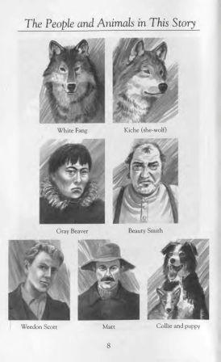  Tasks for A learners  Learners matching the pictures with definitions  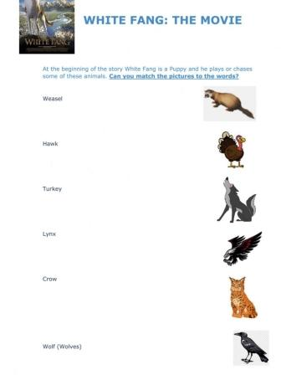  (W) At the end of the lesson, teach makes up a quiz "Quick Questions and Answers".  It is used to repeat the lesson materials and develop memory.  Homework:  "Finish the sentences." Complete the sentences by providing evidence and arguments to defend your position:  - I like the extract from White Fang  - I think the story will continue  - I want to read the book "White Fang" because...  Feedback  The "Finish Sentences" method.  Students write down their impressions of the lesson and suggestions on the stickier using the following phrases:  I understood everything.... because…  It was hard for me to understand...because…  I was wondering…  I would like to know more | Learners listen to the recording of a short biography of Jack London and match questions 1-6 to answers a-f to find out about him.  Descriptor  1. interprets the recording correctly  2. matches questions with answers correctly  Learners watch the video and repeat the words correctly.  Students look at pictures and answer to the questions. Then they listen to a piece out of the book from Jack London's White Fang and check your answers.  Descriptor  A learner  • works in pairs;  • expresses opinion on topic;  • answers questions;  • pronounces words clearly;  • uses linking words to speak coherently;  .  Descriptor:  Learners make dialogue about the main idea of the book;  Learners describe the pictures;  Learners matching the pictures  Students quickly answer the teacher's questions.  Descriptor  A learner :  1. Highlights the main ideas ...  2. Expresses opinion on topic  3. Provides evidence and arguments | The "Score-not mark" method. The teacher notes aloud and with a gesture each success of the student.  The "Rating" method. When completing the work, the student makes a mark for himself. For the same work, the teacher also makes a mark. A fraction is written. For example: 4/5, where 4 is the student's mark and 5 is the teacher's mark.  Give basic information about story  Provide a point of view on topic in conversations and  discussions  Mutual evaluation on stickers using phrases  "we agree, but we offer …»  Criteria:  Act out dialogue a dialogue and discuss.  Describe pictures. Using 5 sentences  Matching pictures correctly.  FO self-assessment according to the box.  I know I disagree I learned something new Something I didn't understand | https://youtu.be/RtKwQ9DgIks  Class CDs  Full Blast for Kazakhstan  Class CDs  Full Blast for Kazakhstan  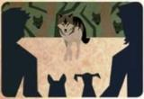  PPT  PPT

