Long-term plan unit: Cell Biology |  |  |  |  | School: NIS CmB Shymkent
Date: |  |  |  |  | Teacher name: Nuraliyev Y. T.
Grade: 11 |  |  |  |  | Number present: | absent:
Theme of the lesson |  | Comparison of the spermatogenesis and oogenesis
Learning objectives that are achieved at this lesson (Subject Program reference) |  | Students will learn to  - explain the differences of spermatogenesis and oogenesis
Lesson objectives |  | Students will be able to  - Comparative description of spermatogenesis and oogenesis. Assigning a pair of spermatogenesis and oogenesis to a comparative schedule.
Success criteria |  | Students will be able  1. Diagrams with correctly matched structure and function as well as labels.  2. Completed tables with structure and function.
Language objectives |  | (Speaking, Listening, Writing and Reading skills)  Explain the difference between spermatogenesis and oogenesis, as well as listening and comprehending the types of spermatozoa and ovarian excretion pathologies;  Subject-specific vocabulary & terminology:  Can comment on the terms of embryo, genitalia follicles, oocytes, sperm.  Useful sets(s) of phrases for dialogue and writing:  The embryo developed lasts in _______________.  The incubation of eggs in ____________.  The genitalia follicles showing ______________.  The stages of spermatogenesis includes _______________.  My observations ______________________.
Values instilled at the lesson |  | Give knowledge about this topic for future generations
Kazakh Culture |  | In traditional Kazakh culture, the in vitro method has never been used. But these are new opportunities for determining the processes of spermatogenesis and their use in life.
ICT skills |  | Instructor will use the interactive whiteboard.
Previous learning |  | This section examines and extends students' knowledge of different disciplines. Gametogenesis and extracorporeal fertilization in this chapter are related to some basic biological principles, as well as extracurricular debates.
Course of the lesson
Planned stages of the lesson | Planned activities at the lesson |  |  |  |  |  | Resources
0-15min.  16- 20 min  21- 25 min  26-30 min  31-35 min  36-40 min | Introduction:  Organizational period: Explanation of a picture of a sperm and spermatogenesis (group work).  By working with the terms in the terminology, we connect the picture task.  We design a few good pictures of spermatozoids and ovaries and ask them what they can find in class.  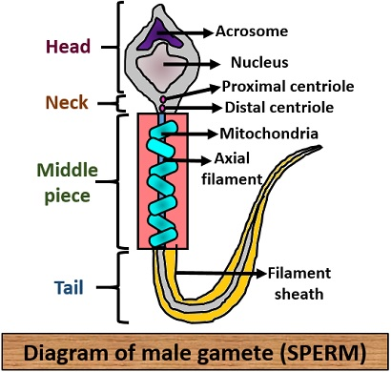  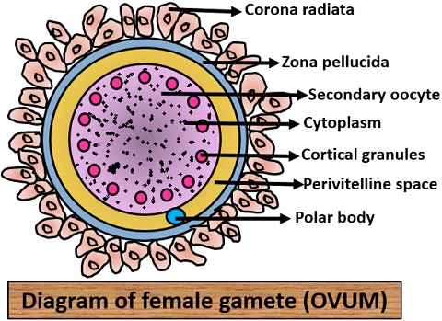  Additional information.  In humans, mammals, Drosophila and many other species, the female sex is homogametic XX), and the male is heterogametic (XY). In these species, the same eggs and different sperm cells form during meiosis. In chickens and other birds, as well as in silkworms and butterflies, on the contrary, heterogametic female sex (HU), and homogametic - male. Animals of these species during gametogenesis form different eggs and the same sperm. In grasshoppers and bedbugs, females are homogametic, while males are heterogametic in moths; on the contrary, females are heterogametic and males are homogametic.  We explain the types of spermatozoa and ovarian excretion by means of diagrams.  Please provide a comparative table for spermatogenesis and oogenesis in pairs; we'll return it to the second pair for a more consistent feedback and then return it for corrections / additions.  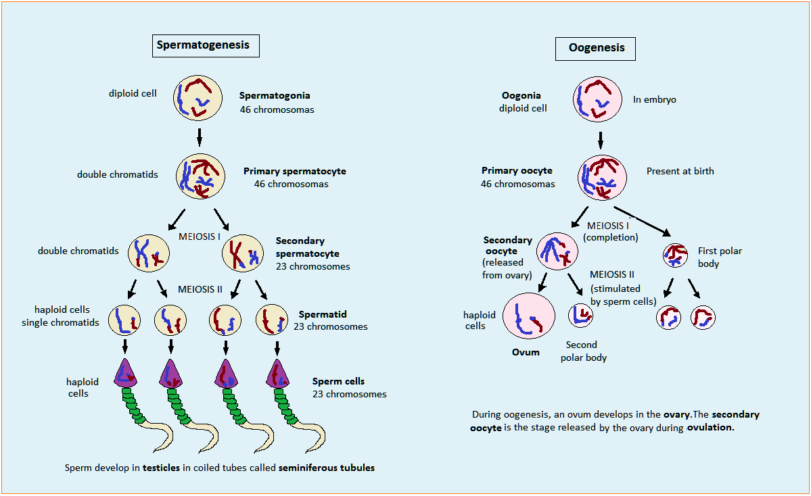  We ask you to create a queue of actions that show gametogenesis in humans. They can use charts, tables and other information for reference.  Criteria, such as color, clarity, a bit of creativity, etc. thereby pupils evaluate one another. Identifying students will show their initials, which will then be used to check student performance and assessment.  We present a series of slides that show sperm and ovary glands in different ways.  Closing  We are preparing for SAT questions. |  |  |  |  |  | Pictures of human spermatozoids and ovaries in a slide show:  http://www.medicinenet.com/conception_pictures_slideshow/article.htm  "Wellcome Trust"  Various approaches to spermatozoa and ovary glands in the program "Wellcome Trust":  http://www.wellcome.ac.uk/Education-resources/Teaching-and-education/Big-Picture/All-issues/The-Cell/Image-galleries-Aspects-of-imaging/WTDV030833.htm
Differentiation – how do you plan to give more support? How do you plan to challenge the more able learners? |  |  | Assessment – how are you planning to check students’ learning? |  |  |  | Health and safety regulations
Students will be put in pairs to take advantage of interaction that will assist with learning. Students may be given different types of transport to research based on levels. |  |  |  |  |  |  | No hazard risks when doing this activity.
Reflection  Were the lesson objectives/learning objectives realistic? Did all learners achieve the LO?  If not, why?  Did my planned differentiation work well?  Did I stick to timings?  What changes did I make from my plan and why? |  |  |  | Use the space below to reflect on your lesson. Answer the most relevant questions from the box on the left about your lesson.
Summary evaluation
What two things went really well (consider both teaching and learning)?
1:

2:

What two things would have improved the lesson (consider both teaching and learning)?
1:

2:

