**FLIPPED CLASSROOM FOR THE DEVELOPMENT OF SPEAKING SKILL IN ENGLISH LANGUAGE LEARNING**

Kaldykulova Balausa

email:kaldykulovabalausa8@gmail.com

3 year student of the specialty «5B011900 Foreign language: two foreign languages», Astana International University, Astana, Kazakhstan

Scientific supervisor Kantaeva G.G

**Abstract**

The flipped classroom model has gained popularity in recent years as a teaching strategy that shifts the traditional lecture-based classroom to a more interactive and student-centered approach. This paper explores the effectiveness of using the flipped classroom model to develop speaking skills in English language learning. The flipped classroom model involves pre-recorded lectures and materials being delivered to students before class, which frees up class time for interactive activities, discussions, and practice. The study finds that the flipped classroom model can be an effective method for developing speaking skills in English language learning, as it provides students with more opportunities to practice speaking and receive immediate feedback from their teachers and peers. Additionally, the flipped classroom model allows students to learn at their own pace and provides them with a sense of ownership over their learning. Overall, this paper highlights the potential of the flipped classroom model as a valuable tool for enhancing speaking skills in English language learning.

Overall, this paper aims to provide insights into the potential of the flipped classroom model for enhancing speaking skills in English language learning.

**Keywords:** English language, Teaching, Flipped classroom, Speaking skills

English language learning has become an integral part of education in many countries around the world. The ability to speak English fluently and confidently is a crucial skill in today's globalized world, as it provides individuals with increased opportunities for communication, education, and career advancement. However, despite the importance of speaking skills in English language learning, many students struggle to develop these skills due to the traditional lecture-based classroom approach that often focuses on grammar and vocabulary learning.

The flipped classroom model has emerged as a new teaching strategy that aims to address these challenges by providing students with more opportunities for interactive learning and practice. In a flipped classroom, students are provided with pre-recorded lectures and materials to review before class, which allows for more interactive learning activities, discussions, and practice during class.

This study paper explores the potential of the flipped classroom model as a tool for developing speaking skills in English language learning. The paper examines the theoretical framework of the flipped classroom model and its effectiveness in enhancing speaking skills. Additionally, the paper discusses the benefits and challenges of using the flipped classroom model for English language learning and provides recommendations for educators interested in implementing this approach in their classrooms. Overall, this paper aims to provide insights into the potential of the flipped classroom model for enhancing speaking skills in English language learning.

The flipped classroom model has gained popularity in recent years as an innovative approach to teaching and learning. This model involves reversing the traditional classroom structure by delivering instructional content outside of class time, typically through online videos or other digital resources, and using class time for active learning activities such as discussion, collaboration, and problem-solving. One area where the flipped classroom model has shown promise is in the development of speaking skills in English language learning.

Speaking is often considered the most important skill in language learning, as it is the primary means of communication. However, many traditional language classrooms focus primarily on reading and writing, with limited opportunities for students to practice speaking. The flipped classroom model addresses this issue by providing students with opportunities to engage in speaking activities during class time, while also providing them with the necessary input and language practice outside of class.

In a flipped classroom model for speaking skills development in English language learning, students would typically be assigned video or audio recordings to watch or listen to outside of class time. These recordings could include lectures, dialogues, interviews, or other authentic language input. Students would be expected to take notes, answer comprehension questions, or complete other activities related to the content of the recordings.

During class time, students would then engage in a variety of speaking activities designed to build their speaking skills. These activities could include role-plays, debates, discussions, presentations, or other interactive tasks. The teacher would act as a facilitator, providing feedback and guidance to help students improve their speaking skills.

One of the main benefits of the flipped classroom model for speaking skills development is that it allows students to engage in authentic speaking practice in a supportive environment. By providing students with input and language practice outside of class, they come to class better prepared to engage in speaking activities. This allows for more meaningful and engaging speaking practice, as students are able to draw on their knowledge and experience to engage in real-world communication.

Another benefit of the flipped classroom model is that it allows for more individualized instruction. Students can work at their own pace outside of class, reviewing content as needed, while also receiving personalized feedback and guidance from the teacher during class time. This can help students to identify areas where they need additional support and to focus their efforts on improving their speaking skills.

In spite of that flipped classroom may be or maybe modern wonder in higher instruction, a few experimental investigations has been conducted. For occurrence, McLaughlin et al. (2013) and McLaughlin et al. (2014) analysis of pharmacy students’ experiences of flipped classroom courses revealed that students prefer learning content prior to class and using class time for applied learning and that students who learned through a flipped classroom approach considered themselves more engaged than students attending traditional courses.

The flipped classroom learners’ accomplishment through fitting exercises, such as inner and outside work in the classroom. The teacher gives the learning constructions so that the student can complete the assignment with the right sum of help, which can offer assistance to the learner by the Zone of Proximal Advancement.

Basically, the Flipped Classroom (Figure 1:the model of Flipped classroom) has begun to actualize in the early 2010s and displayed momentous results in arranging to instruct and learn. This kind of classroom sort is one of the interesting instruction-based of blended learning type and aimed to develop the students’ interaction with peer instructing and working collaboratively in group works as well.

In 2011, Salman Khan utilized the term “flipping the classroom” in his TED conversation. Salman Khan has supported the flipped show and has expressed that his recordings permit the instructor to center on higher-level learning exercises, such as running reenactments, and labs with understudies, doing person intercessions and encouraging peer-to-peer learning. From that date, intrigue about flipped classroom instruction has developed exponentially with modern articles, and blogs on the flipped classroom educating method.

The flipped classroom instruction is all most an unused teaching technique, endeavoring to bolt in understudies inside the learning handle. Moving the address outside the classroom implies development and moving homework into the classroom, through learning works out.

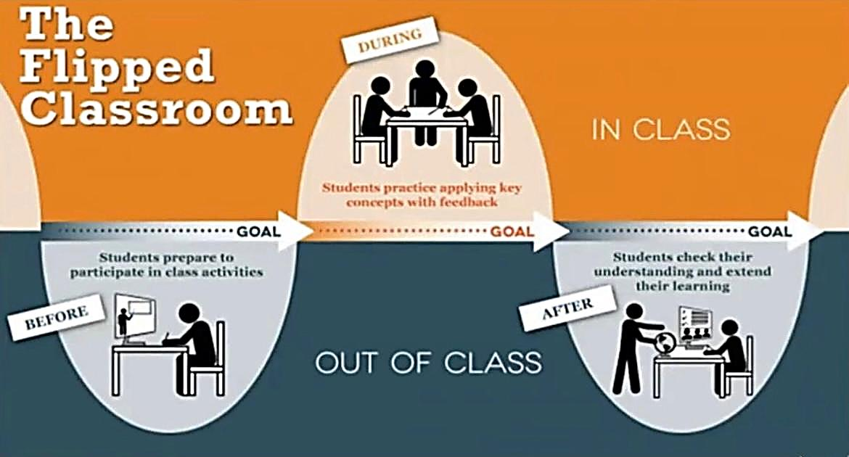

*Figure 1: The model of Flipped Classroom*

These are some basic guidelines that can help students succeed in a flipped classroom.

1. Watch or read the assigned content before class: To get the most out of the flipped classroom approach, students should complete the assigned content before coming to class. This will help them engage more effectively in-class activities and discussions.

2. Take notes: While watching or reading the assigned content, students should take notes to help them remember key ideas and concepts.

3. Come to class prepared: Students should come to class ready to participate in discussions and activities related to the assigned content. This may include bringing materials such as textbooks, notes, and laptops.

4. Participate in class: In a flipped classroom, class time is designed for discussion and collaboration. Students should be prepared to engage in class discussions, ask questions, and work with their classmates to solve problems.

5. Complete assignments on time: Just like in a traditional classroom, students will be expected to complete assignments related to the content covered in class. Students should make sure to submit their assignments on time to avoid falling behind.

6. Seek help when needed: If students are struggling with the assigned content or have questions about the class material, they should not hesitate to seek help from the teacher or their classmates.

7. Stay organized: With a flipped classroom approach, students will be responsible for managing their learning outside of class. This means staying organized and keeping track of assignments, due dates, and other important information.

**Method**

To investigate the effectiveness of the flipped classroom model for developing speaking skills in English language learning, several methods can be employed. These methods can include:

1. Literature review: Conduct a comprehensive review of relevant literature on the flipped classroom model and its effectiveness in developing speaking skills in English language learning. This can involve reviewing both theoretical and empirical studies on the topic.

2. Pre-and post-assessment: Administering pre-and post-assessments to measure students' speaking skills before and after implementing the flipped classroom model. This can involve using standardized speaking tests, self-assessment tools, and teacher evaluations.

3. Classroom observations: Observing classroom activities and interactions to assess the effectiveness of the flipped classroom model in promoting speaking skills. This can involve using checklists and rubrics to evaluate students' participation, engagement, and speaking performance.

4. Student feedback: Collect feedback from students on their perceptions of the flipped classroom model and its impact on their speaking skills. This can involve using surveys, focus groups, and interviews.

5. Case studies: Conduct case studies of individual students or groups of students to gain a deeper understanding of the effectiveness of the flipped classroom model in promoting speaking skills.

By employing these methods, educators and researchers can gain valuable insights into the effectiveness of the flipped classroom model for developing speaking skills in English language learning.

In conclusion,the flipped classroom model has the potential to be a powerful tool for the development of speaking skills in English language learning. By providing students with input and language practice outside of class and engaging them in authentic speaking activities during class time, the flipped classroom model can help students to develop the skills they need to communicate effectively in English.

Low achievers, who experienced a strengthening utilizing the flipped classroom model in terms of picking up more openings to reflect and learn in their claim pace. Might find traditional lectures challenging and fast-paced (Young et al., 2009),

**REFERENCES**

1. McLaughlin, J. E., Griffin, L. M., Esserman, D. A., Davidson, C. A., Glatt, D. M., Roth, M. T., …Mumper, R. J. (2013). Pharmacy student engagement, performance, and perception in a flipped satellite classroom. American Journal of Pharmaceutical Education, 77(9), 196.
2. McLaughlin, J. E., Roth, M. T., Glatt, D. M., Gharkholonarehe, N., Davidson, C. A., Griffin, L. M., …Mumper, R. J. (2014). The flipped classroom: a course redesign to foster learning and engagement in a health professions school. Academic Medicine, 89(2), 236–243**.**
3. Khan, S. About Khan Academy. Khan Academy.[Electronic resource]. http://www.khaacademy.org/about.- (Accessed 15.10.2018)
4. Alexander, M. M. (2018). The flipped classroom: Engaging the student in active learning. *J. Legal Stud. Educ.*, *35*, 277.
5. Young, M. S., Robinson, S., & Alberts, P. (2009). Students pay attention! Combating the vigilance decrement to improve learning during lectures. *Active Learning in Higher Education*, *10*(1), 41-55.