Short term plan: term 3

Unit 5: Art and Music
Teacher name: |  | Assel Assankyzy
Date: |  | 05.02.2024
Grade: 3 Б |  | Number present: | absent:
Lesson title | My music
Learning objectives | 3.4.7.1 correctly write down more familiar frequently used words when performing writing activities under the guidance of a teacher  3.5.9.1 use the present tense (basic narrative, negative and interrogative forms) to describe what they like, their desires and habits, presenting facts  3.3.1.1 recognize, identify and sound with support a limited range of familiar words in simple sentences;  3.2.4.1 answer questions within a limited range of general and educational topics;  3.4.3.1 write short phrases describing people, places and objects;  3.4.1.1 compose, record and check with significant support short sentences on a limited range of personal, general and educational topics;
Lesson objectives | Learners will be able to:  - to explore other subject areas  - to distinguish different types of musical instruments and the sounds they make  - to talk about their favourite type of music.
Value links | the value of the lesson is to love music, in particular national music, like music performed on the dombra
Plan

Stages / Time | Teachers actions | Students actions | Assessment criteria | Resources
Beginning of the lesson  Warming-up    Pre-learning  «Brainstorming» method | Organization moment :  1.Greeting.  Activity 1 “Say “Hello”  Instruction:  - Listen and sing the song with the recoding  The teacher sets the lesson objectives, letting students know what to anticipate from the lesson.  Warming up  By collecting puzzles, students will determine the name of their groups  Lead – In  What’s in the box?  Let the children touch with their hands and find what kind of musical instrument it is. | .  The aim: To develop pupils speaking skills and create friendly atmosphere  Efficiency: Having sung the song, they will be positive about the lesson.  Students of the class are listed.  Students' attention is drawn to the lesson.  • Learners remember previous lesson vocabulary  Determines the topic and purpose of the lesson  Students say different words from the picture, puzzle  • Children feel with their hands and find what kind of musical instrument it is. | The teacher to assess learners for their ability.  “Good job!  Well done!”  Formative Assessment    Good job!  Descriptor:  - can solve the puzzle  Assessment criteria  - Learners have met the learning objectives if they can talk about musical instruments  Descriptor:  Touch and find what is it | Song “Hello”  Adapted from:  https://www.youtube.com/watch?v=tVlcKp3bWH8  worksheets  Pictures  Box with musical insrtuments
Middle of the lesson  Presentation part. | Unscramble the words  • Give them pieces of papers with letters  Listen to music and find the names of instruments on the walls of the classroom  • Explain the activity. Allow the pupils some time to listen to music and find the words. Check the pupils’ answers.  Work with text  Give the children texts. Explain the task.  Guess the melody  • Explain the activity. Allow the pupils some time to listen to the music and find name of the song. Check the pupils’ answers.  Karaoke time  • Give the children a microphone, explain the karaoke task  Conclusion during the lesson some tasks differentiated by outcomes of the students and by their abilities. | Pupils listen and collect the words.  ANSWERS:  Zhetygen  Guitar  Recorder  Teacher: Yes. It’s drum, recorder etc.  ANSWERS:  recorder, drum, guitar, piano, tambourine, violin, kobyz, zhetygen, dombra.  Pupils read and find missing word.  My name is Lilly. I like playing the guitar. I play the guitar very well. But I don’t play the piano at all. When you play the guitar you have to ________ it.  ANSWERS: pluck  Pupils listen to the music and find name of the song.  ANSWERS  Pyala, Sedaya noch’ etc.  Pupils sing songs following the words | Descriptor:  - find and collect  Total: 1 point  Descriptor:  - listen to the music and find the words  Total: 1 point  Descriptor:  - read and find the word  Descriptor:  - listen to the music and find name of the song  Total: 1 point  Descriptor:  - watch and sing  Total: 1 point |   Card  Worksheet  Worksheets  Pictures  Worksheets  Song performed by teacher on dombra  Videos on YouTube
End of the lesson | FEEDBACK  Learners provide feedback on what they have learned at the lesson.  Ex:  To write about their favourite musical instruments. | 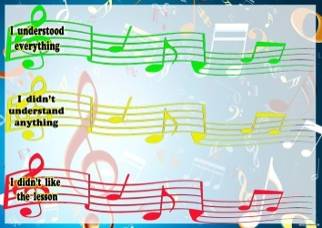  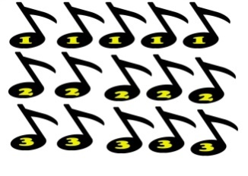 |  | Poster Success  

