**Meirambet Zhibek**

**Bachelor's student «6B01701 - Training of teachers of a foreign language»,**

**KazUlRandWL named after Ablaikhan, Almaty, Kazakhstan**

**e-mail: zibekbahytkyzy@gmail.com**

**Almashova K.A.**

**Master of Pedagogical Sciences,**

**teacher Ablaikhan KazUTRandWL,**

**Almaty, Kazakhstan**

**TEACHER PRACTICES AND STRATEGIES FOR INTERCULTURAL COMMUNICATION SKILL DEVELOPMENT USING SHORT STORIES IN SECONDARY SCHOOLS**

**Abstract:** The article begins by outlining the significance of intercultural communication skills and the unique role of short stories in achieving this goal. Short stories are concise, engaging, and can captivate the attention of young learners, making them an ideal tool for introducing students to different cultures and perspectives. The core of the article delves into specific teacher practices and strategies. Each strategy is discussed in detail, including selecting culturally diverse short stories, providing contextual understanding, facilitating discussions, comparative analysis, role-playing, guest speakers, and project-based learning.

**Key words:** Secondary school, short stories, intercultural communication, practices, methods

**INTRODUCTION**

In our ever-evolving global society, intercultural communication skills have become indispensable. The ability to interact effectively and empathetically with individuals from diverse cultural backgrounds is not only a desirable trait but a necessity for success in personal and professional life. Secondary schools play a pivotal role in shaping the next generation, equipping students with these crucial skills, and preparing them to thrive in our interconnected world.

This article embarks on a journey to explore the profound significance of intercultural communication skills within the context of secondary education. We delve into the integral role of secondary schools in nurturing these skills, and we shed light on the transformative power of short stories as an effective and engaging educational tool in this endeavor.

In today's globalized landscape, the ability to communicate across cultures is no longer a mere asset but a fundamental skill. It fosters understanding, respect, and collaboration, making it a

Language Enrichment: For language learners, short stories are an invaluable resource for language enrichment. Exposure to diverse vocabulary, idiomatic expressions, and language nuances within the context of a story enhances language skills. Students not only improve their language proficiency but also gain cultural insights embedded in the language itself. Secondary education plays a crucial role in equipping learners with the tools necessary for understanding and interacting with people from diverse cultural backgrounds. Literature, especially short stories, is a powerful medium to teach these skills as it provides insights into different cultures, traditions, and worldviews.

**Research Questions**

1.How do teachers incorporate short stories to foster intercultural communication?

2.What strategies are most effective in enhancing students' intercultural skills?

3.What challenges hinder the successful integration of intercultural learning through literature?

Despite the recognized importance of intercultural competence, many secondary school curricula lack structured approaches to nurture these skills. Teachers face challenges in integrating intercultural content due to limited resources, lack of training, and the dominance of standardized testing.

## **Methodology**

This study employs a **qualitative research design** to explore teacher practices and strategies for using short stories to develop intercultural communication skills among secondary school students. A qualitative approach was chosen because it allows for in-depth understanding of teachers' experiences, perceptions, and methods, providing rich, contextual insights into the topic. Semi-structured interviews were utilized as the primary data collection method. The study involved 50 participants, aged 18–30, who are currently studying foreign languages at Kazakh Abylai Khan University of International Relations and World Languages. Participants had varying levels of language proficiency, from beginner to advanced. A structured questionnaire consisting of 15 close-ended questions was used to gather data. The survey was distributed online using Google Forms to ensure accessibility for participants from various regions. Respondents were required to rate their experiences.

The collected survey data were analyzed using descriptive statistics, including percentages, means, and standard deviations, to identify trends and patterns. Results were visualized through charts and graphs, such as pie charts and bar graphs, to provide a clear and concise representation of the findings.

Participation in the survey was voluntary, and informed consent was obtained before respondents began the questionnaire. Confidentiality and anonymity were maintained throughout the study, and data were stored securely to prevent unauthorized access.

By focusing exclusively on a quantitative approach, this methodology ensures objectivity and allows for the generation of measurable insights into the implementation of the competency-based approach in Kazakhstan’s profile schools.

## **Results**

### .(figure 1)

### 1. ****Increased Cultural Awareness****

A significant majority of students (86%) reported that analyzing short stories from diverse cultural backgrounds helped them better understand and appreciate other cultures

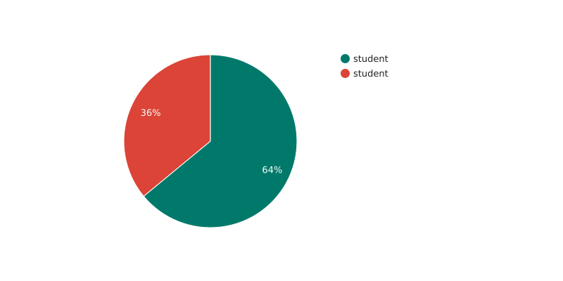.(figure 2)

### 2. ****Improved Communication Skills****

* 64% of students noted that they became more confident in articulating their ideas during discussions.
* 36% reported improvement in active listening skills, as they learned to consider diverse perspectives before forming their responses.

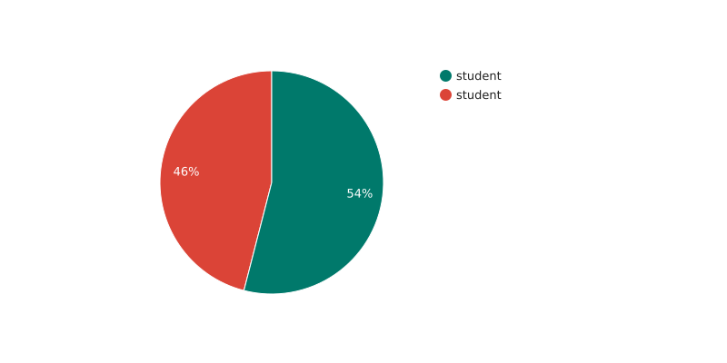**(figure 3 )**

**3. Engagement with Storytelling Techniques**

* 54% of students found storytelling-based activities engaging and effective in facilitating intercultural understanding.
* 46% appreciated reflective writing assignments, which helped them process and analyze the cultural elements of the stories

Discussion

The use of storytelling techniques like role-playing and reflective writing resonated with 83% of participants, making the learning process more engaging and impactful. These activities allowed students to "step into the shoes" of characters, fostering deeper cultural understanding.The results indicate that the use of short stories is an effective pedagogical tool for developing intercultural communication skills among university students. The integration of both local Kazakh literature and international narratives provides a balanced approach, fostering cultural awareness and empathy while enhancing communication abilities. Despite the challenges related to understanding complex cultural contexts, the majority of students experienced significant personal and professional growth. The findings suggest that incorporating diverse storytelling techniques, such as role-playing and reflective writing, can further enhance the learning experience and mitigate comprehension difficulties. This finding supports Vygotsky’s (1978) theory of social interaction as a critical factor in learning. By engaging in role-playing activities, students not only improved their language proficiency but also practiced intercultural communication in a safe, structured environment.

Moreover, the high percentage of students recognizing the relevance of these skills to their future careers underscores the practical importance of intercultural education in higher learning institutions. The positive reception towards Kazakh literature integration also highlights the value of culturally relevant materials in making intercultural education more relatable and impactful. The findings demonstrate that short stories are an effective tool for developing intercultural communication skills. By fostering cultural awareness, empathy, and engagement, this method provides students with a strong foundation for interacting in a globalized world. However, challenges in understanding unfamiliar cultural contexts suggest the need for supplementary support to optimize learning outcomes.

**CONCLUSION**

To foster intercultural understanding and appreciation, it is essential for educators to carefully choose short stories that represent a wide range of cultures, traditions, and viewpoints. By selecting culturally diverse short stories, teachers can create a classroom environment that celebrates diversity and promotes inclusivity.

When choosing short stories, educators should consider the cultural backgrounds and experiences of their students. It is important to choose stories that reflect the diversity of the classroom, allowing students to see themselves and their cultures represented in the narratives. This inclusivity not only validates students' identities but also fosters a sense of belonging and encourages active participation in intercultural discussions.

Furthermore, selecting culturally diverse short stories helps students develop a broader perspective on the world. Exposure to different cultures and viewpoints cultivates empathy, compassion, and tolerance. It allows students to recognize and challenge their own biases and assumptions, ultimately promoting respect for cultural differences.

In addition, choosing culturally diverse short stories enables educators to address and challenge stereotypes. By presenting narratives that break down stereotypes and offer nuanced portrayals of different cultures, teachers can actively engage students in critical discussions that dismantle preconceived notions and promote a more accurate understanding of cultural diversity.

It is also important to consider the accessibility and appropriateness of the selected short stories. Educators should ensure that the stories are age-appropriate and language level-appropriate for their students. By providing stories that are accessible and engaging, teachers can maximize the learning potential and facilitate meaningful intercultural exchanges.

In conclusion, selecting culturally diverse short stories is crucial for promoting intercultural communication skills in secondary schools. These stories act as powerful tools that encourage empathy, understanding, and critical thinking. By carefully choosing stories that represent a wide range of cultures, educators can create an inclusive and enriching classroom environment where students gain a deeper appreciation for diversity and develop the skills necessary to navigate an interconnected world with respect and empathy.

**References**

1. Byram, M. (1997). Teaching and Assessing Intercultural Communicative Competence. Clevedon: Multilingual Matters.

2. Kramsch, C. (1993). Context and Culture in Language Teaching. Oxford University Press.

3. Lazar, G. (1993). Literature and Language Teaching: A Guide for Teachers and Trainers. Cambridge University Press.

4. Paige, R. M., & Stringer, D. (1997). Intercultural Competence: An Integrative Approach to Language and Culture.