Calendar Thematic Plan
Healthy snacks
(The theme of a lesson)

Unit:6 | Healthy World
Teacher name:

Date:
Grade:4 | Number present: | Number absent:
The theme of the lesson: | Healthy snacks
Learning objectives(s) that this lesson is contributing to | 4.1.5.1 identify initial, middle and final phonemes  and blends;  4.3.5.1 understand the main points of short simple texts on  a growing range gen. and some curr. topics by using contextual clues;  4.4.2.1 begin to use joined-up handwriting in a limited range of written work;
Lesson objectives | Learners will be able to recognize new vocabulary words and know about healthy food and how to stay healthy  They can tell about their diet and know what food is healthy and what is unhealthy  They will be able to develop their reading, speaking and writing skills;
Lesson plan
Planned timings | Teacher's actions | Students` actions | Assessment | Resources
10minutes | ORGANISATION MOMENT:  Teacher greets students  Teacher: Good morning!  How are you?  Learners answer the question ‘How are you?’  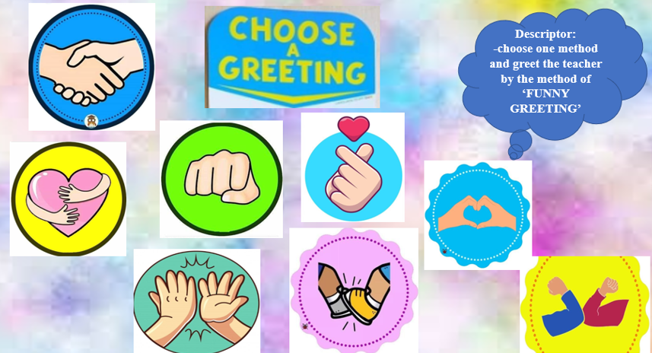Welcome to our English lesson  Ok, if you are ready let’s start our lesson  Psychological situation    Dividing into groups | Students respond to greeting and take their places  Students come to the blackboard and say their best wishes to each other  Descriptor:  -choose one method and greet the teacher by the method of ‘FUNNY GREETING’  Descriptor:  -listen to the teacher attentively  -touch your body parts by a command  -try to take up the cup quickly by the method of ‘FUNNY CUPS’  Descriptor:  -take any ladybird and find your group by the method of ‘LADYBIRD’ | Formative assessment  By the method of “Thumb”    ‘excellent’  ‘well done’  ‘good job’  ‘excellent’  ‘good job’  ‘very well’ | Books  Copybooks  Interactive white board  Activity book  music
25 minutes  10 minutes | MAIN PART  Speaking  Group work  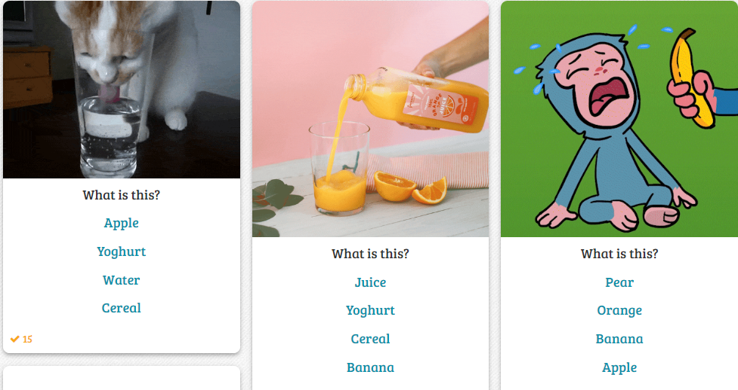  Let’s watch the video  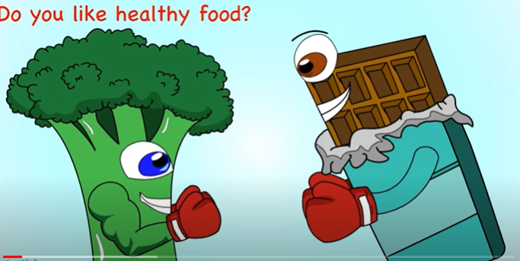  New words:  Salt and pepper-Тұз бен бұрыш  Cabbage-орам жапырақ Mustard-қыша  Pizza-пицца Mushrooms-саңырауқұлақ  Sausage-шұжық Olive oil-зәйтүн майы  Mayonnaise-майонез Cucumber-қияр  Lettuce-латук салаты  Listening  Pair work  Exercise 1  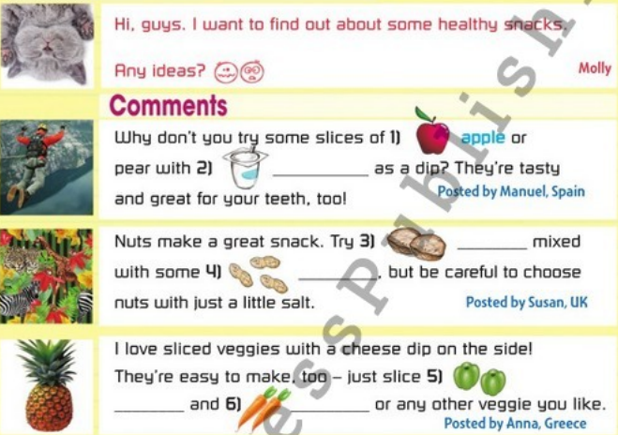  Writing  Individual work  Exercise 2  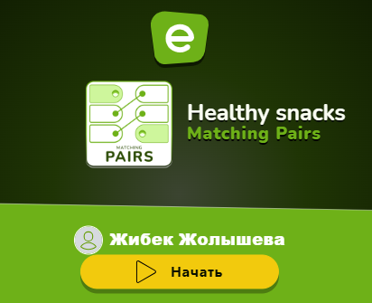  Warm-up  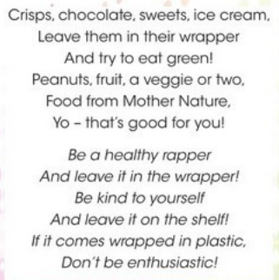  Reading  Individual work  Exercise 3    Writing  Group work  Exercise 4  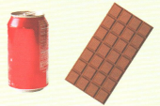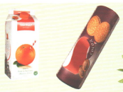  Conclusion  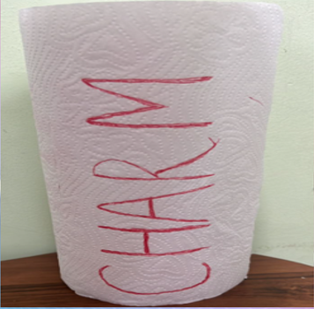  ENDING THE LESSON:  Assessment chart  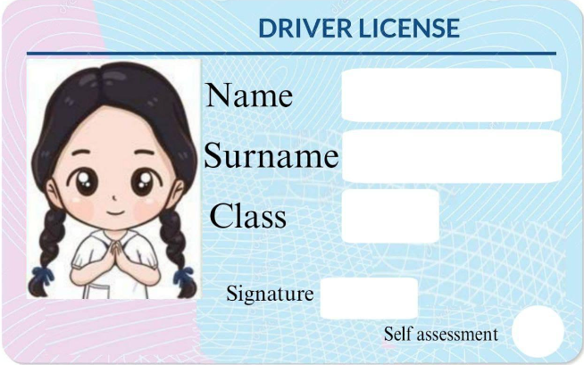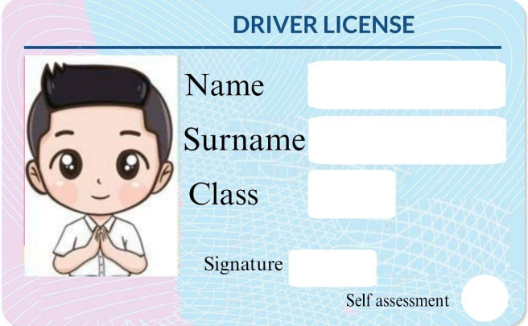  Well what did we do in our lesson?  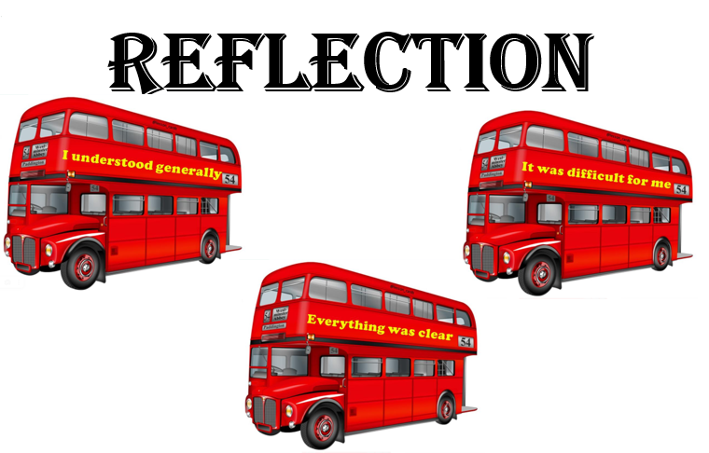  Evaluation of the lesson  Give the home task  Draw the food you usually eat at breakfast/lunch and dinner  Say Good bye | Descriptor:  -look and say if they are healthy and unhealthy snacks on the platform ‘BAAMBOOZLE’ by the  method of  ‘BRAIN ATTACK’  Pupils should watch the video to recognize the theme  Descriptor:  -look at the pictures attentively  -repeat and name the lost picture by the method of ‘HIDDEN PICTURE’  Descriptor:  -listen to the recorder attentively  -try to write the correct words to each gap by the method of  ‘THINK TOGETHER’  Descriptor:  -read the half of the dialogue carefully  -match with answers on the platform ‘EDUCAPLAY’ by the method of  ‘BREAK A BRAIN’  Descriptor:  -listen to the recorder  -sing a song  Descriptor:  -scan the code  -read and fill in the sentences with the words in the box by the method of ‘BRAIN ATTACK’  Descriptor:  -look at the pictures  -read and match by the method of  ‘THINK, FIND and SEEK’  Descriptor:  -pay attention to the teacher  -try to read and unscramble the letters to read the words and say if they are healthy or unhealthy correctly by the method of ‘ROLL OF PAPER’  Learners should complete the card with information and points  answer to some questions to know how they understand the lesson  Pupils tell the class if they understand today’s lesson  If they don’t understand they write it to the stickers and leave it to class  Learners should draw some pictures  Children say Good bye | Formative assessment  1-2 points  By the method of ‘COMPLIMENTS’  ‘EXCELLENT’  ‘WONDERFUL’  ‘GOOD TRY’  By the method of ‘COMPLIMENTS’  ‘Good job’  ‘Well done’  ‘Excellent’  Formative assessment  By the method of “ID-Card”  1-2 points  Formative assessment:  By the method of ‘ID-card’  1-2 points  By the method of ‘COMPLIMENTS’  ‘brilliant’  ‘good job’  ‘very well’  By the method of ‘ID-Card’  1-2 points  By the method of ‘ID-Card’  1-2 points  Feedback  ‘EXCELLENT’  ‘WONDERFUL’  ‘GOOD JOB’  ‘EXCELLENT’  ‘WONDERFUL’  ‘GOOD JOB’ | https://www.baamboozle.com/game/1735605  https://youtu.be/fE8lezHs19s?si=nzvJdSUCSNskhbre  Flashcards  Activity book  https://www.educaplay.com/learning-resources/17956522-healthy_snacks.html  Interactive  White boards  https://youtu.be/PAGDAcVfobA?si=ikXY1Th506eN2-XZ  Cards  Pupil’s book  Cards  Board  Activity book  Stickers  White board

