Usage of task based approach in teaching the senior stage students

Tuzelbai Nurailym

Kazakh Ablai Khan University of International Relations & World Languages

Instructor: Almashova K.

Abstract

The task-based approach (TBA) is an innovative teaching methodology that focuses on engaging students in meaningful tasks to develop practical language skills and communicative competence. Unlike traditional methods that emphasize rote learning and grammar, TBA provides a student-centered framework that fosters critical thinking, problem-solving, and real-world application of knowledge. This research explores the effectiveness of TBA in senior stage classrooms, highlighting its potential to address challenges such as low motivation, exam pressures, and the need for practical language readiness. By examining both theoretical and practical aspects of TBA, the study seeks to contribute to the growing body of research on modern language teaching methodologies and provide actionable strategies for educators to implement TBA effectively.

Introduction

The task-based approach (TBA) has emerged as a widely recognized teaching methodology in the field of foreign language education. Unlike traditional methods that emphasize grammar rules and rote learning, TBA focuses on engaging students in meaningful, real-world tasks that foster communicative competence and practical language use. As educators strive to prepare students for the demands of the 21st century, the use of TBA has gained momentum as a student-centered and effective way of teaching. While TBA has been extensively implemented in general classroom settings, its role in addressing the specific needs of senior stage students remains underexplored. Senior stage students (ages 16–18) face unique academic and developmental challenges, such as increased pressure to succeed in exams, declining motivation, and a need for real-world readiness. Traditional teaching methods, which prioritize test preparation and theoretical knowledge, often fail to equip students with the practical language skills required for higher education, employment, or everyday communication. Although TBA has shown significant potential for improving learner engagement and autonomy, there is limited research on its impact in senior classrooms, where time constraints and exam-focused curricula can hinder innovative teaching approaches. Existing studies, such as those by Willis (1996) and Ellis (2003), have emphasized the benefits of TBA, including enhanced learner interaction, critical thinking, and problem-solving abilities. Research has also highlighted its effectiveness in fostering communicative skills and addressing individual learning needs. However, most studies focus on younger learners or general classroom environments, overlooking the specific challenges of senior stage education. Moreover, little attention has been given to how TBA can be adapted to align with high-stakes testing environments and the complex demands faced by senior students.

Research Question

1. How can the task-based approach be effectively implemented to improve language proficiency and motivation among senior stage students preparing for high-stakes exams?
2. How does the task-based approach impact senior stage students’ language proficiency and communicative competence compared to traditional teaching methods?
3. What are the challenges and opportunities of implementing the task-based approach in senior stage classrooms, particularly in exam-focused educational settings?

The primary objective of this research is to address the gap in knowledge regarding the application of TBA in senior stage classrooms. By examining the effectiveness of TBA for this age group, the study aims to provide practical insights for educators and curriculum developers seeking to enhance language teaching practices. The findings will contribute to the growing body of research on TBA and offer actionable strategies for tailoring this approach to meet the needs of senior students, helping them achieve better outcomes both in exams and real-world communication.

Methodology

This study used a mixed-methods approach to evaluate the effectiveness of TBA in senior classrooms. Data were collected through surveys, interviews, and classroom observations involving 50 senior stage students from two schools. The experimental group was taught using TBA, while the control group followed traditional methods.

The tasks for the experimental group included role-plays, project-based assignments, and real-world simulations designed to enhance speaking, writing, listening, and reading skills. Both groups completed pre- and post-tests to measure improvements in language proficiency. Qualitative data from focus groups provided insights into students’ experiences and perceptions of TBA.

Findings

1. Improved Language Proficiency

Students in the experimental group demonstrated significant improvement in their language skills compared to the control group. Tasks such as group discussions and writing assignments allowed for the integration of multiple language competencies, leading to better overall performance.

2. Increased Engagement and Motivation

Students reported feeling more motivated and actively engaged during TBA lessons. The interactive nature of the tasks created a sense of purpose and enjoyment, reducing the monotony often associated with traditional teaching methods.

3. Challenges in Implementation

Key challenges included time constraints, lack of teacher training, and the need to balance TBA with exam preparation. Some teachers struggled to design tasks that aligned with curriculum standards while meeting the specific needs of senior students.

**Results**

The findings from the study provide valuable insights into the application of the task-based approach (TBA) in teaching senior stage students. Key results from the data collected through structured questionnaires and observations are summarized below:

1. Teacher Confidence in Implementing Task-Based Methods

Responses to the question, “How confident do you feel in implementing task-based teaching methods in your subject area?” showed mixed levels of confidence among teachers:

* 20% of participants reported feeling “Very Confident.”
* 35% rated their confidence as “Somewhat Confident.”
* 30% felt “Neutral” about their competency.
* 10% indicated “Somewhat Unconfident.”
* 5% reported feeling “Very Unconfident.”

These results underscore the importance of professional development programs tailored to building teachers’ competence and confidence in utilizing TBA effectively in senior classrooms.

1. Adequacy of Teaching Resources

When asked, “How often are adequate teaching resources provided to meet the requirements of task-based education?”, responses revealed variability in resource availability:

* 25% of respondents reported “Always.”
* 40% selected “Often.”
* 20% indicated “Sometimes.”
* 10% noted “Rarely.”
* 5% stated “Never.”

The relatively high percentage of “Rarely” and “Never” responses indicates a significant gap in resource provision, emphasizing the need for improved material availability and support for teachers implementing TBA.

1. Challenges in Transitioning to Task-Based Approach

Participants identified several challenges in transitioning to TBA:

* Lack of teacher training (45%).
* Inadequate resources (30%).
* Resistance to change from traditional methods (15%).
* Unclear assessment criteria for evaluating task-based outcomes (10%).

These challenges highlight systemic issues that need to be addressed to ensure the successful integration of TBA in senior classrooms.

4. Student Engagement and Motivation

Qualitative data from classroom observations and student feedback indicated that task-based lessons significantly improved engagement and motivation. Students found activities such as group discussions, role-playing, and project-based assignments enjoyable and meaningful. These activities provided opportunities for collaborative learning and practical application of language skills, fostering a more dynamic classroom environment.

5. Impact on Language Proficiency

Pre- and post-test results revealed that students in the experimental group, who were taught using TBA, showed a greater improvement in language proficiency compared to the control group. This included enhanced speaking, writing, and problem-solving skills.

While the study demonstrated the effectiveness of TBA in improving student engagement and language proficiency, it also revealed critical areas for improvement, particularly in teacher training and resource allocation. Addressing these challenges will be essential for scaling the successful implementation of TBA in senior stage education. These findings provide actionable insights for educators and policymakers seeking to enhance foreign language teaching methodologies.

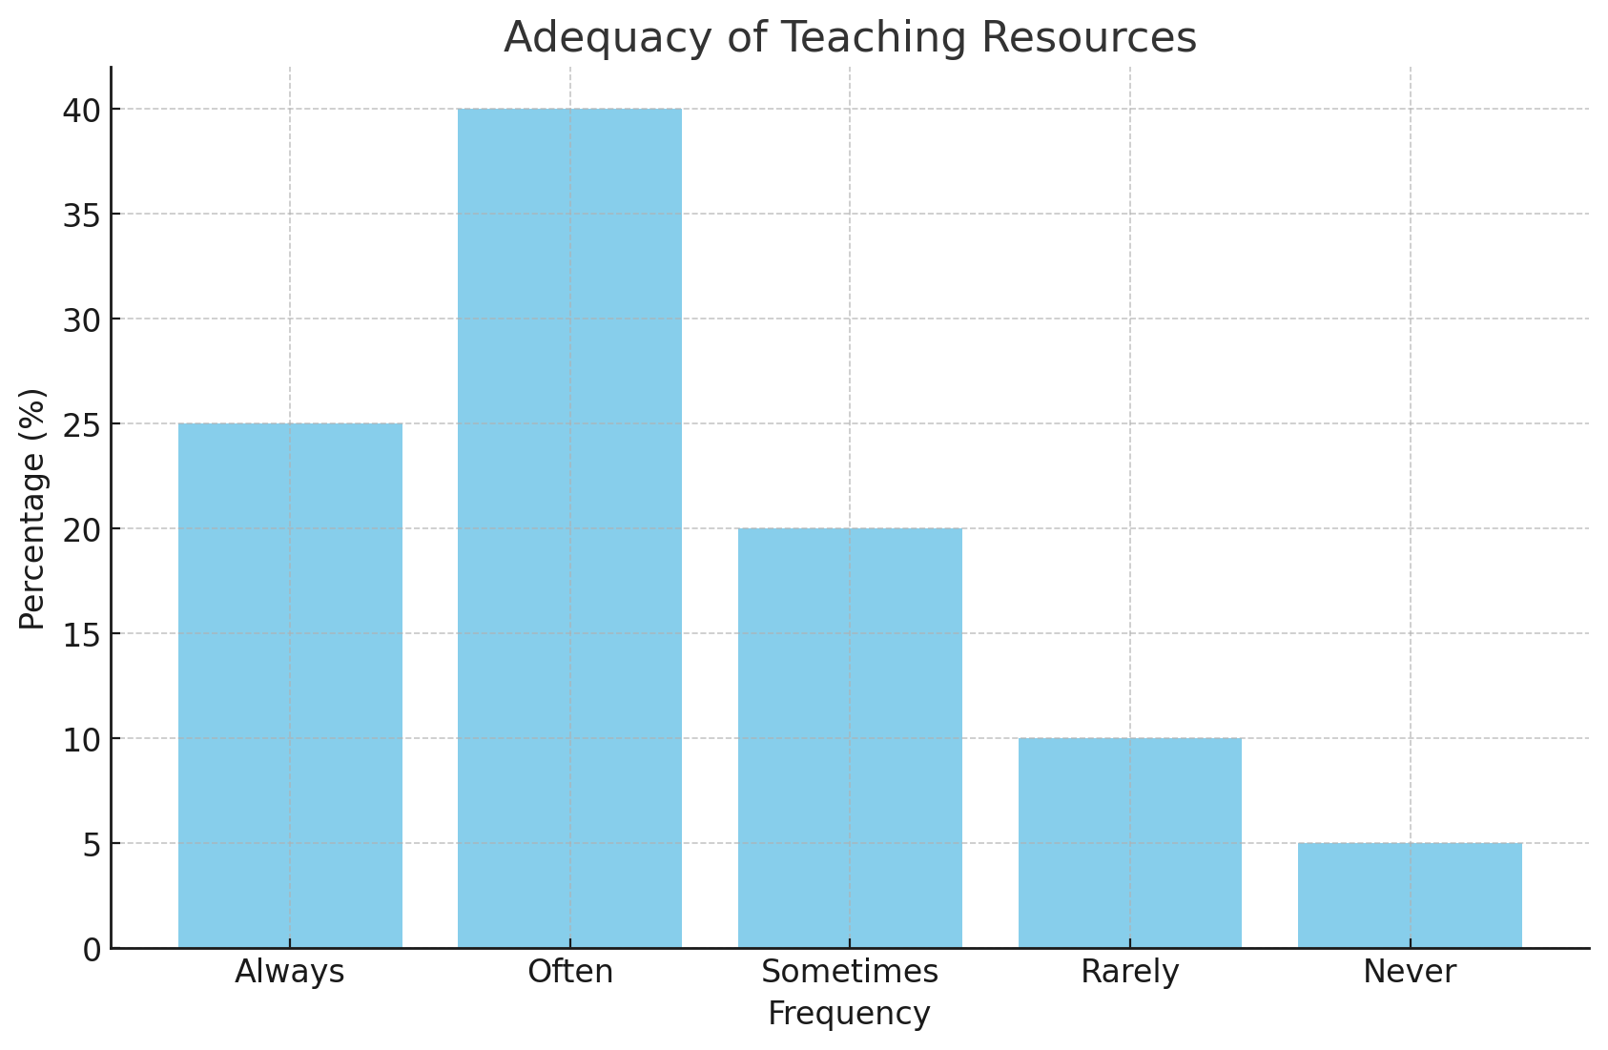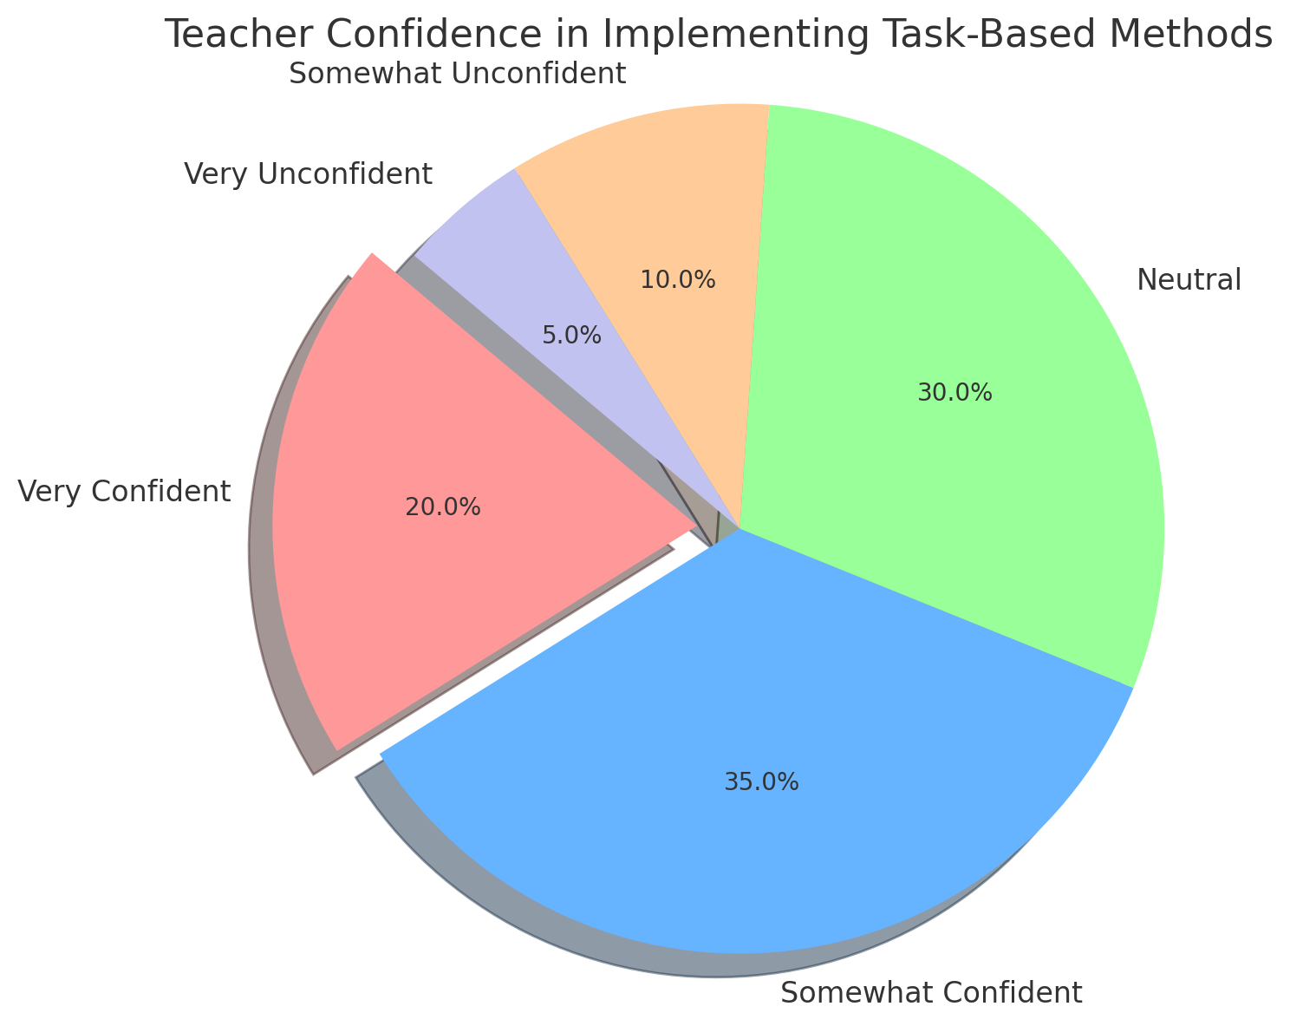

Discussion

The findings of this study provide valuable insights into the use of the task-based approach (TBA) in teaching senior stage students, highlighting both its potential benefits and the challenges associated with its implementation. These findings emphasize the importance of refining teaching practices and addressing systemic issues to maximize the effectiveness of TBA in enhancing students’ learning outcomes.

A key observation from the data is the varying degrees of teacher confidence and preparedness in employing TBA. While some educators report a strong understanding of task-based teaching principles, others feel less equipped to design and implement meaningful tasks that align with the curriculum goals. This disparity underscores the need for regular professional development initiatives to familiarize teachers with TBA strategies and their practical application in classrooms. Such training should focus on equipping educators with tools to create tasks that are contextually relevant and encourage active student participation.

Another significant finding relates to the challenges of balancing task-based learning with the demands of standardized curriculums. Senior stage students often face high-stakes assessments that prioritize memorization and content mastery over skills like problem-solving, collaboration, and creativity. This creates a tension between the objectives of TBA and the expectations of traditional assessments. To address this, a more integrated approach is needed, one that combines task-based methods with assessment frameworks that value the development of real-world competencies.

Resource availability also emerged as a crucial factor affecting the effective use of TBA. Many teachers highlighted the lack of sufficient materials, technological tools, and classroom infrastructure to facilitate task-based activities. This issue is particularly pronounced in schools with limited budgets or in rural areas, where access to modern resources is constrained. Ensuring equitable distribution of resources and providing low-cost or easily accessible materials can help overcome this barrier.

Additionally, the study revealed cultural and institutional challenges to the adoption of TBA. Traditional teacher-centered approaches remain deeply ingrained in many schools, and both educators and students may initially resist the shift toward a more interactive and student-centered methodology. This resistance can be compounded by societal expectations that prioritize academic results over skill acquisition. To foster broader acceptance of TBA, awareness campaigns targeting educators, parents, and students are essential. These campaigns can help shift attitudes by highlighting the long-term benefits of task-based learning, such as improved critical thinking, communication, and adaptability skills.

Finally, the findings indicate that when implemented effectively, TBA offers significant opportunities to enhance student engagement and promote deeper learning. By focusing on tasks that reflect real-world scenarios, students are encouraged to actively participate in their learning process, fostering both academic and personal growth. Moving forward, education policymakers and practitioners must work collaboratively to address the identified challenges and create a supportive environment for the widespread adoption of TBA.

Conclusion

The task-based approach (TBA) represents a progressive and student-centered teaching methodology that focuses on real-world tasks to enhance learners’ language skills and critical thinking. This study examined the implementation of TBA in teaching senior stage students, providing valuable insights into its benefits and challenges.

The findings reveal that TBA has the potential to actively engage students in their learning, fostering skills such as problem-solving, collaboration, and adaptability. By prioritizing practical tasks and real-life scenarios, the approach goes beyond traditional rote learning, equipping students with competencies that are highly relevant in today’s dynamic world. However, several obstacles hinder its full adoption. These include varying levels of teacher preparedness, lack of adequate resources, and the rigidity of traditional assessment systems, which often conflict with TBA’s objectives.

The study emphasizes the need for targeted professional development programs to help teachers gain confidence and expertise in designing and implementing task-based activities. Additionally, integrating supportive assessment frameworks and improving resource availability—particularly in under-resourced schools—are key to the effective application of TBA. Cultural and institutional resistance also needs to be addressed through awareness campaigns and policy initiatives that highlight the long-term benefits of this approach.

Future research could expand on this work by exploring the integration of digital tools, subject-specific applications of TBA, or its implementation at different educational levels. Such studies would provide a more comprehensive understanding of the approach’s broader impact on learning outcomes.

In conclusion, TBA offers a promising pathway for enhancing language education for senior stage students. With appropriate strategies, professional support, and systemic reforms, TBA can bridge the gap between theoretical learning and practical application, ensuring students are better prepared for academic, professional, and personal success in a globally interconnected world.

**References**

1. Galskova, N.D., Vasilevich, A.P., & Akimova, N.V. (2017). Methods of teaching foreign languages: a textbook. Phoenix, Moscow.

2. Kolker, Ya.M., Ustinova, E.S., & Enalieva, T.M. (2000). Practical methods of teaching a foreign language.

3. Kunanbayeva, S.S. (2005). Modern foreign language education: methodology and theories. Edelweiss, Almaty.

4. Milrud, R. (n.d.). Methods of teaching English: English teaching methodology. A manual for students of pedagogical universities.