Short term plan: Term 3

Unit 5 Reading for pleasure |  | Lesson 50
Teacher name: Kalimoldina B.E.

Date:
Grade: 7 |  | Number present: 19 | absent:1
Lesson title | The time Machine
Learning objectives | 7.4.2.1 understand specific information and detail in texts on a range of familiar general and curricular topics  7.3.3.1 give an opinion at discourse level on a growing range of general and curricular topics  7.3.8.1 recount some extended stories and events on a growing range of
Lesson objectives | Students will able to  -identify and summarize specific information from a text.  -express their opinion about the central message of the text in a discussion
Value links | Loyalty – Loyalty might be a core personal value to you if you highly prize friends that are reliable and trustworthy. You might put your friends or chosen family first, always being there for them when they need you.
Plan

Stages / Time | Teachers actions | Students actions | Assessment | Resources
Beginning of the lesson  Warming-up    7 min  Pre-learning  «Brainstorming» method  8 min. | Organization moment :  1.Greeting.  Ask about the weather.  The teacher sets the lesson objectives, letting students know what to anticipate from the lesson.  Setting atmosphere  Who is on duty today?  What date is it today?  What day is it today?  Who is absent?  What is the weather like for today?  Dividing into groups  T: Before beginning a lesson, let’s divide into groups according to the number  Checking up home task  T: Today we’ll check the home task using the clock method.  The person sitting next to us will check the homework, and we will pass our copybooks to the next person in a clockwise direction.  Ex.4 p.55  Ex.5 p.55  Lead – In  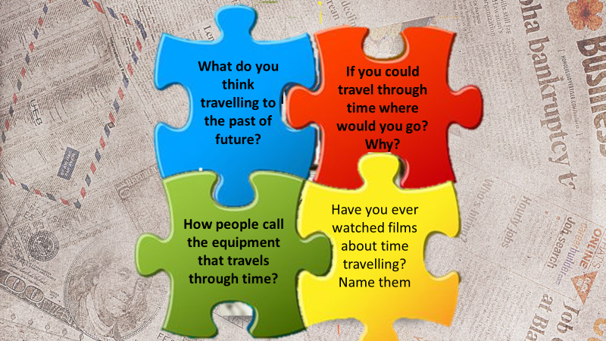Ask the puzzles questions to find new lessons theme .  What do you think travelling to the past of future?  How people call the equipment that travels through time?  If you could travel through time where would you go? Why?  Have you ever watched films about time travelling? Name them  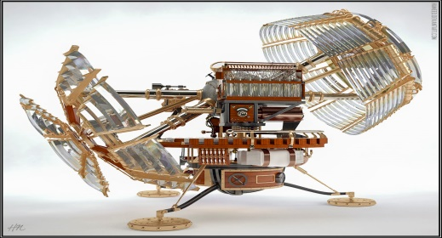  Read about author’s biography Elicit what Ss know about H.G. Wells and the stories he wrote. Allow time for Ss to read the biography and then elicit answers around the class.  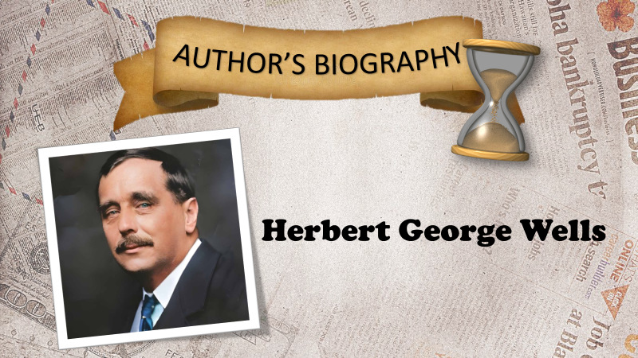 | The aim: To develop pupils speaking skills and create friendly atmosphere  Efficiency: By wishing each other they feel better and feel the support of others  Pupils choose the diamond  1 true  2 doesn’t say  3 true  4 false  5 doesn’t say  6 true  1 broke  2 burst  3 ruin  4 hung  5 stared  6 sprung  Answer the questions one by one.  Students' attention is drawn to the lesson.  Determines the topic and purpose of the lesson  •Learners remember previous lesson vocabulary  Did you listen about the time machine?  Pupils read the biography and complete the card  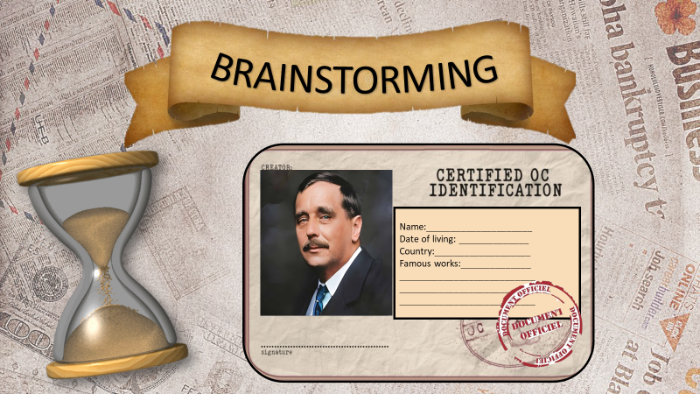 | The teacher to assess learners for their ability.  “Good job!  Well done!”  Formative Assessment    Good job!  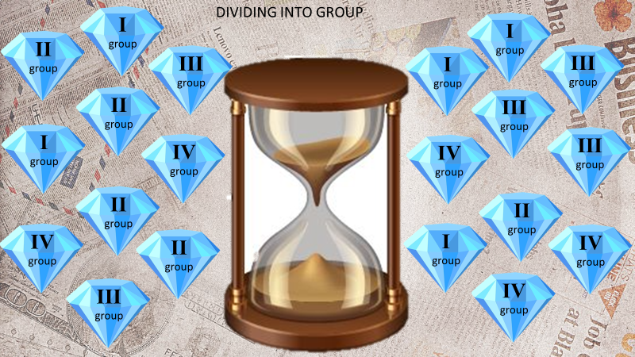  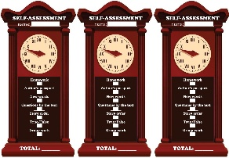  Descriptor:  - knows last lesson vocabulary and uses them  - understands and corrects the false statements  Descriptor:  - reads and understands the text meaning  - completes the card informations | Pictures  Presentation with animation  Assessment sheet  Student’s book  Presentation  Cards  Assesments sheet  Self – assesment
Middle of the lesson  Presentation part.  25 min | New vocabulary  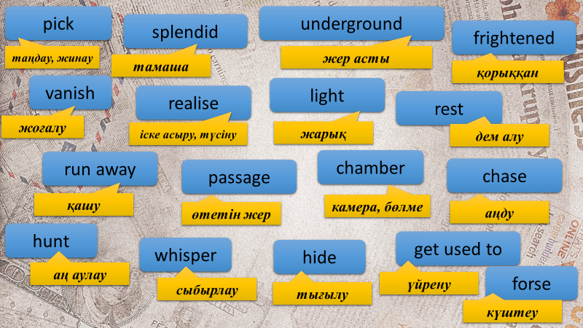  Vocabulary checking  Give the words and their definitions  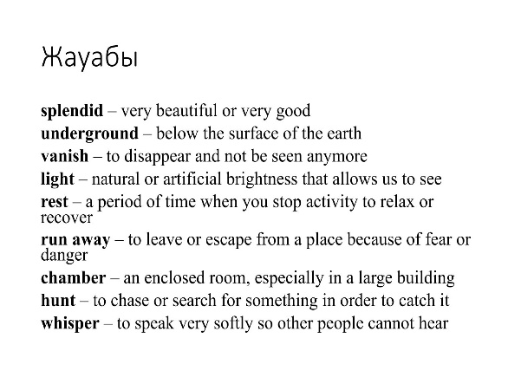  Ex: 2 P: 56  • Ss read and listen to the text to find  -Watch the video  -Answer the questions from AI  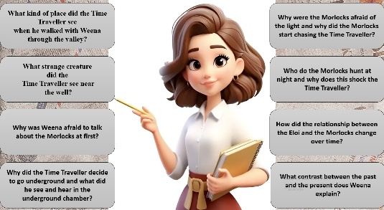 | Pupils repeat and write new words  Pupils find the word definitions  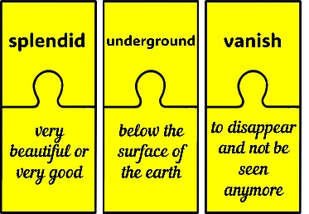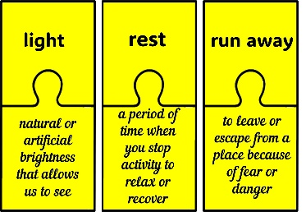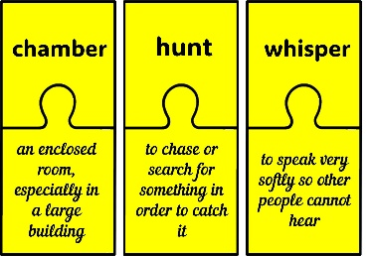  • Pupils listen and read to find out. Answer the question  ANSWERS  The Time Traveller and Weena are walking the gardenA Morlock appears and the Time Traveller follows a wellHe finds a of Morlocks under the groundlights match and discovers that the Morlocks are of the light. frightened when they start to follow and he climbs out the | Descriptor:  - knows the meaning of new vocabulary  - finds the definitions  Differentiation: «Verbal support» method is used to help Ss use new words in the sentences.  Descriptor:  - answers the questions  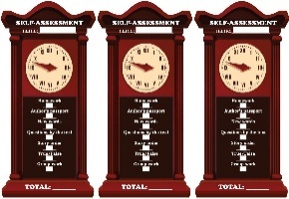 | Presentation  Presentation  Assessment sheet  Puzzle  https://www.youtube.com/watch?v=YFpMwpiXo4M  Presentation
 | Students are given AI -generated images based on the story’s plot  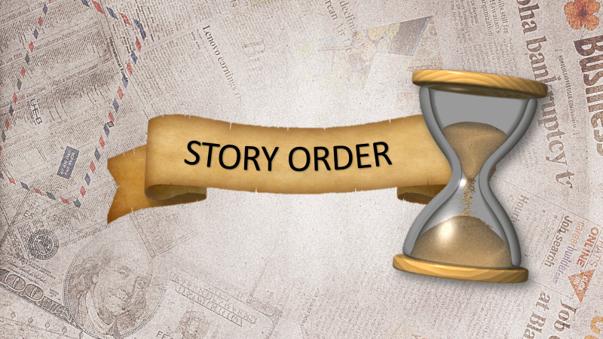 | Pupils put the given images in the order of the story plot and say which part of the event/story is shown in each picture.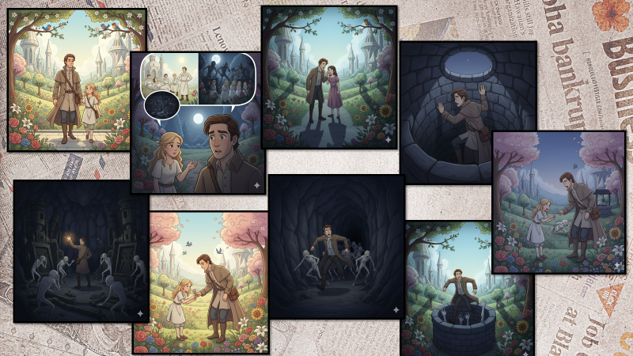 | Descriptor:  - reads the text  - puts the picture in correct order | Pictures  Assessment sheet
 | Pair work  Ss read the extract and mark the sentences True or False  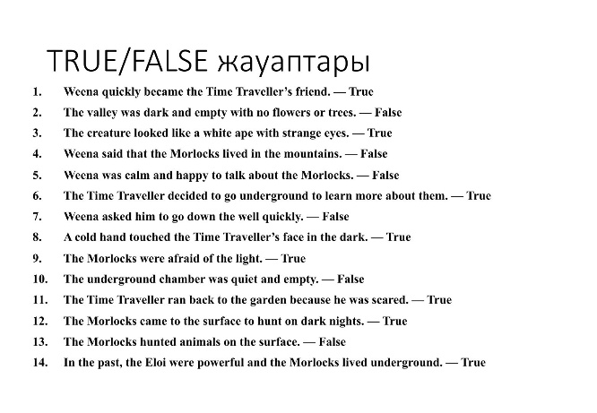 | • Pupils read the extract and choose the true or false sentences. | Descriptor:  - reads the text and finds information  - chooses the correct answer | https://wordwall.net/ru/resource/105269680/7-grade
 | Warm up  Ss do warm up exercise |  |  | https://www.youtube.com/watch?v=KhqNQ1CvS-Y
 | Group work  Ss work in a group  Conclusion during the lesson some tasks differentiated by outcomes of the students and by their abilities. | Pupils answer the questions and draw picture time machine  Which period of history would you like to travel to with a time machine?  What would you do there?  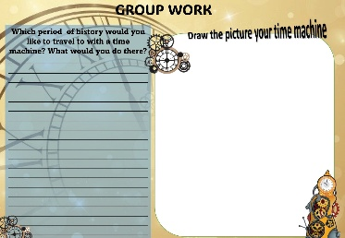 | Descriptor:  - reads the questions and writes own answer  - draws the picture  Assessment criterial  -Clear reasoning for the chosen historical period (10 points)  -Description of activities or events planned for the visit (10 points)  -Uniqueness of the time machine design (10 points)  -Contribution to the group discussion and brainstorming (10 points)  Teamwork demonstrated during the project (10 points)  Total 50 |   Worksheet  Students book
End of the lesson  5 min | FEEDBACK  Learners provide feedback on what they have learned at the lesson.  Home task: Ex:4,5 P:  Write the days | 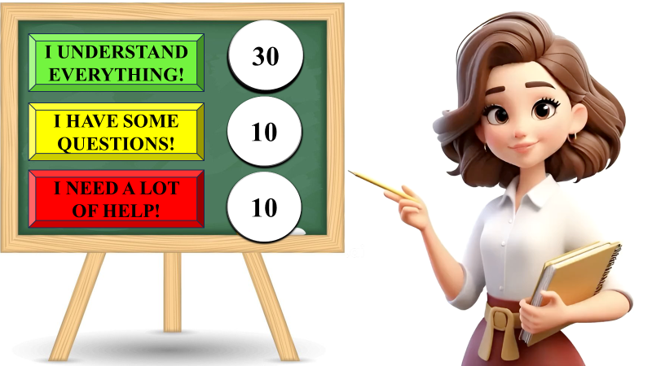 |  | Poster Success

