Short-term lesson plan for secondary school teachers
Unit: Our planet
Teacher’s name: _______________
Date: ____________
Grade: _______________
The number of students present: ___________________
The number of students absent: ____________________
The theme of the lesson: Environment
Learning objectives:
9.6.17.1 use if only /wish [that] clauses [past reference]; use a variety of relative clauses including prepositions from where, to whom on a range of familiar general and curricular topics
9.3.7.1 use appropriate subject-specific vocabulary and syntax to talk about an increased range of general and curricular topics
Lesson objectives:
By the end of the lesson most students
All learners will be able to:
- recognize and use nouns related to the environment.
- construct the sentences using the first conditional with support.
Most learners will be able to:
- construct the sentences using the first conditional to talk about possible situations with minimal support.
Some learners will be able to:
- apply the first conditional to talk about a future situation and its consequences without support.

The procedure of the lesson

Lesson stage/timing | Teacher’s activity |  | Student’s activity | Assessment | Recourses
Lead in activity  (5 min) | People’s actions or activity can either save the environment or destroy it.  Constant destruction of the environment can lead to the environmental problems.  Some people’s decisions can lead to the following environmental problems.  Let’s revise environmental problems: look at the pictures and match them with the names of environmental problems. |  | Students look at the picture and guess the topic of the lesson: The Environment.  Match the pictures with the names of environmental problems.  1) water pollution  2) deforestation  3) air pollution  4) energy waste  5) rubbish | Teacher’s assessment | - picture of the planet earth  - Handouts with the task
New vocabulary: the environment  (5 min) | Our conscious decisions can help to preserve healthy environment.  - Revise key words on environment: handout for students: three key actions to save the environment: reduce/reuse and recycle (to make our environment healthy). Write down key verbs into vocabulary copybook. |  | Ss listen to the words and repeat chorally or individually  Ss write down new words into their vocabulary copybooks | Self-assessment | -handouts with the words
Vocabulary practice: the environment  (10 min) | Complete the table, using the phrases below. Add your own phrases, if you can  Teacher monitor student’s activity and help them, if they have any difficulties |  | Students complete the table, using the phrases below. Add your own phrases, if you can | Peer-assessment | -handouts with the task
Grammar revision: first conditional  (5 min) | Two sentences are on the board  If we don’t use public transport more often, we won’t reduce the amount of air pollution.  Unless we use public transport more often, we won’t reduce the amount of air pollution.  T hands out grammar rule for students and explain it |  | Ss glue grammar rule into their grammar copybooks and make some additional notes  Ss ask questions if they don’t understand grammar rule | Whole-class assessment | Card with the grammar rule for each student
Controlled grammar practice  (8 min) | Teacher explains the task and monitors students’ activity and help them, if they have any difficulties |  | Task 1. Choose the correct words. Then complete the sentences with the correct form of the verb.  1) If, won’t get.  2) unless, don’t stop  3) will miss, unless  4) won’t know, unless  5) will get, if  Task 2. Complete the first conditional sentences. Use the correct form of two phrases in the box in each sentence.  1) Unless they hurry, they'll miss their plane.  2) If they don't leave, he'll call the police.  3) Unless they stop talking, she'll get angry.  4) Unless we change the laws, the streets won’t be safe.  Task 3. Write sentences with if or unless. Use the words. Don't change affirmative verbs to negative or negative to affirmative.  1) Unless he leaves now, he'll miss his train.  2) Unless you do that exercise now, I'll make you finish it after school.  3) Mum won't let us go to the cinema if we don't tidy our bedroom. | Peer-assessment  Self-assessment | - handouts with grammar tasks
Freer grammar practice  (5 min) | Teacher explains the task and monitors students’ activity and help them, if they have any difficulties |  | Use the cause of the environmental problems and their solutions from task 1 and write 6 first conditional sentences, using sample pattern | Self-assessment | Handouts with grammar task
Reflection  (2 minutes) |  | How well do I understand?  4 - I can do this and explain it to someone else.  3 - I understand and can do this by myself.  2 - I need more practice.  1 - I don't understand this yet.
Homework |  |  | -Learn new words: environment.  -Learn grammar: first conditional.  -Ex 2 p 35 (write the complete sentences / underline the verbs / circle if or unless).

Environment
Task 1. Match the pictures with the names of environmental problems.
energy waste water pollution air pollution deforestation rubbish

1) 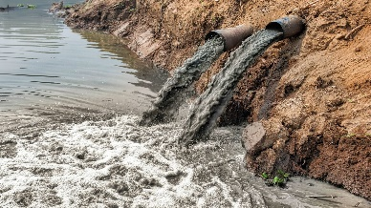 2) 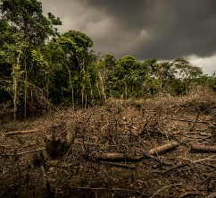 3)
4) 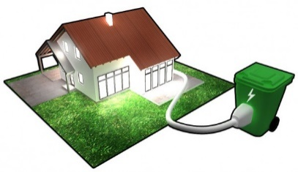 5) 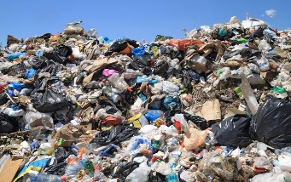

Three key actions to save the environment:
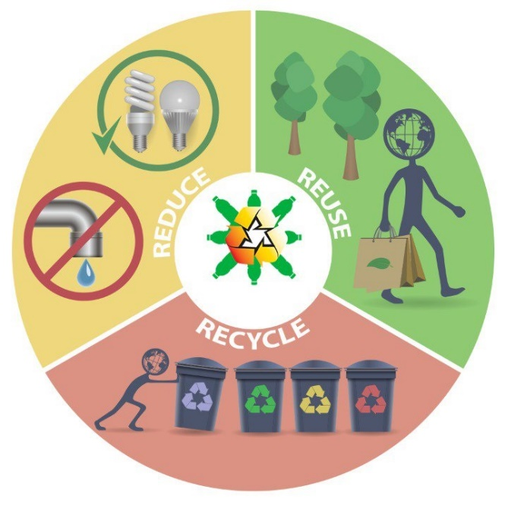
Other vocabulary
Leftovers – остатки еды
Renewable energy – возобновляемые источники
энергии
Consume / consumption = use – потреблять,
потребление
Produce – производить
Invest in – инвестировать, вкладывать деньги во
что-то
Power plant – электростанция

Task 2. Complete the table, using the phrases below. Add your own phrases, if you can.
throw away too many leftovers use renewable energy (wind, wave, hydro)
eat everything we buy ride a bike cut down the number of products we buy
consume natural resources too quickly reduce petrol and diesel consumption
use your own bag while shopping buy and eat fruit, vegetables, rice and other groats
use public transport produce a lot of meat products
put solar panels on the roof of your house turn the heating down a few degrees
use and throw a lot of plastic bags use petrol and diesel cars
invest in power plants that produce renewable energy
recycle used paper, glass and plastic use electric cars

Environmental problem | The cause of the problem | Solution
Rubbish
Air pollution
Energy waste
First conditional
Task 1. Choose the correct words. Then complete the sentences with the correct form of the verb.
1) If / Unless you don't finish your vegetables, you ___________ (not get) any ice cream.
2) The teacher will get angry if / unless the students ___________ (not stop) talking.
3) We ___________ (miss) our train if / unless we leave now.
4) The teacher ___________ (not know) what's wrong if / unless you tell him.
5) They ___________ (get) home in time if / unless they don't miss their bus.

Task 2. Complete the first conditional sentences. Use the correct form of two phrases in the box in each sentence.

they / miss / their plane
we / change / the laws
they /not leave
she / get / angry
the streets / not be /safe
he / call / the police
they / hurry
they / stop / talking
1) Daniel and Anna are late for their flight to Paris.
Unless ________________________________________
2) There are people fighting outside Tom's house.
If ___________________________________________
3) The students in Mrs. Brown's class are being too noisy.
Unless _______________________________________
4) Crime is a problem in our country.
Unless _______________________________________

Task 3. Write sentences with if or unless. Use the words. Don't change affirmative verbs to negative or negative to affirmative.
1) he / leave now / he / miss / his train
2) you / do that exercise now / I / make you finish it after school
3) Mum / not let / us / go to the cinema / we / not tidy our bedroom

Task 4. Use the cause of the environmental problems and their solutions from task 1 and write 6 first conditional sentences, using sample pattern

If | people | ______________ | it | reduce / increase the amount of
Unless | individuals |  |  | Limit the risks of
 |  |  |  | Improve the quality of____________ in cities / in the world / in our planet

Homework:
-Learn new words: environment.
-Learn grammar: first conditional.
-Ex 2 p 35 (write the complete sentences / underline the verbs / circle if or unless).

First conditional
(условные предложения первого типа)
Мы используем first conditional, когда говорим о действии, которое произойдёт в будущем, если будет выполнено условие.
Условные предложения состоят из двух частей: main clause (главное предложение) и if clause (придаточное предложение)
If – если Unless = if not – если не V (verb- глагол)
 | If clause |  | Main clause
Форма глагола | Present Simple |  | Future Simple
Утвердительная форма глагола | I, you, we, they, plurals | V | will + V
 | He, she, it, singular | Vs
Отрицательная форма глагола | I, you, we, they, plurals | don’t + V | won’t + V
 | He, she, it, singular | doesn’t + V
Утвердительная форма глагола be | I am  he / she / it / singular is  you / we / they / plurals are |  | will be
Отрицательная форма глагола be | I am not  he / she / it / singular isn’t  you / we / they / plurals aren’t |  | won’t be
Если слово if находится в начале предложения, то между главным и придаточным предложениями СТАВИТСЯ ЗАПИТАЯ If the weather isn’t fine, I won’t go for a walk
Если слово if находится в середине предложения, то ЗАПЯТАЯ между главным и придаточным предложениями НЕ СТАВИТСЯ. I won’t go for a walk if the weather isn’t fine
Unless = if not I won’t go for a walk unless the weather is fine

