School 7 named after K.Ushinskii
Lesson Plan
Theme of the lesson: Days of the week-2

Unit:3 | Time.
Teacher’s name: | Baltabekkyzy A
Date: | 24/11/2022
Grade: 3 Б | Number present: absent:
Theme of the lesson: | Days of the week-2
Learning objectives(s) that this lesson is contributing to: | 3.4.4.1 write with support short basic sentences with appropriate spaces between words;  3.2.1.1 make basic statements which provide personal information on a limited range of general topics;  3.2.6.1 take turns when speaking with others in a limited range of short, basic exchanges;
Lesson objectives: | All learners will be able to:  Write with support  Practice learned vocabulary with support.  Take turns when speaking

Plan:

Part of the lesson/Time | Teacher’s activity | Student’s activity | Assessment | Resources
Beginning of the lesson  Warm up activity.  5 min. | Organization moment:  - Greeting.  Teacher suggests class to do warm up activity  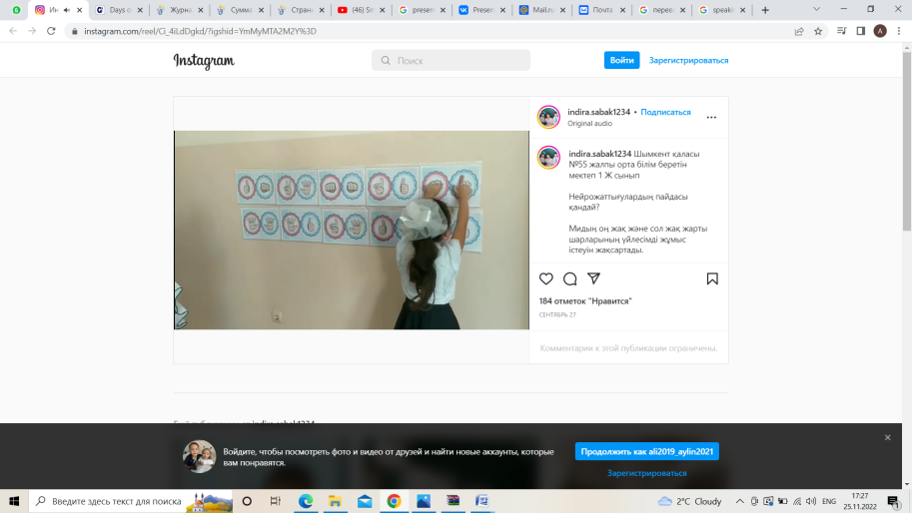 | Pupils great teacher and take their seats  Pupils do warm up activity | At the organization moment T tries to award active Ss
Middle of the lesson  5 min.  5 min  7 min  2 min  10 min  6 min | Main part  Teacher asks pupils to solve quiz about days of week.  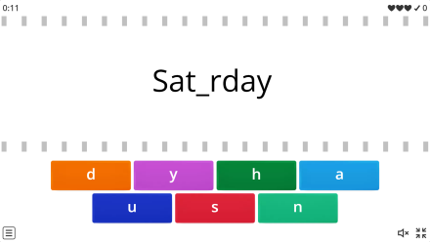  Task for functional literacy  Listening  Teacher to read the text and ask pupils put picture on correct days of the week picture. Say the words correctly.  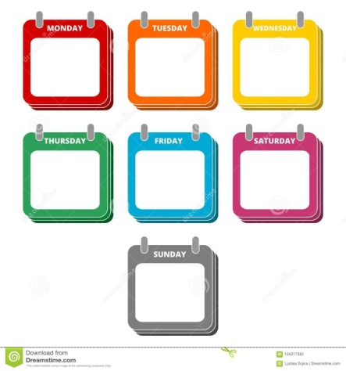  Writing  Teacher asks pupils to listen the text again and write True or False next to the sentences  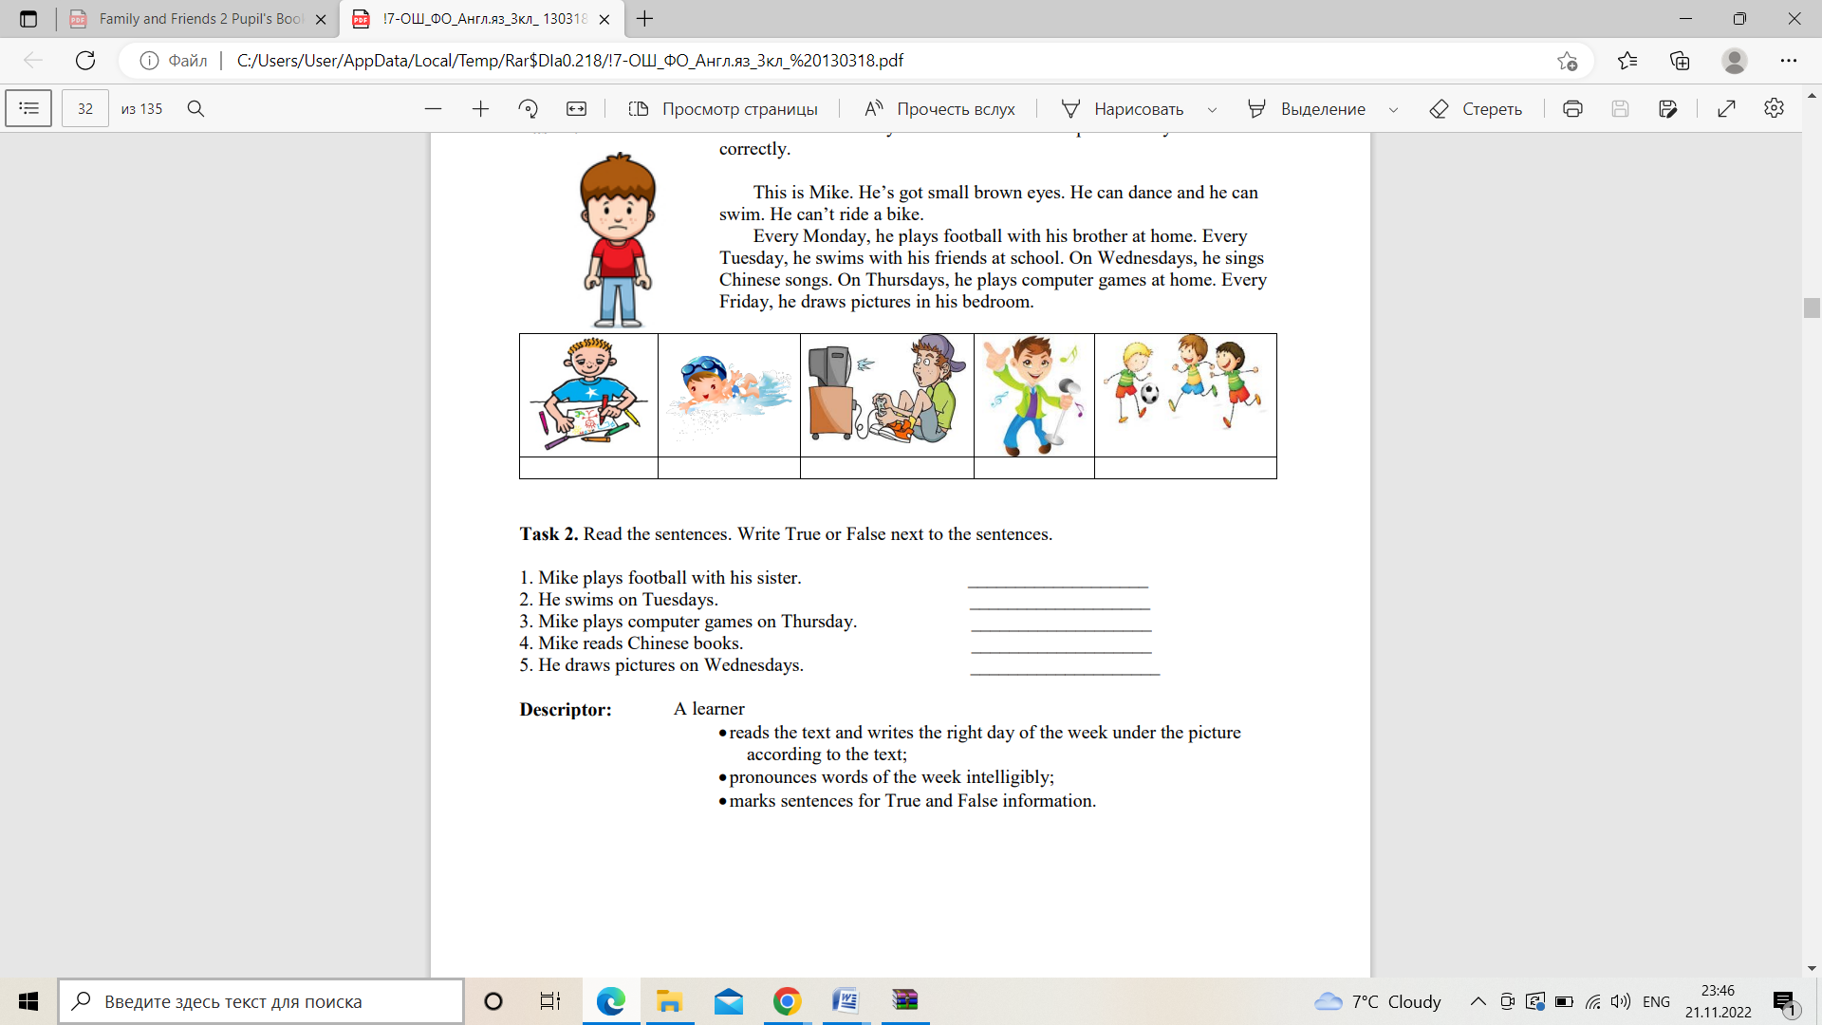  Physical training  Reading  Quiz game  This is a simple game to practice days of the week in English. The game has text for days of the week and has sentences for context. The aim of this game is simply to practice and reinforce the days of the week. In the first part, pupils are presented with the days in a jumbled order and have to re-arrange them correctly. In the second part pupils have to read or listen to the text and then move the images to the correct day.  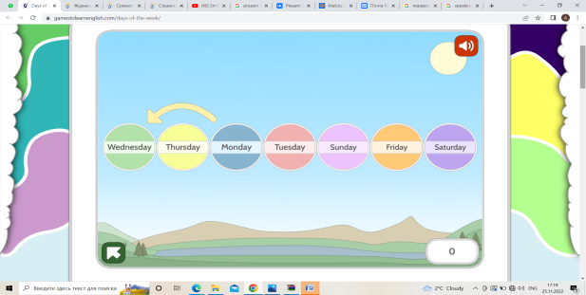  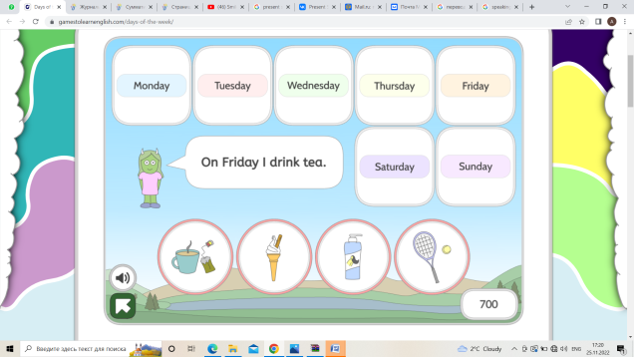  Speaking:  Teacher suggests pupils to choose a card, to read the question and to give correct answer.  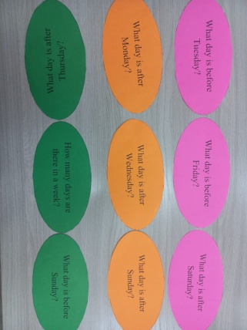 | Pupils should find and match the correct letter  Pupils should look at the picture, listen to and put picture on correct days of the week  Pupils should listen the text again and write True or False  Pupils dance  Pupils to click and listen to each in turn. Also they should jumbled order correctly, move the images to the correct day.  Pupils choose a card,  to read the question and to give correct answer. | 1 point  Descriptor:  Pupil can:  - Understand the main point of the text.  - Glue correct pictures on the days of the week  1 point  Descriptor:  Pupil can:  • pronounces words of the week intelligibly;  •move the images correctly  5 points  2 point  Descriptor:  Pupil can:  • answers the questions;  - Talk about days of the week  1 point | https://wordwall.net/resource/22444323/esol/days-of-the-week  Worksheet 1  Worksheet 2  Video  https://www.gamestolearnenglish.com/days-of-the-week/  Card
End of the lesson.  Reflection  - 5 min | Teacher tells class to reflect on their learning by messengers  Home task: p 29 Ex 9. | Pupils reflect on their learning by messengers | Feedback | AB

