Unit: Natural Disasters  ;: |  |  | School: Akhmer School
Date: |  |  | Teacher name: M.Nurpeissova
CLASS: 7 |  |  | Number present: |  | absent:
Lesson title: An article
Learning objectives(s) that this lesson is contributing to (link to the Subject programme) |  | 7.S3 Give an opinion at discourse level on a growing range of  general and curricular topics  7.С3 Respect different points of view  7.R5 Deduce meaning from context in short texts on a growing  range of familiar general and curricular topics
Lesson objectives |  | All learners will be able to:  - Read the text and understand the main idea with some support  - Discuss the topic using 3-4 simple sentences  Most learners will be able to:  - Read the text and understand the main idea with less support  - Use topic-related vocabulary in their own context independently with less freedom  Some learners will be able to:  - Read the text and understand the main idea without support  - Compare own opinion with group partners’, using 6-7 sentences
Language objective |  | Vocabulary, related to the topic: outdoors, flood, land, rebuild, resident, indoors
Assessment criteria |  | Know the meaning of new words.  Recognize the main idea.  Share their opinions with each other according to the topic.
Level of thinking |  | Comprehension, Analysis
Values links |  | Responsibility
Cross-curricular lin links |  | Geography and Social Studies
Previous learning |  | Vocabulary related to the topic “Extreme weather”
Use of ICT |  | Projector or Smart board for showing video, pictures
Intercultural awareness |  | Readiness to support
Pastoral Care |  | Create a friendly atmosphere for collaborative work.
Plan
Planned timings | Planned activities (replace the notes below with your planned activities) |  |  | Resources
Start  3mins  5mins  6mins | Organization moment  Greeting.  Good morning, pupils! How are you?  Marking absentees.  What date is it today?  Who is absent today?  (W) Warm-up  “Magic ball” game according to Multilingual policy.  Learners should stand in a circle. The beginner throws the ball and says the word by previous theme in Kazakh. The leaner who catches the ball should translate the word into Russian and also throw the ball. The third learner catches the ball and translates the word into English. The next learner names the other word. The exercise continues for about 4-5 minutes until learners revise all the vocabulary from last lesson.  For example: бұршақ- град-hail, etc.  (W) Brainstorm  Learners will watch the video and answer some questions after that.  - Can you name kinds of natural disasters?  - What have you seen in this video?  - When did it happen?  - Can you guess the theme of our lesson today? |  |  | ball  https://www.youtube.com/watch?v=HbJaMWw4-2Q
Middle  2mins  2mins  5mins  10mins  10mins | Group division using picture puzzles.  There are 4 puzzles 4 pieces each.  Learners take one of 4 pieces of puzzle. Then they look for their group members by putting the pieces together. And take their places according to the pictures.  1 group – Fire  2 group – Flood  3 group – Earthquake  4 group – Tornado  (W, G) Pre-reading task  Task 1.  Look at the photos near the text and answer the questions:  - Do you know what happened in New Orleans in August 2005?  - What do you think the man is doing?  (I) Task 2. Work with the words.  Differentiation by difficulty of the task.  - translate the words  Matching Strategy  - match the definition to the word  - find the definition using mobile  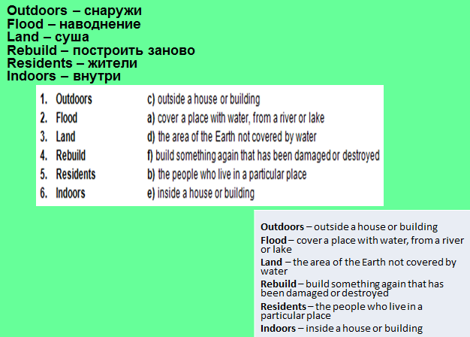  Descriptor  A learner  - translates the words  - matches the definition to the word  - finds the definition using mobile  Self-assessment by showing thumbs  (I,P,G) While-reading task.  Think-Pair-Share Strategy  There are 4 paragraphs in the text. Each group member reads his/her part. Next discuss in pairs. Then share information with the other pair from their group.  Descriptor  A learner  Reads and discusses the information from the text  (G) Post-reading task  Share your ideas with your group partners  How can people and places be protected from natural disasters like hurricanes?  Differentiation by level of thinking skills.  - Discuss the topic using 3-4 simple sentences  - Discuss the topic using 6-7 sentences  - Discuss the text using their own content independently  Descriptor  A learner  Discusses the topic using 3-4 simple sentences  Discusses the topic using 6-7 sentences  Discusses the text using own content independently  Peer-assessment by presenting smiles |  |  | 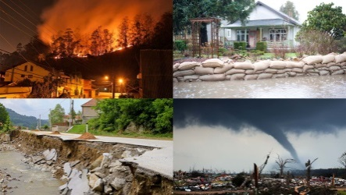  https://yandex.kz/images/search?text=natural%20disasters&img_url=https%3A%2F%2Fs.yimg.com%2Fuu%2Fapi%2Fres%2F1.2%2FcS6L26UvMEQ0gUrcI3U3Ug--~B%2FaD0xMTI1O3c9MjAwMDtzbT0xO2FwcGlkPXl0YWNoeW9u%2Fhttp%3A%2F%2Fmedia.zenfs.com%2Fen-US%2Fhomerun%2Frealtor_com_80%2Fe9d33cebf760cd2e7123502666f3e286&pos=10&rpt=simage&lr=162  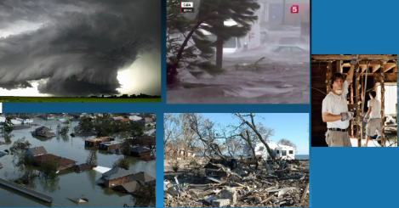  https://yandex.kz/images/search?p=2&text=ураган%20катрина%20фото&img_url=https%3A%2F%2Fds04.infourok.ru%2Fuploads%2Fex%2F0b49%2F000ab9a8-34ef9a41%2Fimg20.jpg&pos=87&rpt=simage  Eyes Open 3. SB p.74  Eyes Open 3. SB p.74
End  2mins | Home task  Teacher describes the task.  WB p. 78 ex.2,3  Reflection  A learner marks own position in each of 5 given sectors according to evaluation of result.  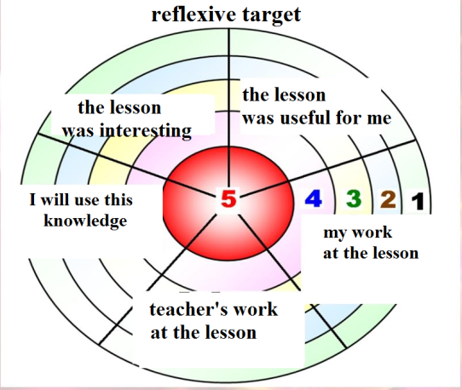 |  |  | The idea is taken from https://goo.gl/images/kN41eY

