Short term plan: term 3

Unit of a long term plan: Unit 9 Reading for pleasure. |  | Lesson 57

Teacher name:

Date: 05.02
Grade: 5 |  | Number present: | absent:
Lesson title | Learners read non-fiction books in Kazakh, English, Russian languages  The fisherman and the fish
Learning objectives | 5.3.7.1 use appropriate subject-specific vocabulary and syntax to talk about a limited range of general topics  5.4.3.1 understand the detail of an argument on a limited range of familiar general and curricular topics;
Lesson objectives | Learners will be able to:  • Learn and practise nouns to talk about types of writing.  • Practise asking questions about stories.
Value links | Kindness – If you value kindness, you’ll likely always be respectful of people around you, be gentle with criticism, and always willing to welcome people with open arms.
Plan

Stages / Time | Teachers’ actions | Students’ actions | Assessment criteria | Resources
Beginning of the lesson  5 min | Organization moment  1.Greeting. Hello students  How are you today? I’m glad to see you today.  Warm-up  Look at the desk  What do you see on the desk?  -Well done, This is rebus!  Let’s solve the encrypted words in the puzzle!  Reading for pleasure – good job students!  Let’s translate the phrase  What do you think it’s about?  Lead – In  Look at the blackboard and answer the questions  Who was Alexander Pushkin? Where was he from? Read the biography to find out.  Who is it?  Who was Alexander Pushkin? Where was he from? When was he born? | The aim: To develop Ss speaking skills and create friendly atmosphere  Efficiency: By telling the wishes they show their appreciations .  Students say about different questions | At the organization moment T tries to award active Ss. «The praise» method is used to evaluate Ss with phrases like:  “Good job!  Well done!”  Formative Assessment    Good job! | Pictures  Student’s book
Middle of the lesson  Presentation part.  35 min | Ex: 2 P: 76  • Look at the picture. Which one shows:  Explain the task. Allow time for Ss to look at the pictures and choose the descriptions from the list. Check answers.  1F 2D 3A 4B 5C 6E  Next tasks, Who said the following… Students shows the pictures to whom phrases from the fairy tale correspond:  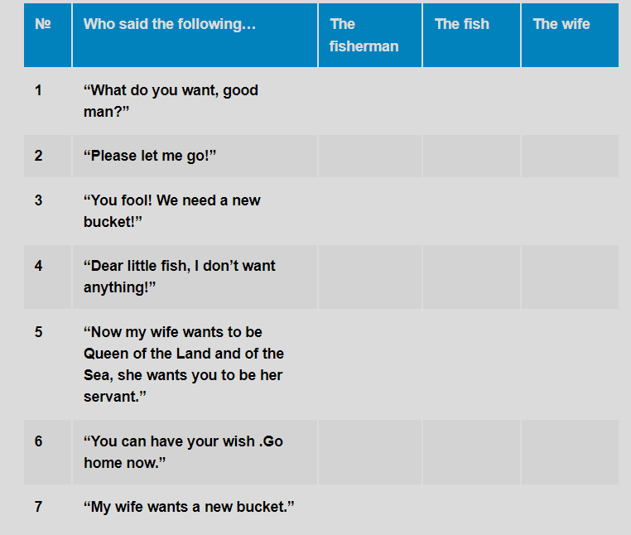  Differentiation:  «Verbal support» method is used to help Students use new words in the text.  Ex: 3 P:76  • Explain the task and do an example together to make sure students know what they have to do, pointing out that only one item on the left matches an item on the right.  • In a stronger class, ask students to do the activity individually before checking their answers in pairs. In a weaker class, check their understanding of the vocabulary and ask them to do the task in pairs.  • Check answers as a class. Ask students to think of more examples of each type of writing.  Ex: 4 P:77  • Explain the task and do the first question with the class. If necessary, review when we use wh- questions, e.g. Ask the class ‘Who is your maths teacher?’ (person) ‘When is your Geography class? (time), etc.  • Circulate and monitor. Give assistance where necessary. | Students do the quiz and check their score  ANSWERS:  1F 2D 3A 4B 5C 6E  Students look at the phrases in blue in the quiz. Math the types of writing with the names of the characters  ANSWERS:  1 c  2 f  3 d  4 g  5 a  6 h  7 b  8 e  Students complete the questions with a wh- or how question word  ANSWERS:  1 let it go  2 want anything  3 fool  4 new house  5 land and sea  6 a small house and the old bucket | Assessment criteria  - Learn and practise nouns to talk about types of writing.  Descriptor:  - do the quiz and check their score  Assessment criteria:  - Practise asking questions about stories.  Descriptor:  - complete the questions with a wh- or how question word  Make CCQ questions  Yes / No |   Cards  Worksheets
End of the lesson  5 min | Home task:  Ex: 1 P: 60 WB | 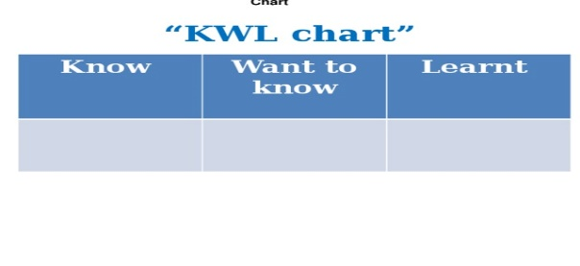 | Students use their stickers to show their knowledge according to the lesson. | Poster  KWL chart  

