Unit of a long-term plan: | School: gymnasium#67
Date: 02.02.2023 | Teacher’s name: Nabiyeva Maral Makhsutkyzy
Class: Grade10В | Number present: | absent:
Lesson title | Types of questions in English grammar
Learning objective(as) | 10.03.1-use all types of questions in talk on a wide range of general and curricular topics.  10.1.1-use speaking and writing skills to solve problems creatively and cooperatively in groups  10.4.1- understand main points in extended tests on a wide range of familiar and some unfamiliar general and curricular topics.
Level of thinking skills | Understanding, Knowledge, Application
Lesson objectives | All learners will be able to:  - to form questions and to ask questions correctly  Most learners will be able to:  - improve grammar skills  Some learners will be able to:  - identify the types of questions
Assessment criteria | - use the relevant vocabulary and grammar  - justify opinion
Values links | Respecting each other and using feedback
 | Plan
Planned timings | Planned activities |  |  | Resources
Start  2 min | Greetings, organisational moment.  -Who is on duty today?  -Is anybody absent?  -What is the day and date today?  -What season is it now?  -Do you like winter or summer?  T: S/s What have I done now?  P: You asked questions.  T: Yes, But what is a question? Why do we use it?  P: To get information, to understand each other to speak, etc  T: yes, we ask questions every day. We answer questions every day. Asking questions and getting answers to them, we become smarter. By asking questions we learn.  The Theme of our lesson is Types of questions in English grammar.  II. Presentation. |  |  | Slide presentation
Middle  25 min  5 min  2 min  5 min  3 min  End  3minutes | Objectives: How to form questions in English?  How to ask questions in English correctly?  What types of questions exist in English? They are our research questions  Contents  - General questions (Yes/No Questions)  - Tag Questions  - Alternative questions  - Questions to the subject  - Special questions (Wh-questions) |  |  | Active board
 | III. 1) General questions (Yes/No Questions)  Question: Are you going to work today?  Answer: Yes, I am.  Question: Do you want us to have dinner at a cafe?  Answer: No, I don’t want to, thanks  A general question is one of the most popular and frequently used ways to get information. A general question is a question that we can answer simply YES or NO.  Look at the examples:  - You like your new job.  Do you like your new job?  - She knows the secret.  Does she know the secret?  - We can help you this time.  Can we help you this time?  2) Tag Questions  (+) (-)  You are going to see your grandmother, aren’t you?  (-) (+)  You aren’t going to see your grandmother, are you?  I am late, aren’t I?  3) Alternative questions  We not only ask but also offer alternatives  for the answer! We can ask an alternative question to any Parts of the Sentence  Do you like to go to the cinema or to the theatre?  Would you like tea or coffee?  Have you played football or basketball?  4) Questions to the subject  We ask a question to the subject when we want to know WHO is performing the action.  Question: Who will go for a walk with you?  Answer: John.  Question: Who broke the cup?  Answer: Tom did it!  e.g. Mother has just come home.  Who has just come home?  5) Special questions (Wh-questions)  Question: Where were you yesterday?  Answer: I visited my friend Frank.  To ask a special question we usually use these question words:  What? When? Where? Why? Which? Whose? Who(m)?  Take a look at examples:  When do you want me to leave?  Why do you stay ith him?  What are you doing here?  Why can’t you be with us tonight?  IV. Ask all types of questions to the sentence  The girl saw me yesterday.  - Did the girl see me yesterday?  - The girl saw me yesterday, didn’t she?  - Did the girl see me yesterday or last week?  - Who saw me yesterday?  - What did the girl do yesterday?  - Whom did the girl see yesterday?  - When did the girl see me?  V.Movement activity  Double, double this, this  Double, double that, that.  Double this, double that  Double, double this, that  - Work with test books  - Speaking: dialogues in pairs  - Feedback  - A game |  |  | 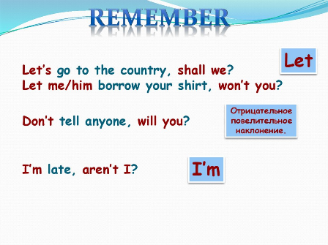  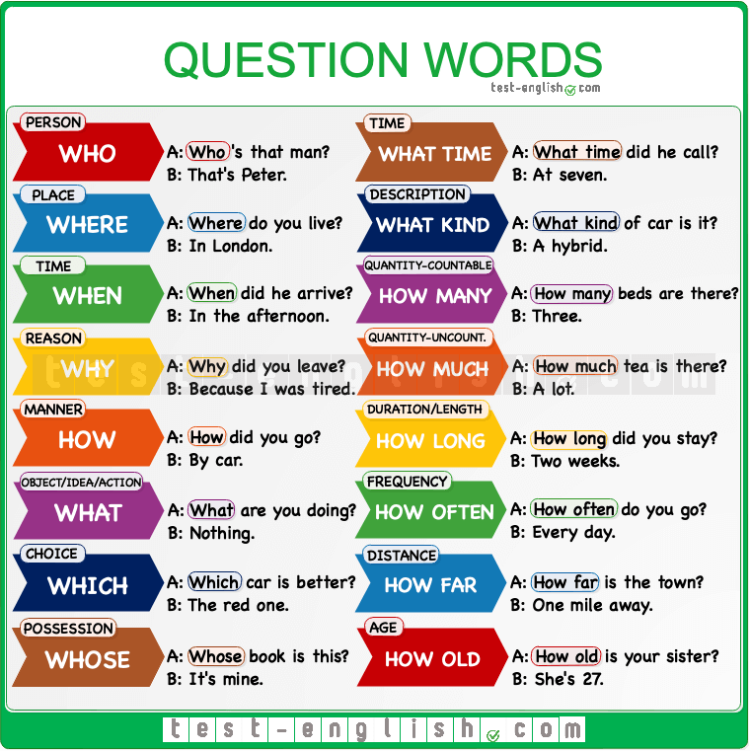  Activity  Test books  A game
 | - Homework: write 2 sentences and ask all types of questions
Additional information
Differentiation – how do you plan to give more support? How do you plan to challenge fast finishers?  Ask fast finishers to start working on the mind map. |  |  | Assessment – how are you planning to check students’ learning?
Reflection  Were the lesson objectives/learning objectives realistic?  Did all the learners achieve lesson objectives/learning objectives? If not, why?  Did my planned differentiation work well?  Did I stick to timings?  What changes did I make from my plan and why? |  |  | Use the space below to reflect on your lesson. Answer the most relevant questions from the box on the left about your lesson?

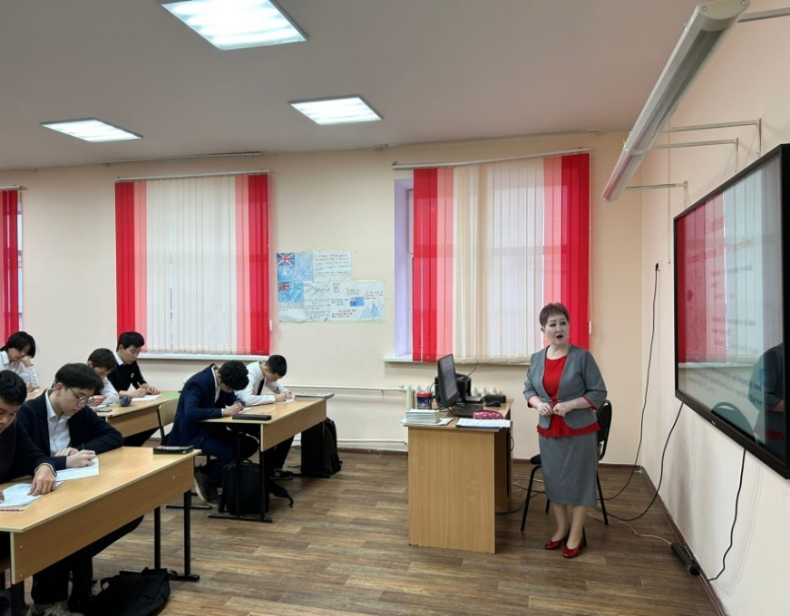
Photos from the lesson

