Short term plan: term 3
The theme: Activities in and out of school

Unit of a long term plan: Our health |  | School: Сам МБК
Date: 09.01.23 |  | Teacher name:
Grade: 6 |  | Number present: | absent:
Lesson title | Activities in and out of school
Learning objectives | 6.1.9.1 use imagination to express thoughts, ideas, experiences and feelings  6.2.1.1 understand a sequence of supported classroom instructions  6.3.1.1 provide basic information about themselves and others at sentence level on an increasing range of general topics
Lesson objectives | Learners will be able to:  • Learn vocabulary for school and free-time activities.  • Do a general knowledge quiz.  • Learn how to talk about school routines.  • Write sentences about your routines.
Plan

Stages / Time | Teachers actions | Students actions | Assessment criteria | Resources
Start | Organization moment  1.Greeting.  Ask about the weather.  Warm-up  • With books closed, ask students: What do you usually do at the weekend? Elicit ideas and write them on the board.  • Ask: What activities do you do at school? Elicit some ideas and write them on the board.  Lead - In  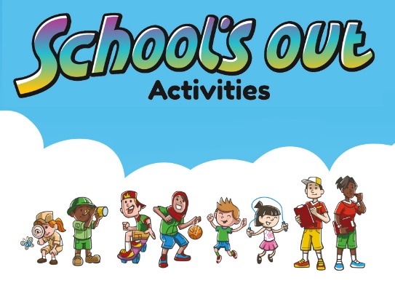  The School’s Out team is made up of a blend of different backgrounds and specialities to ensure we deliver the best camp experience to all children. From qualified Primary School Teachers to experienced Sports Coaches, our team is driven to providing premium holiday activities. | The wish flower” method helps to start the lesson with good wishes to each other.  The aim: To develop Ss speaking skills and create friendly atmosphere  Efficiency: By telling the wishes they show their appreciations .  Describe and imagine the pictures  Students say different words from the picture | At the organization moment T tries to award active Ss. «The praise» method is used to evaluate Ss with phrases like:  “Good job!  Well done!”  Formative Assessment  Good job! | CD 1  Pictures  PPT
Main part  - | Ex: 1 P: 56  Point out the full forms of PE and ICT.  • Ask students to match the words individually, then compare their answers in pairs.  • Check answers, and check understanding of the remaining words in the box. Drill the pronunciation of any unfamiliar words  Differentiation:  «Verbal support» method is used to help Students use new words in the text.  Ex: 2 P: 56  • In a weaker class, allow students to do the quiz in pairs.  • If you have time to extend this activity, you can let them look up answers they do not know.  • Check answers with the class. Find out who got the most correct answers.  Ex: 23 P: 56  • Students use their dictionaries to check the meanings.  • Point out that several combinations are possible. Students must think carefully about meaning and make logical combinations. | Students with photos.  ANSWERS:  1 football  2 ICT  3 maths  4 chess  5 art  6 science  7 geography  8 drama  Students do the Test your knowledge  ANSWERS:  1 a  2 c  3 a  4 c  5 b  6 b  7 c  8 b  Students check the meaning of phrases with the words in blue  ANSWERS:  1 dance/basketball/music/chess/football practice  2 maths/science/history/geography/French/music/ICT test  3 maths/science/history/geography/French/music/ICT/art homework  4 ICT/PE/drama/maths/science/history/geography/French/ dance/art/music class.  5 maths/science/history/geography/French/art/music/ ICT exam 6 football/basketball match | Assessment criteria  - Learn vocabulary for school and free-time activities.  Descriptor:  - match eight of words in the box  Peer assessment: answer key  Assessment criteria:  - Do a general knowledge quiz.  Descriptor:  - do the Test your knowledge  -Make CCQ questions  Yes / No | Cards  Student’s book  Workshets
End | Home task:  Ex: 1 P: 40 WB | 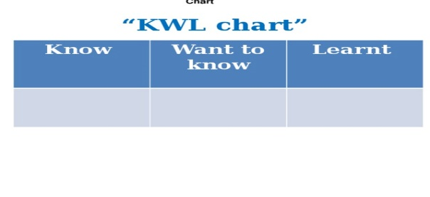 |  | Poster Success

