Lesson plan

Unit: Comedy and Drama |  |  | School: 79
Date: |  |  | Teacher name: Mukasheva Dinara
CLASS: 6 |  |  | Number present: |  |  | absent:
Lesson title |  | Famous writers
Learning objectives(s) that this lesson is contributing to (link to the Subject programme) |  | 6.3.7.1 - use appropriate subject-specific vocabulary and syntax to talk about a limited range of general topics, and some curricular topics;  6.3.8.1 - recount some extended stories and events on a limited range of general and curricular topics  6.4.2.1- understand independently specific information and detail in short, simple texts on a limited range of general and curricular topics
Lesson objectives |  | All learners will be able to:  - spell words correctly  - give examples of another famous writers  Most learners will be able to:  - understand the meaning of the words  - recite about famous writers  Some learners will be able to:  - apply appropriate words in their speech  - recite about famous writers in detail
Assessment criteria |  | - know the meaning of the words  - use new words in their speech  - understand the texts about two famous writers
Level of thinking |  | Understanding, remembering, applying, creating
Values links |  | Leaners work kindly with each other showing respect.
Cross-curricular links |  | Kazakh literature, English literature
Previous learning |  | Types of films
Plan
Planned timings | Planned actilvities |  |  |  | Resources
Start | Organization moment  Teacher greets learners! Hello boys and girls! How are you?  Students greet teacher! Hello teacher we are fine, and you? Teacher responds the question.  Lead-in  Game (Hangman)  Teacher draws a bank line on the board to represent each letter of a word (e.g. for the word snake you write _ _ _ _ _.)  Leaners call out the letters. If a letter is included in the word, teacher writes the letter on the appropriate blank line. If the letter is not included teacher draws one line of a Hangman picture. Leaners have to guess the title of the lesson. (Famous writers)  Warm-up  First of all teacher shows pictures of William Shakespeare and Mukhtar Auezov and ask questions.  - Who are they?  - What do you know about them?  - Do you read their novels?  Leaners respond to these questions and share information. |  |  |  | Excel - Virginia Evans, Jenny Dooley, Bob Obee
Middle | Reading for detail  Teacher draws attention of leaners to the texts William Shakespeare and Mukhtar Auezov.  Differentiation  Teacher hands out worksheets to leaners and give instructions of the activity. Leaners listen to the teacher attentively.  Activity 1.  Group A  Read the texts. Complete the table with information about two writers.  Name Place/ Date of birth Studies/ Family Achieve ments Works Place/ Date of death  Descriptor  A learner  - Works in group and reads the texts  - Completes the table about two writers  - Presents his work to his classmates  Group B  Read the texts. Complete the Venn diagram about William Shakespeare and Mukhtar Auezov.  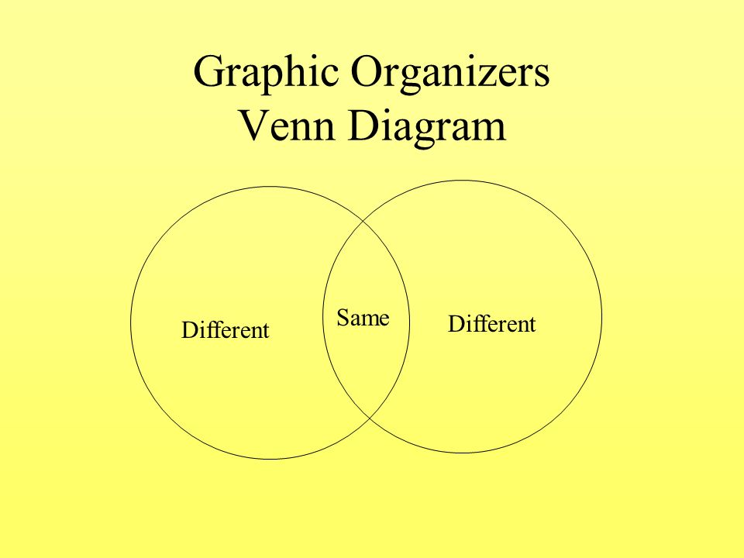  Descriptor  A learner  - Works in group and reads the texts  - Writes differences and similarities using diagram  - Presents his work to his classmates  Leaners do project work. Teacher explains how to do this activity.  Activity 2. Think of a famous writer. Collect information and then write a short text about him/her. Then make a poster.  Write: name, where/when born, some examples of their works, their achievements (50-60 words). Then, present it to the class.  Descriptor  A learner  - Works in group and choose a famous writer  - Discusses about this writer  - Writes about him or her on his poster  - Presents his poster to the class |  |  |  | www.biography.com  www.kino-teatr.ru  Excel - Virginia Evans, Jenny Dooley, Bob Obee  Worksheet 1  Worksheet 2
End | Feedback  Two stars and one wish  Teacher gives out to learners blank two star and one wish. Learners have to write two things which they learnt at the lesson and one wish what do they want to know.  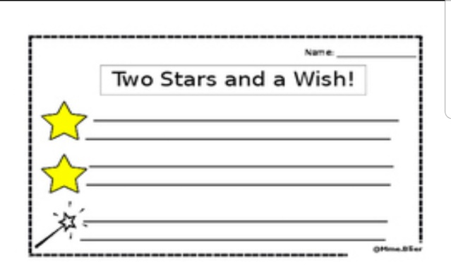
Additional information
Differentiation – how do you plan to give more support? How do you plan to challenge the more able learners? |  |  | Assessment – how are you planning to check learners’ learning? | Health and safety check
By support:  Less able leaners are supported by gestures while they are presenting their work. Giving the table with prompts and by visuals. Displaying words on the board which are difficult for them.  More able leaners work independently without visuals, developing their critical thinking.  By learning styles:  Visual leaners are supported by visual aids, Venn diagram, chart with prompts during the lesson.  Auditory leaners are supported by listening the texts, giving opportunity to discuss about famous writers in groups.  Kinesthetic leaners are supported by giving diagram and chart with prompts to complete. Doing posters about famous writers. |  |  | Monitoring leaners during the lesson. Asking questions related to the theme of the lesson. Giving to leaners descriptors for peer-assessment. Using two stars and one wish for self – assessment. | Health saving technologies.  Using physical exercises and active activities.  Rules from the Safety Rules book which can be applied in this lesson.

