1. The theme of the lesson: Healthy bodies.

2. Primary objectives of the lesson:
an activity to develop fine motor skills and consolidate the language of the module
1.L1 recognise short basic instructions for a limited range of classroom routines spoken slowly and distinctly
1.L3 recognise with support common names and names of places recognise the spoken form of a limited range of everyday and classroom words
1.L4 recognise with support short basic questions about what something is
1.L5 recognise the sounds of phonemes and phoneme blends
1.S3 pronounce familiar words and expressions intelligibly
1.S5 use words in short exchanges
3. Equipment of the lesson: pictures, poster, a tape-recorder, video.

Plan of the lesson

- Organization moment.

а) - Good morning, children! Nice to see you at our lesson. I am glad to see you happy and
healthy today. – We are glad to see you too.
- How are you? – I am fine, thank you. And you?
- I am fine, thank you. Take your seats.

b) - What date is it today? Is it Thursday today? – No, it isn’t. Is it Wednesday today? – No, it isn’t.
What day is it today? – It’s Friday today.

c) - Tomorrow is Saturday. Where do you usually go on your days out? – I go to the cinema./theatre,
café, shopping centre, skating rink…

d) - Look at the windows. Let’s talk about the weather. How’s the weather? – It’s cloudy/cold/wet/not
windy/ not rainy/not snowy/not foggy.

e) - What season is it now? – It’s winter.
- Do you like winter? Why?
- I like winter because it’s snowy./I like snow./I can skate./I can play snowballs./I can ski….

f) - It’s cold outside. Do you wear warm clothes? Why? – I am afraid to be cold./ not to have a cold.
Yes, we should have healthy bodies.
That’s nice.

- The aims of the lesson.
Let’s begin our lesson. Children, today we are going to talk about the healthy bodies. Are you ready?

- Actualization of the knowledge and skills.
- And now dear friends, look at the board. This is a crossword. Try to guess the words and topic of our lesson.

h | e | a | l | t | h
a | a | c | u | o | a
n | t | t | n | o | i
d | i | i | c | t | r
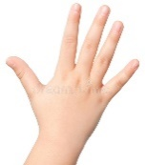 | n | v | h | h | 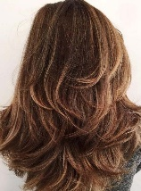
 | g | e | 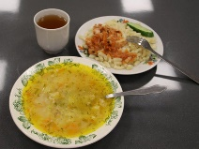 | 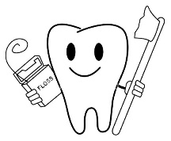
 | 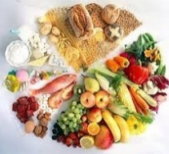 | 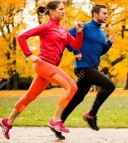

- Well done!

- Phonetic drill.
Boys and girls let’s do phonetic drill. Look at the crossword and say the words with the sounds:
[æ] – hand, active,
[θ] – health, tooth
[ŋ] - eating
Repeat after me.

Very good!

3) I want you to touch your head, hair, eyes, nose, mouth, shoulders, stomach, legs, foot.

4) Now I mime, you say: I am cold. I am sick. Cough, runny nose, medicine, stomachache,
healthy, get active.

Great job!

- Main questions of the theme.
- Dear friends, health is very important in our life. As you know some people are healthy,
some people are unhealthy. We can’t buy health, but we can do a lot to keep it.

- Look at the poster. There are three pictures.

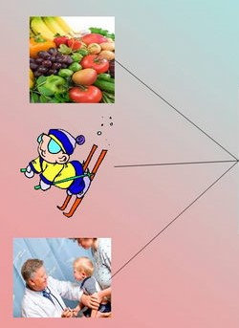

Healthy way of life

- What can you see in the first picture? – I can see healthy food.
- What does healthy food mean? – Fruit and vegetables, milk, water.
- Should you eat fast food? – We shouldn’t.
- Why? – It’s unhealthy.
- And this is the second picture. What can you say about it? – We should get active. We should
do sport, do morning exercises.
- This is the third picture. – We should follow hygiene.
- How? – wash hands, brush teeth twice a day.
- This is healthy way of life.

- - Children, what do people do if they are sick? - They visit a doctor.
- Now imagine you are patients, and I am a doctor. You are sick. You are at a doctor office. Who is the first patient? Pupil 1 is my assistant.
(cough, runny nose, toothache, stomachache, headache…)
Super work!

- Making up of the topic «Healthy way of life in our school».
- Now you’ll tell about healthy way of life in our school. You should divide into three groups in four.
- Choose a theme. Describe the picture and tell.

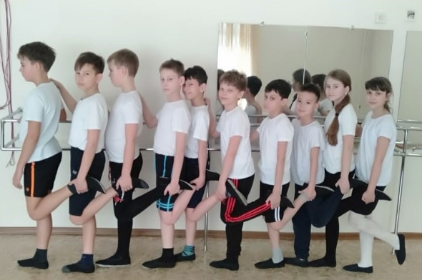

Sport in our school.

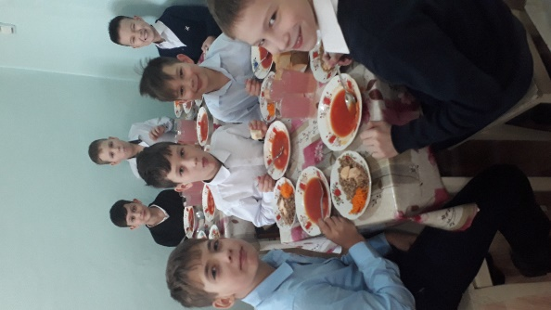

Our school canteen.

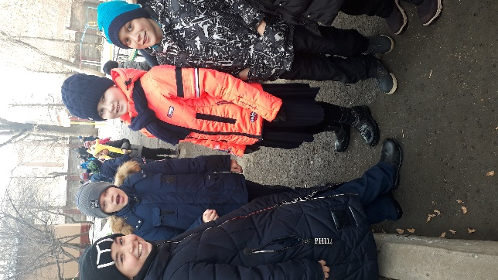

Our walks.

- Summing up.
- Our lesson is to the end. Thank you for your work you were active.
- I would like to remind you of the proverb.
«An apple a day keep doctors away».
If you eat an apple a day, you will be healthy.
- These are our apples. Help youself.

- Reflection.
Did you like our lesson?
-What did you like more?
- Our lesson is over, thank you for your being active and participation.
Good bye!

