Lesson plan

LESSON: Module 2 Lesson 10 |  | School: 10 gymnasium after Z.Tashenev
Date: 27.10.2021 |  | Teacher name: Tleukhan Aitoty Kuandykkyzy
CLASS: 6 Z |  | Number present: | absent:
Theme of the lesson: |  | Heroes
Learning objectives(s) that this lesson is contributing to | 6S.6 communicate meaning clearly at sentence and discourse level during, pair, group and whole class exchanges;  6S.7 use appropriate subject-specific vocabulary and syntax to talk about a limited range of general topics, and some curricular topics;  6R.1 understand the main points in a growing range of short, simple texts on general and curricular topics;
Lesson objectives | All learners will be able to:  identify some specific information in speaking and reading and use some target vocabulary accurately in production tasks with support
Most learners will be able to:
Guess the meaning of the words by the pictures given.
Answer the questions by the text
Participate in a group work
Some learners will be able to:
Easily make up their own sentences with the new words.
Participate in the discussion freely and use topic-related vocabulary properly.
Previous  learning | Recommending a book
Success criteria | Understand most specific information and detail of supported, extended talk on a range of general and curricular topics.
Value links | Global citizenship. Respect for self and others. Cooperation. Academic honesty. Students will foster these values through pair work and class work while discussing their personal thoughts and ideas. Remind students about following the rules of academic honesty while students are given individual task and FA.
ICT skills | Retrieve information from the Internet, Power point presentation, Handouts, Video
Plan
Planned  timings | Planned activities |  |  | Excel  Resources
Beginning  5min | Warming – up  Students look at the pictures on presentation and guess the lesson objectives watch the video and try to guess the theme of the lesson.  Possible answers: Today we will listen an audio, we will speak, we will do exercises  Learning objectives:  - Improve speaking and reading skills  - Learn new target vocabulary  Ss look at the pictures on presentation and try to guess the theme of the lesson  Theme of the lesson: Heroes |  |  | ppt Slides  3-6
Middle  3 min  2min  3min  8min  2min  7min  6min  6min | Introducing with the new target vocabulary  Task 1.Teacher distributes cards with English words and their translation. On presentation T shows pictures with the English words, students have to match the English with their translations.  Task 1. Ss desc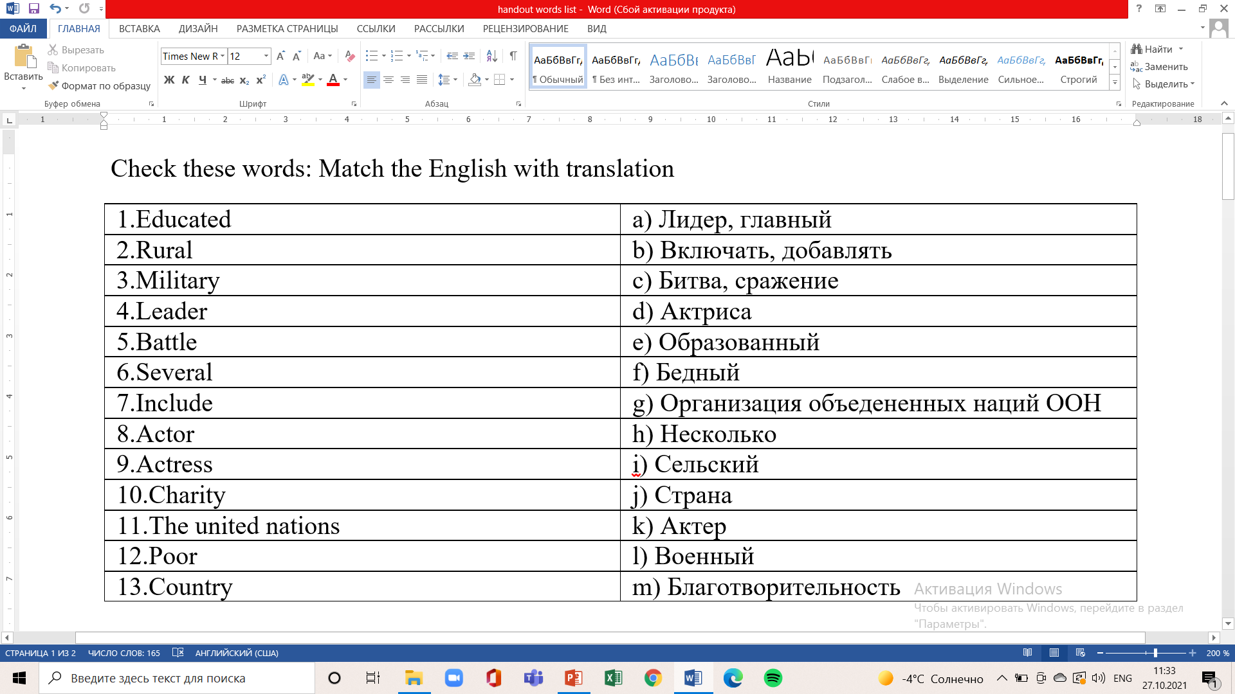  Pre-reading task  Students answer the questions about two famous figures.  - Who are the famous figures in the pictures?  - What do you know about them?  - What are they famous for?  Reading  Students take 3 min and read the text by themselves  Speaking  Task 2.Students work in pairs. Game “Interview”. Ss take turn and ask each other questions about the text they have read.  Questions:  - Where was Baurzhan Momyshuly born?  - How is he remembered?  - Who is Angelina Jolie?  - What does she do for the United Nations?  After the “Interview” Ss answer the questions orally.  Group work  Ss are divided into 4 groups by randomizer.  Each group makes up a mind map.  Group 1 “Why is Bauyrzhan Momyshuly is the hero?”  Group 2 “Why is Angelina Jolie is the hero?”  Group 3 “Who is the hero”?  Group 4 “Real life heroes”  Each group assesses others, using these criteria  - Gives full answer  - Everyone participated  - Gives presentation on topic  Feedback  Ss guess the target vocabulary by pictures on presentation  Self-assessment |  |  | Ppt Slides 7-20  Handout_1  ppt Slide21  SB p25 Ex 1  SB p25  SB p25  Ex 2  Ppt Slides 23-24  Ppt slides 25-26  Handout 2-3  Ppt slides 27-38  Handout 4  Ppt 39-40
End  3min | Plenary  Ss give feedback on lesson objectives  Home work: SAT 1 preparation |  |  | Ppt 41-42

