Город Кентау

Школа-гимназия № 22 им.М.Ауэзова

Учитель английского языка

Кенжибаева Айнаш Кенесовна

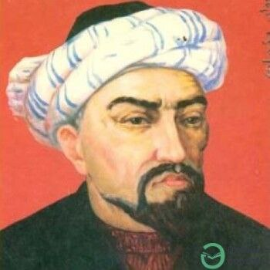

**Akhmed Yassawi: life, words and significance in the Kazakh culture.**

Yasavi was a Central Asian philosopher, Sufi poet, and Islamic preacher. He left behind a great number of spiritual works that bring joy to art admires entered the culture of various nations nations of Central Asia. One of his outstanding works is the book "Diwani hikmat". This book was written about philosophy and Islamic rules. The mausoleum in Turkestan was built by the order of Amir Timur in honor of the great educator of Central Asia, Khoja Ahmet Yasawi. At the age of 63, he accepted asceticism, since the Prophet Muhammad died at the age of 63, he decided to accept asceticism, that is, not to see the sun for the remaining days of his life. He called people to Islam by writing poems, books or using music. He acted not only as a spiritual mentor, but also as a wise statesman. He accepted the amanat from the prophet through his spiritual mentor Arystan - bab in the form of a seed from a date. Yassawi's work "Divani Hikmat" is widespread in the world and also this book is a literary work of philosophical and religious content. It covers Islamic values and reveals gaps in our modern society.

School: Gymnasium №22 named M.Auezov.

Saidakhmetov A. Form 8 “A”

Teacher: Kenzhibayeva A.K